**Charge Router/Charge Entry**

Try it out:

Access patient’s HAR/account that requires charge entry and access Charge Router Unit Charge Entry.

Epic – Enterprise Billing – Charge Router – Unit Charge Entry

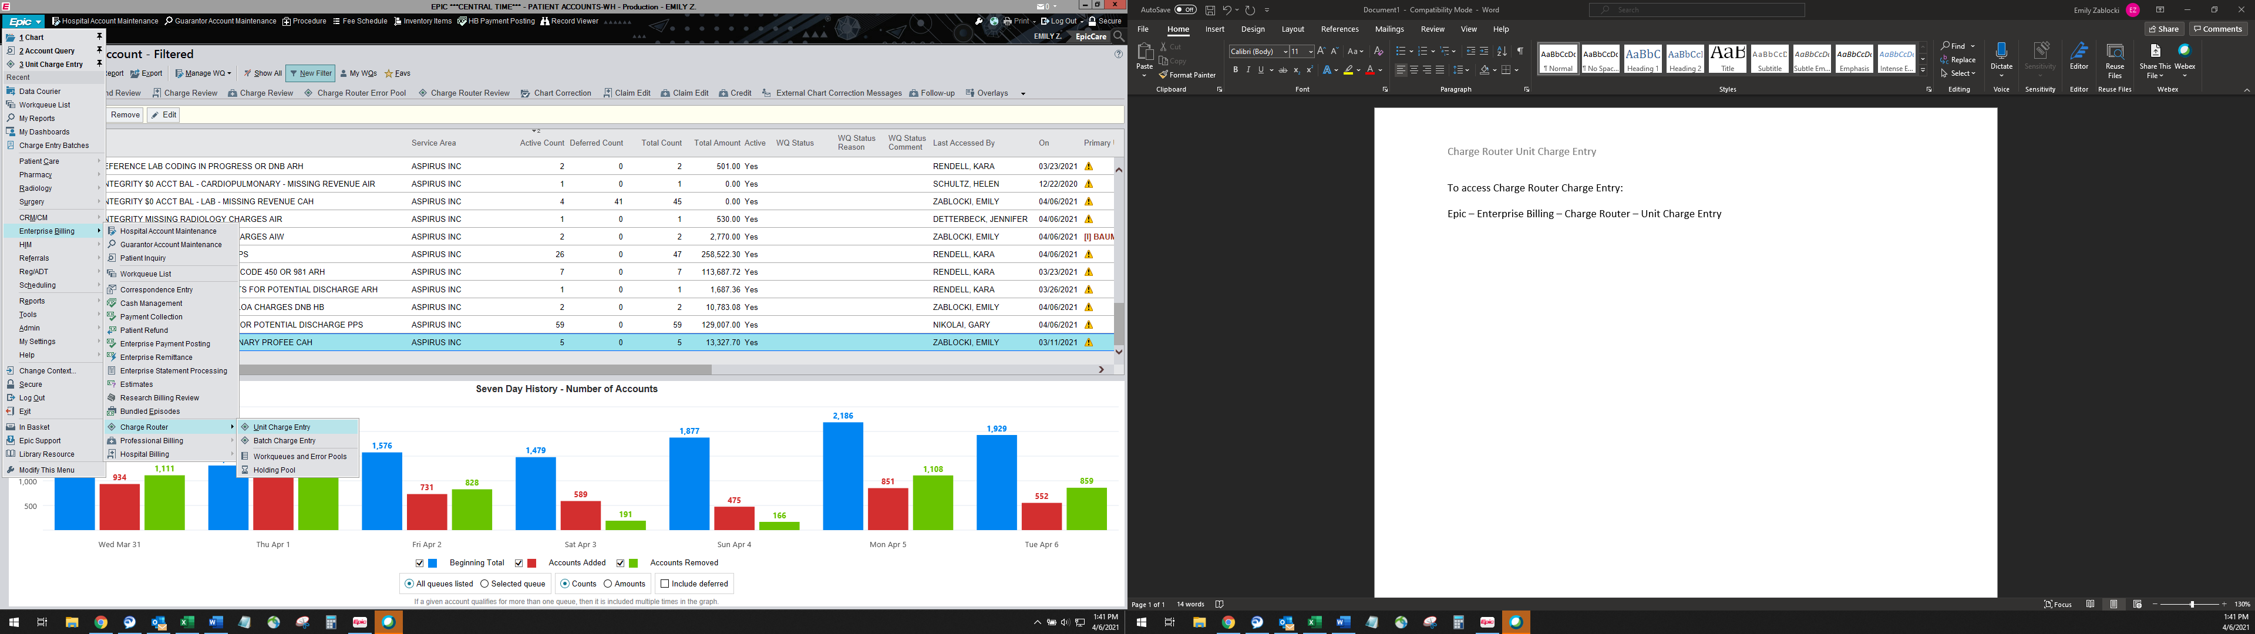

Select patient when “Patient Lookup” box pops up. If adding while in the patient account, information will auto populate.

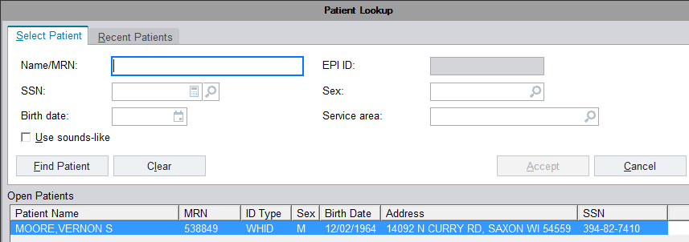

After selecting your patient, the “Encounter Selection” will pop up:

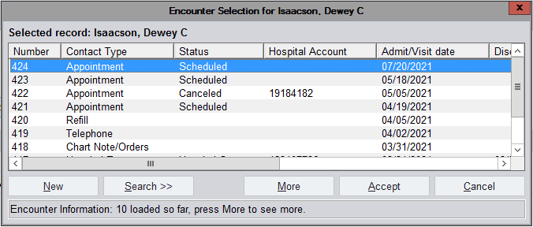

Select the appropriate encounter record for your charge(s). You may need to scroll over to verify you select the appropriate department for the encounter. If you do not see your encounter listed, click “More” to populate additional encounters. When you have found your encounter, select and you will be brought to the “Charge Router Charge Entry” screen.

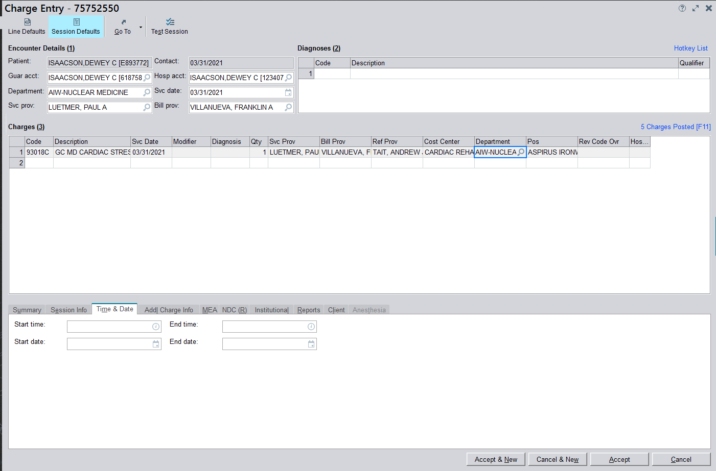

Enter any information missing under “Encounter Details” and enter your charges. Verify all fields (cost center, billing provider, etc.) have the correct information. If your charge is timed, select the charge line and go to “Time & Date” to enter the timing information. When all charges and other information needed have been entered, click Accept.