**Pulling in Electronic Documents to Scan with Twain**

Follow the normal workflow to open the scanning screen:

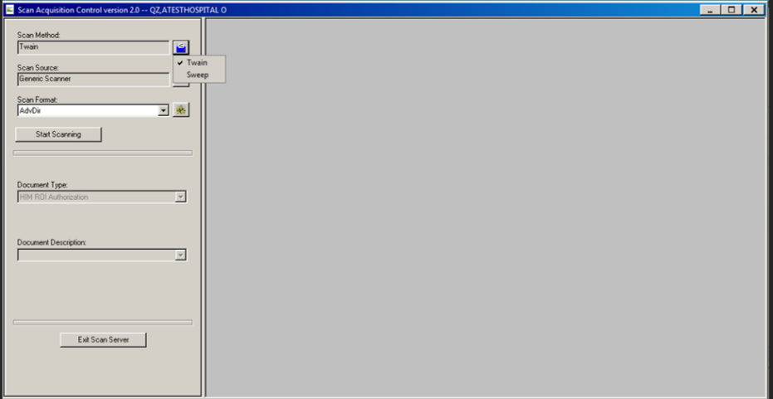**Follow Along:**

1. Click the  button next to Scan Method and select “Twain”
2. On your first time using this, you may need to add a new scan format. Instructions for this are at the end of this document.

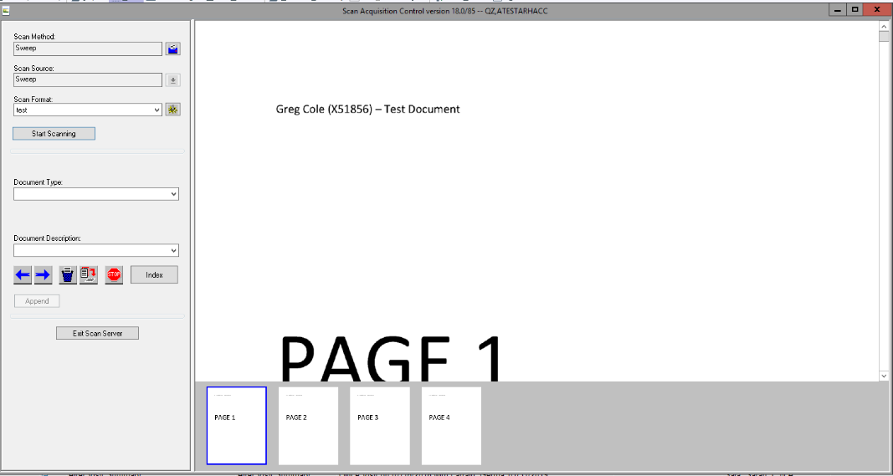

1. Chose document type and if instruction enter in a description (If it’s an internal lab select Scan Lab for Internal)(If it is an outside lab you will select Outside Lab).Outside labs don’t release in to the patient’s My Aspirus.
2. Click Index
3. Click Exit Scan Server.

***It is imperative that you select EXIT SCAN SERVER and NOT the X the process will result in error ***

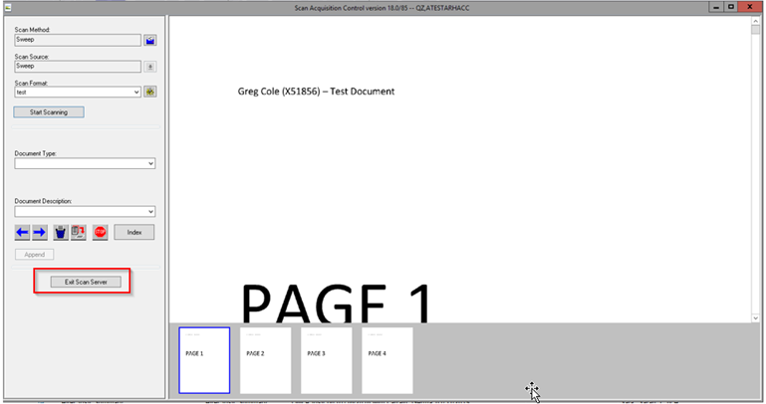**PLEASE NOTE:** This can only be used for documents saved as a single file, if multiple patients are saved in one file it will pull in the entire file and you will not be able to delete pages.

Setting up your Scan Format:

1. 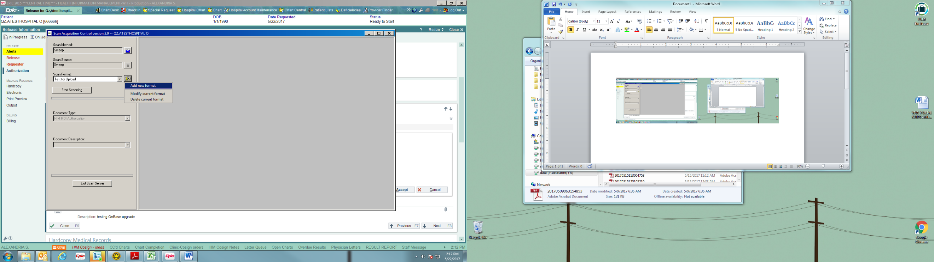Next to Scan Format click on the  button and choose Add new format. Name your format something easy to identify (example: Electronic Scan or Sweep Scan).

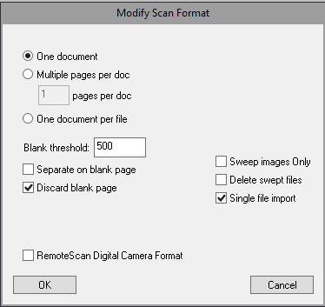

1. A “Modify Scan Format” window will appear. This can be kept as is so just hit “OK”
2. This will create your scan format, and on future use this format will automatically pull in when you switch to Sweep scan method.