**Finding Patients and Releasing Order**

Finding the Patient

**Step 1:**

1. From the top of your workspace, locate the activity called Patient Station from the red header.



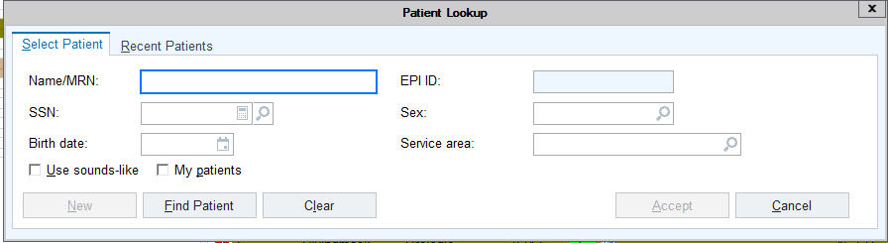The Patient Lookup window opens.

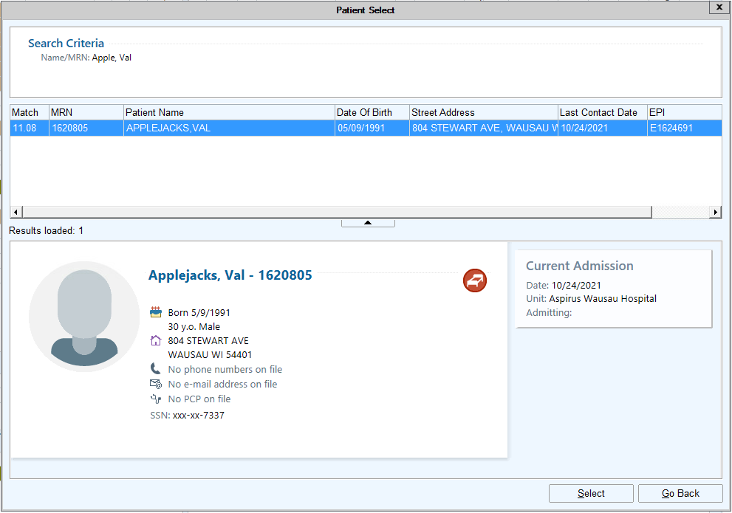In the lookup window you will enter in all the patient demographics you can about the patient you are looking for. Demographics like Name, Age, Sex, and DOB (if available.) Enter in as many details as you can to really narrow your results. In most cases you want to enter in minimal details to see many options, when searching for a patient you want to put in as much information as you can to narrow your options. This will help lesson the risk of selecting the wrong patient. This rule can be helpful with patient who have common last names such as Smith or Johnson. When you are done click FIND PATIENT.

If the patient has been seen by registration you will find their name listed in the Patient Select window. From here click the row with the correct patient’s name and click SELECT from the bottom right of the window. If your patient has been registered skip to step 2.

If the patient has not been registered the NEW button at the bottom of the Patient Lookup window will now be active.

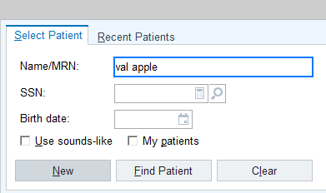

If the patient is not in epic, you will be required to enter in the patient specific demographics such as, SSN, Sex, Birth Date. Once you have entered the required information click New.

The Name Edit window opens where you can enter more info, fort his step just select SKIP.

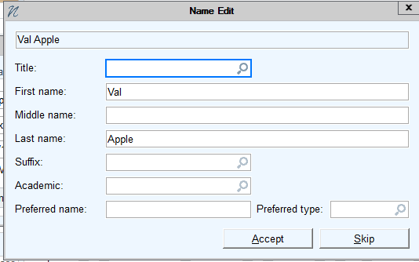

You are now brought to the Encounters section of Patient Station. We are viewing the Current Encounter screen

**If the patient is not Registered, you will need to register them using the registration button highlighted below **

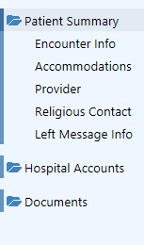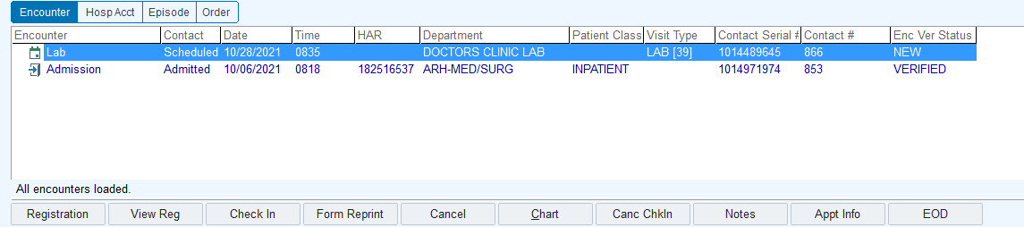

The Demographics section opens, and you will need to fill in these sections with as many patient demographics as you can.

From here make sure to select the ALL option located at the top right side of your workspace to view all encounter types. Then open the appropriate Lab encounter which should be the most recent.

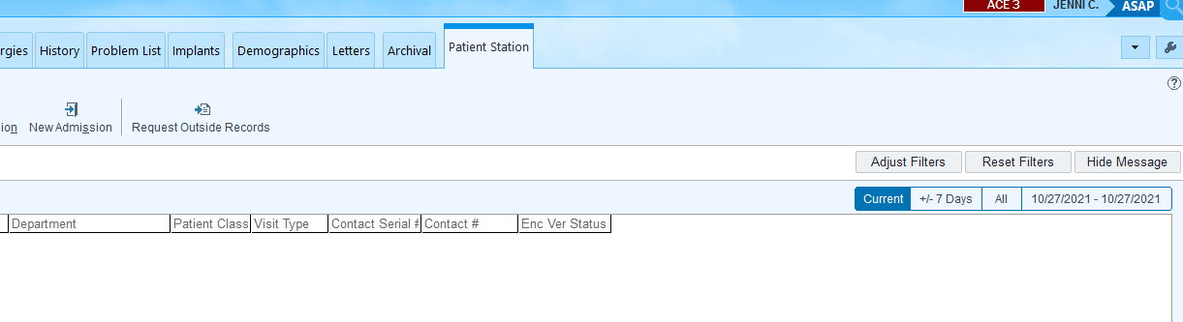

From here you will need find the Lab Orders to be released. Go to Chart search located on the top right corner of your workspace next to your name.

1. Click the magnifineglass. 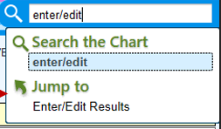

Order Review

1. Now look up Order Review by typing it into the search field.
2. Then select Jump to Order Review.

Order Review

Order Review

From there you can locate the lab from the report and select Release from the toolbar.

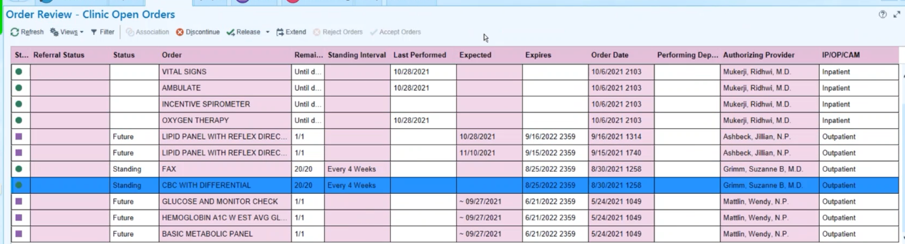

From the report pane at the bottom will show that the order has been released.

The order will now print in the lab. You will then manually enter this order into Meditech.