**Scanning Twain / Desktop Scanning**

Scanning Lab Results from the Enter Edit Results Activity

Setting Up Scan Formats from the enter edit results activity

** This process is a one time set up. Once you complete this you shouldn’t have to do it again. **

1. Select the “Scan” button on the Tool bar
2. Select the “Gear” icon to the right of “Scan Format:”

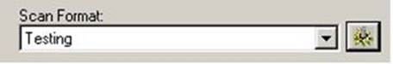

1. Give the new format a name
2. Click “OK”

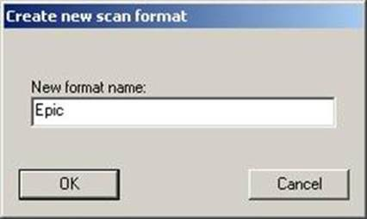

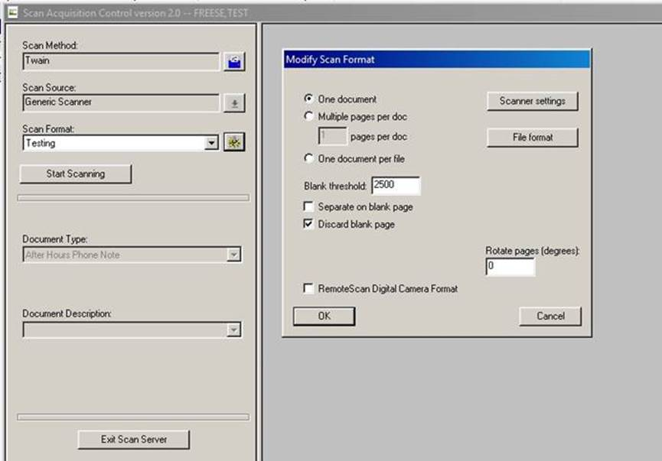

1. Apply the following settings
   1. One document
   2. Blank threshold:  2500
   3. Discard blank page
2. 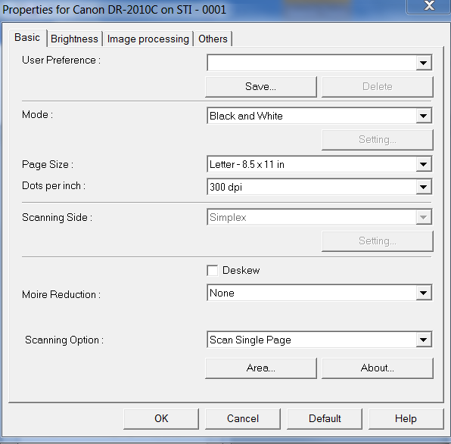Click the Scanner Settings if you need setup scan “duplex” (front & back) update the Scanning side.
   1. Scanner setting (display below) is different per scanner.
3. Click “OK”
4. Click “Accept”