Medical Oncologist-Hematologist (Outpatient) Lesson Plan
Trainer information 2
Course introduction 5
Initial consult visit 6
Get up to speed on the patient 6
Add and stage a cancer diagnosis 8
Assign a chemotherapy regimen 10
Treatment Plan Overview 12
Introduction to Treatment Plan Manager 13
Assign maintenance therapy 15
Write a note 16
Place blood orders 19
Place orders outside the treatment plan 20
Wrap up the visit 21
Treatment plan modification 24
Modify and add orders to the treatment plan 24
Adjust AUC dosing 25
Adjust the treatment schedule 26
Defer, hold, or cancel treatment 27
Review historical information 29
Survivorship follow-up visit 29
Review historical information 29
Create survivorship documentation 30
Care Everywhere placeholder 32
In Basket placeholder 33

Trainer information
In addition to your main talking points, this lesson plan includes underlined steps to demo in the system. Trainees should follow along unless otherwise noted.

Shared content
As you start customizing the specialist lessons to match your organization's workflows, you'll notice that some specialties have similar workflows. For example, most inpatient lessons include a rounding workflow with tasks like reviewing the current admission, managing orders, and writing a note. Although the workflows are similar, each specialty has unique patients, scenarios, and examples.
When you see a box with a dotted outline like this these boxes contain specialty-specific information.

Gather the information unique to this specialty, listed below.

Cancer staging:
Questions to ask:
- How does your organization handle recurring cancer documentation?
Treatment plans:
Questions to ask:
- What documentation is required when creating a treatment protocol?
  - Are Treatment goal and department required information when creating a treatment protocol?
- What is the workflow for placing lab orders?
- What is the workflow for placing recurring orders?
- Does your organization recommend discontinuing a treatment plan or keeping it for historical purposes?
- Is your organization using specific dosing rules?
- Is your organization using survivorship health maintenance modifiers?
Scheduling
Questions to ask:
- Who handles scheduling requests? What's the appropriate protocol?
- Does support staff have the security to sign schedulable orders in the treatment plan?
- Who is responsible for scheduling an appointment after physicians place the request?
- How does your organization handle therapy plan scheduling?
- Is your organization using survivorship SmartSets to place follow-up appointments?
This lesson assumes:
- Appointment requests are built into the treatment plan as schedulable orders.
Treatment Summary:
Questions to ask:
- When, and in what format, does your organization require physicians to provide a treatment summary for patients?
Other
This lesson assumes:
- Express Lane is not used by oncologists. If they do at your organization, pull content from the Quick office visit section in the Internist-Family Medicine Physician (Outpatient) lesson. Update with relevant examples.
- Providers do not frequently place one-off orders outside of the treatment plan. If they do, pull content from the Internist-Family Medicine Physician (Outpatient) lesson.
- Orders placed in clinic automatically show up in the nurse's queue as a signed and held order.

Environment prep
- As a nurse, enter a Reason for Visit on Rosalind’s follow-up appointment of Breast Cancer.
- Enter a Staged and Chemotherapy event on Rosalind’s Oncology History.

Course introduction
- Welcome.
- Today's class will focus on your main workflows.
- You learned the basic concepts and tools in your e-learnings - now we'll put those all together to make sure you can get through:
  - Initial consult visits
  - Assigning chemotherapy treatment plans
  - Survivorship follow-up visits
- I'll demonstrate while you follow along with me in the system.
  - We have a lot to cover and I want to make good use of your time, so we'll move quickly.
  - If at any point you get lost, stop following on your computer and just watch me.
  - You can rejoin during independent practice or with the next topic.
- To get your login credentials for go-live, you need to pass an assessment.
- However, I don't expect you to be an Epic expert when you leave here today.
  - You all should have an exercise booklet.
  - We won't use these today in class, but you should use this for independent practice after class
- During today's class, we won't focus too much on ways that you can customize the system to speed things up for yourself.
  - You'll have a chance to do that during personalization labs.
  - For example, during personalization labs, you'll be able to:
- Build a preference list of your most commonly used orders.
- Create note templates with your preferred text.
TELL CLASS TO FOLLOW ALONG
- Log in to Hyperspace as ONC00/logins Department: AWH Radiation Therapy

Initial consult visit
- Let's start by looking at how to document an initial consult visit with a patient.
- I'll show you how to:
  - Quickly find information in the chart.
  - Add and stage a cancer diagnosis.
  - Assign a chemotherapy regimen.
  - Quickly write a note using point-and-click forms and templates.
  - Place blood orders and non-recurring orders efficiently.
  - Wrap up the visit.
Scenario
- Patient: Rosalind, 33-year-old female
  - Find the patient on your schedule – 8:00 AM appointment
- Reason for visit: Breast mass
dct

Get up to speed on the patient
Demo examples
- CHART SEARCH: As I'm talking to the patient, I'm curious about the patient's last CBC. I'll search for "CBC."

Introduction
- The patient has been referred to oncology by her PCP. She has already had a biopsy procedure and is here for cancer staging.
- The nurse has just finished rooming the patient. I'd like to get up to speed before I enter the room.

Review relevant visit information
- First, I'll quickly review some highlights from the patient's chart right from my Schedule, which I can do first thing in the morning, or between patients.
- Go to the Schedule and single-click the appointment so you can see the report below the Schedule.
  - Point out key info on the report, including where your last note would appear.
- Double-click to open the appointment.
- Similar info appears in the sidebar, if I haven't already reviewed it from my schedule.
  - Both of these places also offer a quick way to record that you reviewed certain info.
- I've discussed allergies and meds with the patient now, so I'll mark those as reviewed.
- Click mark as Reviewed for Allergies and Medications in the This Visit sidebar.

Search the chart
- As I'm talking to the patient, I'm curious about some historical information in the chart.
- Ask: Thinking back to your previous training, how can I quickly find this information without jumping to another screen?
  - Use Chart Search.
- Point out Chart Search field
  - Useful if you're looking for specific information
  - Find notes, meds, problems, and more that are related to your search term.
  - Search for an appropriate keyword Biopsy
  - Hover over some search results to see more info.
  - Point out filters for problems, notes, meds, and labs.

Browse the chart
- I'm also curious about the patient's last few visits, so I'll take a quick look at those in Chart Review.
- Go to Chart Review and select a visit.
  - Encounters tab is organized in a timeline format so you can quickly see the patient's story
  - Contains all historical data, but can quickly narrow it down using filters on any tab
  - Point out quick filter check boxes for visits with you, your specialty, and your department.

Add and stage a cancer diagnosis
Demo examples
- EXPAND PROBLEM: Lump or mass in breast
- CHANGE DX TO: Breast cancer, left laterality
  - Breast location: Upper inner quadrant of breast
  - Patient sex: Female
- ADD DX: Breast cancer
- STAGING DETAILS: T1, N1, M0 G3, ER-, PR+, HER2+
- CANCER STAGE: Stage IIA

Introduction
- After reviewing the patient's chart and biopsy results, I determine the patient has cancer and needs immediate intervention.
- I'll begin by documenting the clinical stage.

Review and update the problem list
- Go to Plan > Problem List.
  - To see more info about a problem, expand it.
  - Any notes that I or other clinicians have entered would appear here
- Ask: If this problem has evolved into something more specific, how should you update the problem list to reflect that and preserve your documentation?
  - Change the diagnosis for that problem - don't delete the problem and add a new one.
  - Saves your overview note and creates a historical record of the problem
- Click Change Dx and enter something more specific: Breast cancer, Upper inner quadrant of breast, left laterality
- When you Click to Accept. Click green Plus Add visit diagnosis right from here to save time and clicks.
  - Point out the green check mark that appears.
INDEPENDENT PRACTICE:
- Take 1 minute to explore the problem list.
- We're finished with our review and updates, so let's mark the list as reviewed

Stage the patient's cancer
- Staging information is attached to the cancer problem on the patient's problem list.
- Click Enter or Add New Staging Information.
- Point out the Classification and Form menus in the sidebar.
  - Digital form is the same as the paper AJCC form
  - Can select a pathologic stage or add a new form
- Can document recurring cancer this way.
- On the main part of the screen, can see any relevant reports
  - Can view the biopsy report while I document the stage
- Document the patient's cancer stage (ex. STAGING DETAILS)
- Click Enter Staging Information
  - Point to down arrow for Classification: both Clinical and pathological staging can be done here.
  - The correct edition of the Colon cancer appears automatically based on the cancer type and diagnosis date.
  - If you need to you can change the body site and edition here. The form includes all fields on the AJCC staging form. Scroll down click the drop-down arrow on the Form
  - There are also Lab/Path Report, Imaging and other relevant Staging forms on this screen that I can reference while filling out the staging form – Point to top left.
  - I will fill out the clinical stage now. To calculate a stage, you need to select the T, N, M values for the patient. Let’s start with the T value. For more information about T values, I can review this list. Scroll down to see all T, N, M choices.
  - T, N, and M values are used to automatically calculate the stage. (ex. CANCER STAGE)
- STAGING DETAILS: T1, N1, M0 G3, ER-, PR+, HER2+
  - Select Primary Tumor (T) and choose T1
  - Select Regional Lymph Nodes (N) and select N1
    - Choose Method of assessment: Core biopsy
  - Select Distant Metastasis (M) to select M0
  - You can also add prognostic indicators and specifications about the tumor
  - Scroll up to Calculated stage group to see the CANCER STAGE: Stage IIA
  - Sign & Accept the stage when finished.
- Point out the calculated stage listed under the cancer problem list.
- Return to the staging activity at any time to edit the existing stage or add a new form.
  - Collapse the sidebar

Create an oncology history
- From the patient’s problem list select create oncology history.

Oncology History
- It has a timeline of all Oncology specific events.
- Oncology history carries over in the patient’s chart from visit to visit and cross both inpatient and outpatient.
- Events are added automatically but can also be added manually by searching for a new event.
  - The automatic events are diagnosis added on the problem list, when cancer staging is complete, when a supportive plan and a treatment plan is added.
- Events are color coded:
  - Search: Remission
    - Notice the green color
    - Point out that a comment can be added to that event.
  - Search: Adverse Reaction
    - Notice the red color
    - Point out that there ma template in the comment field to fill out. We will address how to fill this text out in a later lesson.
  - Click Save
  - Collapse the Oncology History
- For patients with multiple oncology problems Physicians must select the appropriate problem before adding an Oncology History update

Assign a chemotherapy regimen
Demo examples
- TREATMENT PLAN: AC - 21-day cycles - Breast
  - Search for "Breast”
- TREATMENT START DATE: w+1
- DIAGNOSIS: Breast cancer

Introduction
- Scenario: The patient has advanced cancer. I'll assign a chemotherapy regimen now so the patient can begin receiving treatment immediately.
- Prior to go-live, you will complete this workflow on your actual patients during Treatment Plan Conversion.
- NP’s and PA’s can also convert a treatment plan.
- The Treatment Plan activity is where providers are able to apply and monitor orders related to the patient’s chemotherapy treatment.
- Note: Providers should always look for regimens they want to prescribe rather than building their own.

Assign a treatment plan
Description of the Oncology table of content options.
- Plan Summary: Shows the patient’s active treatments including Current treatment cycle, authorization status and signed orders for current treatment.
- Treatment Plan: A patient’s main chemo regimen. Regimented in cycle, day format. This can be Standard of Care or Research protocols. Can be inpatient or outpatient. Some examples include FOLFOX, Oral chemo, Vinorelbine.
- Therapy Plan: Non-chemo medications or other infusion meds. Non-regimented found in Interval format. Some examples include B12 every 28 days, Zometa, Iron, Procrit.
- Blood Transfusion: Used to order blood product transfusions. Examples include RBCs, Plasma and Platelets.
- Miscellaneous: Various Therapy Plans for tests, infusion, and injections.

Here we will add a treatment plan on our patient Rosalind.
First, we select a protocol for Rosalind; protocols are standalone templates, which become a patient’s treatment plan once patient specific information is added.
- Click on Treatment activity tab
- Click on Treatment Plan section
- Click
- The protocols available in the training environment might differ from what you see in production.
- Although there is a blank treatment plan protocol option, Providers should NOT use that option because the existing protocols contain the correct records (medications, labs, etc.) that were intentionally built out based on Aspirus workflows.
- All the plans are built to AJCC guidelines template guidelines you can choose a plan closest to what you want and modify it.
- Search for: "breast"
  - Point Out: ‘Less is more’ when searching for protocols. This brings up an expanded search for providers. "AC"
- Select: AC Breast 21-day cycles
- Preview the plan details before selecting by scrolling
  - Add frequently used plans to the favorite list by clicking the star next to the protocol name.
- Click Accept
- Enter a treatment plan start date: (w+1 usually a week out)
- Line of Treatment: First Line
- Treatment goal: Curative
- Plan Provider – Authorizing Provider for the plan.
- Treatment Department – Where the patient will be receiving treatment, this is extremely important because it ensures the plan goes to the appropriate staff for authorization.
  - When the physician applies a Treatment Plan,
    - A referral is created, which allows the authorization staff to begin working on prior authorization.
    - Documenting the correct, Treatment Department ensures that the treatment plan authorization referral goes to the correct authorization staff.
- Go to the Dosing tab and point out the options available to calculate doses.
  - Recalculate doses each time a new weight or height is documented: the system will automatically adjust medication dosing based on the most recent set of vitals.
  - Point Out: Dosing tab, point out the options available to set warning limits.
    - By default, a yellow warning appears at the top of the treatment plan if the last weight to BSA documented by any clinician is 10% different from the previous value.
    - You can change the threshold for this warning.
  - Point Out: Notes tab, this tab is used to refer to any reference documentation that was done to apply the treatment plan.
- Associate the treatment plan orders with the patient's cancer diagnosis.
- You can change the properties at any time by clicking the Properties link next to the name of the plan from the Treatment Plan Manager.

Treatment Plan Overview

Introduction to Treatment Plan Manager

The Treatment Plan Manager is where the provider manages the patient’s entire treatment plan.
Oncologists can create a single treatment plan that carries over to every oncology appointment for a patient. The treatment plan organizes treatment cycles and keeps the patient’s care team on the same page.

Toolbar options and Icons within the plan including:
Treatment Plan Manager – AC protocol
  - Point out button on the toolbar

Send a treatment plan
- From the Treatment Plan Manager Toolbar, click Send Plan.
- Choose a recipient or a pool.
  - If the recipient you need is not listed, click Other to search the database.
- Enter other relevant details, like a message, and send when finished.
  - The message will send to the recipient's In Basket.
  - From there, the receiver can quickly view and access the plan

Customize your view of the treatment plan
- To organize how you see the information in the Treatment Plan Manager,
Click Add/Remove Views.
- Select check boxes the following views:
  - Med. Spotlight: View and manage the most important treatment plan medications, such as chemotherapy drugs.
    - Click a dose link to adjust it.
  - Calendar: View the treatment days in a calendar.
    - Click a treatment day to expand it in the Treatment Plan Manager, can click the arrow on month header to move to other months.
    - Note that the treatment days in the calendar do not correspond with scheduled appointments.
  - History: View an audit trail of changes made to the treatment plan.

Understand treatment plan levels
- There are several levels to a treatment plan:
- Click the Show button and show all options then go to Days
Treatment plans are organized:
- Green cycles
- Purple days within the cycle
- Days contain labs, appointments, and medications for that day of treatment
- Medications arranged in order of administration

- Click Days
- Double click Cycle 1
- Briefly point out the Plan for Day and Point out Required and Recommended icons
  - Now you can see overall structure of plan
- Treatment plan title: The name and properties of the treatment plan.
- Cycle: A set of one or more treatment days. Cycles appear in green.
- Day: A complete day of care for the patient. Days appear in purple.
- Order Category: A group of orders in a treatment day with a similar purpose. For example, pre-treatment labs appear in a Labs category. Order categories appear in the order in which they are usually carried out.
- Order: The actual orders for treatment.
- Point out the Prior Auth (dollar bill) icon.
  - Question mark = treatment has not been reviewed
  - Green checkmark =treatment is authorized
  - Red X = treatment isn't approved

Complete the Prior to Treatment Cycle
- The treatment plan is divided into cycles.
  - The prescriptions cycle contains orders the patient should have before beginning treatment.
  - Check that the prescriptions look good and then click sign.
    - Users can also change the outpatient pharmacy from within the Treatment Plan
    - Orders signed will appear with green check.
  - Release the Day 1 Prescription orders.
    - The icon with green check and arrow indicated orders have been released
  - To queue up the first day of treatment, I need to mark the Prescriptions Cycle Day 1 as complete.
  - Click Actions > Complete Day for the Day 1 Prescription orders.
    - Orders will be highlighted in grey.
- Typically, infusion nurses will release the orders just before administering treatment, but in this case you are releasing the prescription orders to the pharmacy.

Request future appointments
- Appointment requests are built into the treatment plan.
- Providers will sign appointment requests like other orders in the plan.
  - Once signed the schedulers are then able to view the appointment request orders in their workqueues and begin scheduling current and future appointment(s) for the patient.
- Before signing the appointment requests answer any questions in the order composer for required or recommended fields.
- The scheduling button appears yellow when the patient's next treatment day contains orders that haven't been signed.
- To sign multiple appointment requests at once, click Schedule Orders underneath the plan name.
- Select the range of appointment requests and sign - Day 1 and Accept.
  - Order Validation – Missing Recommended Items, Appointment Provider we will add that later in the order composer
  - Go to Day 1, Cycle 1 and add the Appointment provider press = and Sign
Icons:
  - Calendar with an arrow: order has been signed but not scheduled
  - No calendar icon: order has not been signed
  - Calendar with green check mark: order has been scheduled
  - Once an appointment request is signed the request falls into the oncology schedulers workqueue.

Day 0 - Labs
  - Physicians can add Day 0 to cue up labs for the patient’s treatment day.
  - Click on Day 1, Cycle 1
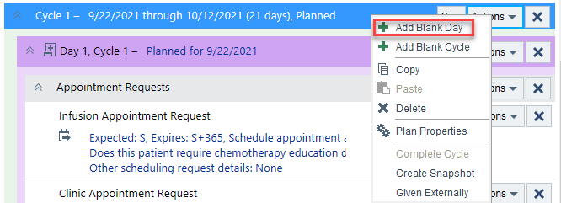
  - Click Action and select Add Blank Day
  - Day Number ‘0’ , date auto populate 7 days
  - Accept for Day 0 Cycles
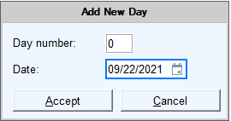
  - Add Day 0 to Cycle 1, Choose other cycles to add and Accept
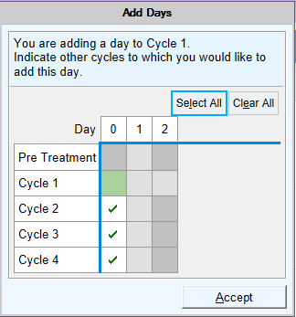

  - You now have Day 0 Cycle 1 and Click Accept
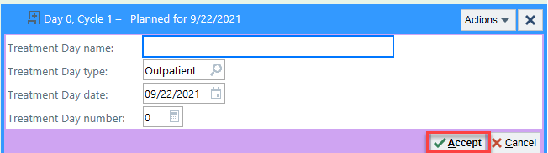
  - Click Action and Select Add Order
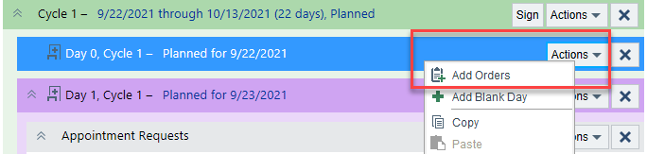
  - Search for your Lab an Click Add
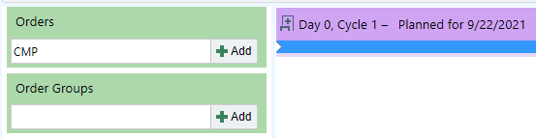
Accept the lab outpatient lab with the house icon
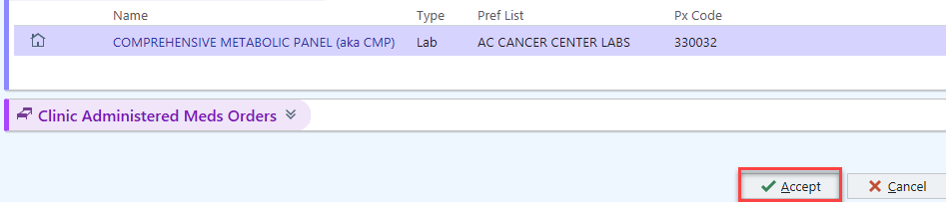

  - Accept Day 0, Cycle 1 Lab
  - The Lab has been added to Day 0, Cycles. Indicate other days to which to add this order
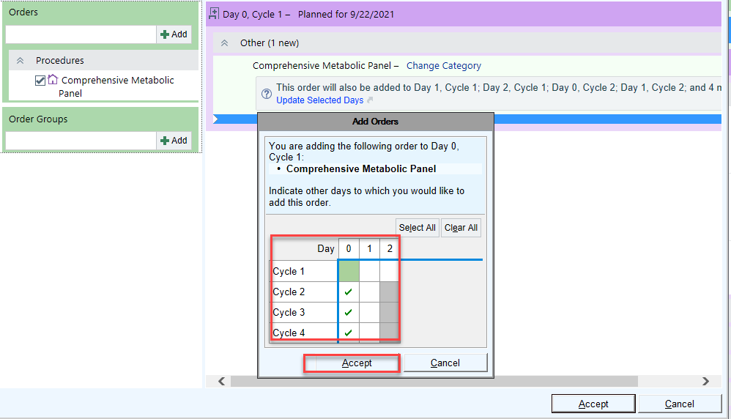

Assign maintenance therapy
Demo examples
- THERAPY PLAN: General Infusion Orders

Introduction
- The patient needs line care maintenance plan to keep the lines clean during treatment.
- I'll place the order through a therapy plan.
  - Assign recurring treatment with therapy plans. Unlike treatment plans, the treatment schedule is not strictly tied to calendar days and is more flexible and easier to access.

Assign a therapy plan
- Go to Treatment > Click the. Line Care
  - Select the therapy plan and enter a start date of "t" for today.
  - Associate the therapy plan with the patient's cancer.
- Assign the plan and click an order name to see order details.
  - Point out that it looks like any other order except for the Order Schedule section at the top.
- A therapy plan is available until it's discontinued, which means it will stay on the patient's chart until someone manually removes it.
  - Edit Interval: how frequently the treatment is given PRN
- Unit of time
- "Daily" does not mean due every day, but that this treatment will be given every 84 days.
- Duration: Specify the number of treatments or end date.
- Like the treatment plan, signed orders aren't active until released by the nurse.
- Unlike the treatment plan, nurses can edit therapy plans if they indicate an authorizing provider.
- Sign all orders in the plan.
  - The Treatment tab is where the nurse can Begin Treatment 1
  - Click Close

Write a note

Introduction
- I'm ready to write my progress note now.
- You don't have to write your note while the patient is still here, but incorporating it into the visit can help save you time.
- Go to the Notes tab in the sidebar
  - It's helpful to write your note in the sidebar so you can have it open while you review and enter other data in the chart.
- Point out speed buttons at the top of the sidebar E-Consult Request and click undo
  - For commonly used note templates
  - Could use other SmartTexts or Phrases if needed
- In the Insert SmartText box, search for Onc Initial Cancer Visit.
  - Can see right at the top that some patient info is pulled in
  - Blue highlighted text is a SmartLink
- If you don't like how this template is organized, or if you always add other information, you can create your own.
  - You'll do this in personalization labs and can create more as you need them.
- Point out the Share w/ Patient button at the top right of the note.

Overview of NoteWriter
- Point out the Orange smart blocks that pulled into the note
- Click HPI tab for NoteWriter
  - An appropriate HPI form should appear.
- If needed, can remove a form or add one using the Add on the HPI form field
- If you can't find the one you need, there is a general form called Other.
  - Point out Narrative field
- Can type, use SmartTools, or dictate to add to the HPI
- Recap basic NoteWriter concepts from prior training:
  - Use point-and-click forms Click buttons and select check boxes on the left to generate note text on the right.
  - Add comments about an entire section by clicking the piece of paper.
  - Add comments about a symptom by hovering over the button and typing.
  - Add free text by typing in the note anywhere outside of the highlighted text.

Create a progress note in NoteWriter
- You learned about a few note-writing tools in your e-learning or clinic training: text templates called SmartTools and point-and-click forms in NoteWriter.
  - I'll use a NoteWriter template today, so I can point and click to document the HPI, ROS, or physical exam, and you don't have to spend the time typing.
  - The basic SmartTool options are best for a brief note or when you want to write more of a narrative. You can always mix and match as needed.
  - Select ROS – Oncology
    - Point out the more detailed
  - If you would like to add the Physical Exam forms
  - Type “.Physical Exam” to pull in the PE SmartBlock forms.
    - Point out the more detailed Physical Exam forms
  - Document by exception by left click for positive and right click for normal. Double click or hover over box to add a comment.
Demo how to create a macro with only “Normals”
- Click Normal macro on the Physical Exam tab
  - Can use macros on the ROS and Physical Exam tabs to speed up normal documentation
  - Use one (or more) to document routine ROS or PE findings and then chart by exception, changing only what's different for this patient.
  - If you apply one part way through, it doesn't overwrite anything you've already documented.
  - You'll be able to create your own macros during personalization labs and after go-live, whenever you find yourself documenting a routine ROS or physical exam.
INDEPENDENT PRACTICE:
- Stop and document an HPI, ROS, and Physical Exam for this patient and explore the various tools we just talked about.
- In 3 minutes, we'll come back and finish the note.

Begin your assessment and plan
- To complete any outstanding items in your note, place your cursor at the top of the note in the sidebar and press F2.
- Complete the History Review SmartList.
- Open the Assessment & Plan SmartList.
  - If you choose an option with "Refreshable" in the name, you can refresh the note to pull in diagnoses and orders any time you update them.
  - If you choose an option with "Editable" in the name, you can pull in the information once and edit or add to it as needed.

Place blood orders
Demo examples
- BLOOD LABS:
  - Type and screen
  - Hemoglobin
  - Hematocrit
- PREPARE:
  - Prepare: 2 units
  - Transfuse indications: Hgb <= 7g/dL
  - Has consent been obtained? Yes
- TRANSFUSE:
  - Prepare: 1 unit
- MEDS: Saline, Benadryl, Tylenol

Introduction
- The patient doesn't need a blood transfusion yet, since we are just starting her on the treatment plan, but I'll show you how to order blood in case she did.

Order blood
- First, I'll go to Treatment Plan activity.
- Click the Blood Transfusion Therapy Plan
- Choose Blood Therapy Plan: Ex: “Red Blood Cell Transfusion”
- Enter Plan Start date, Lead Provider, Tx Dept and associate the department:
  - The Prepare order is for the blood bank.
  - The Transfuse order is for the nurse.
  - Number of units is how many the blood bank should have ready.
  - If the nurse should transfuse the same number of units add units
  - Number of units is how many the nurse should transfuse if different from the Prepare order.
- Complete any necessary required fields and Sign Plan
- In the sidebar, refresh to pull the orders into the Assessment & Plan of the note.
  - Can update the note because we added the refreshable link to the note earlier
  - Blood Order can be released in Sign & Held Orders

Place orders outside the treatment plan

Introduction
- The treatment plan should include the majority of orders you need to place. Usually, you add orders directly into the plan to maintain a complete view of the patient's treatment.
- In this section we'll cover orders that aren't routine, such as one-off medications or labs, and signed and held orders.

Place orders outside the treatment plan
- If my patient needed a one-off order, I could place them in the Meds & Orders section.
- We'll cover how to add medications to the treatment plan in the next section.

Place signed and held orders
- Orders placed in clinic automatically show up in the nurse's queue as a signed and held order.
- Useful for situations such as a patient that comes into the infusion center complaining of extreme pain. The physician can place an order for morphine from the clinic that the nurse can then release in the infusion center.
  - For medications:
  - Select an order with the bed icon (intra-procedure) if the medication will be administered in the clinic during the current visit.
  - For all other medications, choose an order with the house icon.
  - Select the Class that indicates how the order should be processed. Select Normal to e-prescribe the medication.
- Choose the Morphine order with the bed icon and compose the order and Click Sign & Hold
  - Enter reason for holding: Interupted
  - Go to the Treatment Plan and point out the order in Sign & Held Orders

Wrap up the visit
Demo examples
- LOS: New2
- APT: Follow-up 4 weeks

Introduction
- With my orders placed and my note done, I just need to write some follow-up instructions, charge for the visit, and close the encounter so it can be sent to billing.
- We can do all of this on the Wrap-Up tab.
- Go to the Wrap-Up tab.
- There are a few things you don't need to do before the patient leaves - these are things that don't affect their After Visit Summary or appear in MyChart:
  - Writing letters to other providers, entering a level of service, and filing charges.
  - However, taking care of these while you document the rest of the visit can save you time later.

Write a letter
- Use the Communication Management section to print out a work or school excuse letter, or send information to another provider. Support staff can also send letters.
- A letter to your patient's referring PCP has been automatically created.
  - Point out Send Notes icon - the letter will send to the referring PCP your notes. –(Not build in training)
  - If the Recipients field is blank, click the plus sign to add the referring PCP.
- Click Edit to open the letter.
- Point out the contact quick buttons at the top - you can add additional contacts.
- Point out the letter template options Other allow you to search for work excuse or progress note
  - Pulls in information from the patient's chart
  - You can change the template at any time.
  - Because the note type is Send Notes, any progress notes you write will automatically be attached.
- Click Cancel to exit out of the letter.

Request a follow-up appointment
- I'll enter a few quick notes about when I'd like to see the patient back. I have to put any scheduling instruction in the order composer.
  - Go to the Follow-up section and indicate when the patient should return by clicking the ORDER button for the corresponding Follow-up and Accept.
  - Open the order composer and complete the Required fields and Yellow Yield Signs and any additional scheduling information.
  - Sign and Associate the Clinic Appointment Request Order
    - Scroll down and point out the Outpatient Procedures Ordered This Visit and expand for details.
  - Appears on AVS, in MyChart, and at the front desk, so patient can schedule appointments at check-out if necessary
  - Patients can also schedule appointments directly from MyChart.

Document your LOS
- I need to enter my level of service for billing.
- Select an LOS (ex. NEW2).
- Remember from your pre-class e-learning that you can click the wand to calculate an LOS if you're not sure what's appropriate.
  - Back pocket: If you don't see the button you need, you don't have to enter it manually every time. You'll have a chance to add commonly used levels of service as speed buttons during personalization labs.

File charges
- I don't need to file any additional charges for this visit, but if I did, I'd use the Charge Capture section.
- Go to Charge Capture.
  - For procedures, certain charges will be filed automatically.
  - For additional charges, you can browse by category or search in the Add field.
  - Point out the Level of Service (LOS) New patient CPT code that filed.

Close the visit
- I'm ready to close the visit and send it to billing, which we do in the Sign Encounter activity.
  - After the encounter is closed, the patient can see information like the reason for visit, vitals, med list, follow-up instructions, patient instructions, upcoming appointments in MyChart.
- Go to the Sign Encounter activity.
  - If you don't see the Sign Encounter activity tab, go to the Sign Encounter tab in the sidebar.
  - If there's missing documentation:
- Click a red banner to jump to the area of the chart that needs attention.
- When all documentation is complete, return to the Sign Encounter tab.
- Ask: Thinking back to your e-learning or previous training, what happens if you forget to sign the visit?
  - The encounter isn't submitted for billing; with in the appropriate time you'll get a My Open Charts message in your In Basket, reminding you to close the visit.
- Ask: What if you need to change something after you've closed an encounter?
  - Create an addendum by opening the encounter again from your schedule or from Chart Review.

Treatment plan modification
- After assigning a treatment plan, the schedule and orders can be modified at any time, even if the patient isn't present.
- Use an orders-only encounter to update the treatment plan without any of the billing or documentation requirements of an actual patient visit.
- I'll show you how to:
  - Reschedule or cancel treatment days
  - Modify chemotherapy dosing
  - Add or delete orders from the treatment plan
Scenario
- Patient: Rosalind, 33-year-old female
  - Create an orders-only encounter

Adjust the treatment schedule
- In the Treatment Plan section, click Edit Plan to open the Treatment Plan Manager.
- Click the link for next week's treatment day and change the date and click Accept
  - Future days and cycles will automatically update with new dates.
- To view more information about the treatment plan, click Add/Remove Views on the Treatment Plan Manager toolbar.
  - For example, select Calendar View to see the treatment days and cycles marked on a calendar.

Modify and add orders to the treatment plan
- MED: Tylenol

Introduction
- The patient is not tolerating the dose well and I want to decrease the dosage for next week's treatment.
- Order modifications can be applied to all other instances of that order within the treatment plan.
- You can modify orders with weight-based dosing by a certain percentage of the original dose.
- In the Treatment Plan Manager, expand a day in the upcoming cycle (Day1, Cycle 1) and expand the Emergency Medication section.
  - Click Actions > Modify Dose on one of the meds and change the dosage.
  - Select any future days or cycles to copy the modified dosage to.
- Changed orders need to be re-signed.
  - Point out on another day under Emergency Medications how it propagated

Add and modify orders
- Orders can be added to any combination of days or cycles within the plan.
- Select Day 1, Cycle 1
- Click Add Orders on the toolbar and click where you want the order added chemo meds
- Search for and add an order “Carboplantin IVPB”, but don't click accept yet.
- Click the category to add the order. Point out that the order is added directly into a category
  - Required field AUC type: 6
  - Choose quick button for Dose: Use AUC
  - Click Accept
  - Copy the order to other days as needed
  - Resign the order
  - Categories organize orders and make it easier for nurses to administer the right medication at the right time.
- I also want to change a MED from an IV to a tablet.
- Under Suggested Protocol Orders, unselect MED IV and select MED tablet.
  - Point out that suggested protocol orders make it easier for providers to find similar orders.
- Accept the order and copy it forward to the other cycles.
- Sign any new orders.

Adjust AUC dosing
- AUC: 1.5

Introduction
- Normally I would review previous documentation, but for training I'm going to skip straight to AUC dosing.

Use AUC Dosing
- Go to Plan > Treatment Plan and open the Treatment Plan Manager.
- Open the carboplatin order composer to edit the order details.
- A dose has automatically been calculated using the Cockcroft-Gault formula, the target AUC in the order, the height and weight of the patient, and the most recently calculated Serum Creatinine.
- Looking at the suggested dose, I decide that I'd like to use a different target AUC. I'll change that now.
  - Clear the target AUC field.
  - Change the target AUC (ex. AUC).
- The suggested dose automatically recalculates.
- I could also change the creatinine clearance formula.
  - Click the magnifying glass to show the formulas available. Don't change the formula.
- If the patient had not had a recent creatinine result, the system would not have calculated a suggested dose.
- I can enter a manual GFR or Serum Creatinine result.
  - Enter a GFT and SCR. Clear Override and return to using the calculated dose.
- I can also enter my own dose manually. If the dose differs by more than 10% from the system calculation, I'll have to specify a reason.
  - Enter a dose and click the magnifying glass to display the reasons for deviating. Don't select a reason.
- I'll use the dose calculated by the Cockcroft-Gault formula.
  - Ensure Cockcroft-Gault is selected and click "Use AUC."
- I've finished modifying the carboplatin dose.
  - Sign orders and accept.

Adjust the treatment schedule

Introduction
- After leaving the clinic, the patient calls and tells the unit nurse she will need to come in for next week's treatment one day later than scheduled.
- In the Treatment Plan section, click Edit Plan to open the Treatment Plan Manager.
- Click the link for next week's treatment day and change the date.
  - Future days and cycles will automatically update with new dates.
- To view more information about the treatment plan, click Add/Remove Views on the Treatment Plan Manager toolbar.
  - For example, select Calendar View to see the treatment days and cycles marked on a calendar.

Create an Orders-only encounter
- Quick way to open a patient's chart if they're not here for a visit and create an ChartNote/Orders Encounter. Click the quick link for ChartNote/Orders Enc on the Epic Toolbar
- Click ChartNote/Orders enc.
  - Use the recent patient’s tab to select a patient
- At the bottom on the Visit taskbar Click Add Order Can search for any order.
- Search for and order ex: CMP and associate to the Problem and Sign
- Click on the bottom right to Sign Encounter
0

Defer, hold, or cancel treatment

Introduction
- Our patient is unable to receive treatment for a scheduled treatment day due to clinical reasons, you must defer, hold, or cancel the treatment.

Defer treatment
- Use defer treatment to change the date of a day or cycle for clinical reasons.
  - For example, if the patient's lab counts do not meet parameters for treatment that day, and you decide to push back the chemotherapy infusion for one week.
- Go to Actions > Defer Day, enter w+1 for the new date, and enter a reason.
  - The Adjust future dates option is selected by default. This pushes all future days and cycles in the plan back the same amount to keep the regimen structure intact.
- Point out that there are now two rows that say "Day 1."
  - The original Day 1 cycle is grayed out so that other clinicians can see there has been a change to the treatment schedule.
  - The reason for deferring is noted in parenthesis.
- Remember that changing the "Planned for [date]" hyperlink should only be used for non-clinical reasons.
- If a provider decides to delay treatment, a historical record is required.

Hold treatment
- Use hold treatment to stop treatment for an indefinite period of time.
  - No orders can be given while a plan is on hold.
  - The plan will remain inactive until a provider manually takes the plan off hold.
- Click Put Plan on Hold in the toolbar and enter a reason.
- Point out that the options to release orders are grayed out.
- Click Release Plan from Hold to reactivate the plan.

Cancel treatment
- Use cancel treatment to permanently remove a day or cycle from the treatment plan.
- Go to Actions > Cancel Day and enter a reason.
- Canceled days or cycles will be grayed out and note the reason for canceling.

See future appointments
- Each patient has a full history of past and future appointments.
  - Can help with deciding whether to cancel or defer an appointment.
- Go to Chart Review > Encounters.
- Deselect Defaults to see Add'l Visits.
  - Would Shows all admin encounters, future encounters, Orders Only, Refill, and Abstract encounters in production.

Review historical information
Demo examples
- VIEWS: Oncology - Broad, Oncology - Focused, Hematology - Focused

Survivorship follow-up visit
- In this visit, we'll cover how to document a visit with a patient that has successfully completed a course of chemotherapy treatment.
- I'll show you how to:
  - Quickly review information about the patient's cancer and past treatment.
  - Complete survivorship documentation.
  - Assign maintenance therapy.
Scenario
- Patient: Ramona, 50-year-old female
  - Find the patient on your schedule - 11 AM appointment.
- Reason for visit: Breast cancer in remission

Review historical information

Introduction
- The patient has successfully completed a regimen of chemotherapy and is now in remission.
- Before completing survivorship, documentation or assigning maintenance therapy, I'll review her current condition and recent history.

Review oncology treatment information
- Use Synopsis for an in-depth review of the patient's chemotherapy administrations and condition over time.
- Go to Synopsis and point out the possible views.
  - Med Oncology view
- Call out different types of information available on the Oncology View (some examples):
  - Chemotherapy
  - Oncology-pertinent (but not all) lab results
  - Biopsy/surgical procedures
  - Radiation Treatment
- Graph results directly from this view.
  - Expand a folder and select some data. (ex. Vitals > Weight)
- Pin important information to the Patient Spotlight.
  - Hover over an item and click the pushpin icon that appears. (ex. Weight)
  - Pinned items are patient- and user-specific.
  - Use to track a vital you're concerned about.
- Jump directly to the Treatment Plan Manager by clicking a chemotherapy drug.
  - Click a chemotherapy drug to demonstrate

Create survivorship documentation

Create survivorship documentation
- Go to Plan > Problem List and click Create Oncology History under the patient's cancer problem.
  - Add an event of Remission and enter a date of "t" for today.
  - .onchis demo a smartphase
  - Accept and save the history.
  - Click close.

Create an oncology treatment summary
- Still under the patient's cancer problem on the problem list, click Create Oncology Treatment Summary.
  - A template is pre-loaded based on the cancer type, but you can change it if needed.
  - If it does not load click Insert Section and select Treatment Summary Introduction
  - Enter an End of Treatment Date.
- Point out the options to distribute the treatment summary:
  - Print Summary to give a copy to the patient or Delete Summary
  - Demo Send Summary to provide a copy to another provider
    - PCP and free text cover page and Send
  - Mark Complete
    - If you take the time to fill out all wild cards in the template, you can click Complete
    - Or save and close the summary.
    - If your patient has a MyChart, you can also use Send Summary to send it to the patient's MyChart Inbox.

