Beacon OUTPATIENT Oncology Infusion Nurse

Table of Contents
Table of Contents 1
Course Introduction 3
FYI for Trainers (back pocket) 3
Materials 3
Overview of Hyperspace 4
Outpatient Start of a Shift 4
Springboard Report 5
Customize Reports 6
Review Patient Information 6
Starting the Visit 8
Rooming Activity 8
Visit Info 8
Vital Signs 8
Allergies 9
Medication Documentation 9
History 10
Overview of Treatment Activity Tab 11
Treatment Plan Navigator 11
Treatment Plan Manager Overview 12
External Treatment & Cumulative Dose Tracking 14
Outpatient Infusion Visit 15
Add an LDA 15
Document Oncology Assessments 16
Releasing Pre-Treatment Orders for the Day 17
Synopsis Overview 18
Releasing Treatment Orders 18
Nursing Notes 20
Document Medication Administration 20
Administer Chemotherapy 20
Complete a Treatment Day 21
Remove the PIV 21
Wrap Up Documentation 21
Patient Instructions 22
Communications 22
Preview AVS 22
Charge Capture 22
Education 23
Complete the Therapy Day 23
Creating and Administering a Therapy Plan 24
Therapy Plan Overview 24
Therapy Plans – Begin Treatment 1 24
Edit an Order - Therapy Plan 24
Add an Order - Therapy Plan 25
Administer Blood 26
Modifying, Deferring or Cancel Treatment Plan 27
Defer Treatment 27
Cancel Treatment 28
Day 0 - Labs 29

Course Introduction
Welcome to the Beacon Nurse course.
- In our demonstration session today, I will be showing Epic functionality specific to oncology from the perspective of an unregulated nurse.
- Some of the items we will discuss are as follows:
- Finding my patients from the schedule
- Rooming a patient
- Starting a treatment visit
- Completing a treatment visit
- Verifying medications
- Administering Therapy Plans
- As I demonstrate, I will let you know when you should follow along in the system or just watch.
- We have a lot to cover, and I want to make good use of your time, so we will move quickly.
- If at any point you get lost, stop following along on your computer and just watch me.
- You will also have a chance to practice on your own.
- Set logistics and ground rules:
- How often there will be breaks.
- Reminders to put cell phones on vibrate or silent
- Check emails during breaks or after class
- Where are restrooms, vending machines, coffee etc.
Please feel free to ask questions, feel free to add suggestions.

FYI for Trainers (back pocket)
Infusion nurses need to complete their Ambulatory course before attending this Beacon Infusion Nurse course.
This course will focus specifically on oncology specific items.

Materials
Materials for trainees:
- Classroom information sheet (tent cards)
- Exercise booklet

Overview of Hyperspace
Log in as your Nurse on your classroom information sheet (TRN111## | password = logins)
- Default department = AWH-ONCOLOGY INFUSION
Explain the Epic Toolbar.
- The Epic button
- Patient Lookup.

Outpatient Start of a Shift
Scenario: You're about to see your oncology patient, Eva, for the first time. To prepare, you'll use the reports in the schedule to gather information about her, including demographics, medical history, current medications, and upcoming treatment days.

Nurses will use the Schedule activity to view patients that are currently scheduled to a chair. This can be used to view the patients that are currently in treatment at various infusion sites by clicking the Magnifying glass for Departments.

Demonstrate Multi Provider Schedule
Show how to pin calendar to schedule
- Click the down arrow next to the nurse’s name at the top of the schedule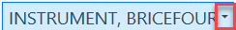
- Click the push pin to pin the calendar to your schedule
- This opens your schedule icon
- Click the nurse’s name at the top of the schedule
- Click the small arrow next to department name
- Click the AWH Oncology Infusion Department
For training ONLY so that students can see the last name of their Eva patients.
- Right Click the nurse schedule (Instrument, BriceXXXXProperties
- Search for Patient Name Last Name, First Name
  - Add Column and move next to Patient Column
- Move Tx Plan Auth Status up next to Tx Plan Signed?
- Click on the Configuration tab
- Click Resource Radio button at bottom
- Find Cancer Center, Chair One
- Click Add
- Click Accept

Our first patient (Eva) has arrived so we want to indicate which chair/room she will be in. DEMO ONLY not working in training.
  - Select your Eva Patient
  - Click on Room Patient on your schedule Toolbar
  - Click chair/room (Exam Room 1)
- Point out: Patient Location and Location Start Time will change in Production. Just point out those columns
  - Point out the list of providers who can be scheduled in the department -- can view any of them separately
  - Scroll to the bottom to see the Cancer Center Chair Resources.
- Click the Chair One to see patients for that chair
Point Out Schedule Columns:
- Oncology specific columns can also be viewed on the schedule.
  - Tx Plan Signed
    - Check that the patient has signed treatment plan orders.
    - Check this first so that you have time to follow up with the physician if needed
  - Research Plan
    - Indicates if the treatment plan has been signed.
    - One thing to keep in mind is that a patient can’t be on a treatment plan and a research Plan. It is one or the other.
    - Tx Plan Auth Status – Users can identify the current authorization status
    - Question mark ? = treatment for plans not yet authorized
    - Green checkmark = treatment is authorized
    - Red X = for plans that have an authorization status denied

Springboard Report
Point Out Report:
Users can review treatment related information in the report section below.
- The Springboard Report provides a single place for users to access all the patient’s cancer treatment information, including the status of a patient treatment plan, dosing parameters, the history of dose changes, history of treatment plans and cancer staging information
- You don’t have to go into the chart or open the Treatment Plan Manager.
- From the Springboard Report, users can access quick links to other important reports or activities that contain information that is more detailed.
Demonstrate Springboard Report:

Patient: Eva
Show Springboard Report

- Single-click on Eva patient
- Select Preview

Customize Reports
Point Out
The reports window is customizable using the Wrench icon. Reports can be added, removed, and reordered depending on the preference of the user:
- Select the Wrench icon
- Click into the first open row
- Click Add Current
- Use the up and down arrows to reorder the reports listed.
  - This will change how the reports are displayed on the report toolbar.
- Click Accept

Review Patient Information
To browse information about past visits, progress notes, imaging, letters, and more Pharmacists can use Chart Review.
Demonstrate Chart Review:
- Find your Eva patient on the Schedule.
- Click the Review button
- Go to the Encounters tab.
- Back Pocket: To view past visits and other encounters like telephone calls. All the patient’s visits appear in a list, organized by date.
- Go to Imaging tab.
- Back Pocket: Displays the patient’s ultrasounds, CT scans, MRI’s etc.
- Go to Episodes tab.
- Back Pocket: This is a collection of visits with a common purpose that can be linked to a single encounter. Some common episode types are: Therapy, Transplant, MVA, Oncology:
  - On the Episode tab, the pharmacist can review treatment plan information in detail.
Demonstrate Chart Search:
- Click into the Search field on the patient’s Storyboard.
- Search “Biopsy”.
- Review topics that contain the keyword.
Demonstrate Storyboard:
- Hover over demographics section.
- Hover over Active Treatment/Therapy section.
- Hover over Labs section.
- Close the patient’s chart.
Demonstrate Filter Information in Chart Review:
Chart Review can be filtered to find specific pieces of the patient’s chart quickly.
- Click on the Encounters Tab
- Click the Filters button
- Click on Provider to filter the orders by the provider who saw the patient.
- Check the box next to a Provider
  - The encounters with that provider should now be the only items displayed
- Single click on one of the appointments
  - The review pane should open on the right side. This allows the user to review the encounter details including the diagnosis, orders placed, etc.
- Click the Save as New Filter button
- Enter a caption name: Oncology Provider
  - Point out the option to make this the default filter. This means that each time the user comes to the Encounters tab of Chart Review this filter will automatically be on.
- Click Accept
  - Point out the new filter across the top of the Encounters tab. This can be clicked on and off as needed.
Explain:
- Filters can be made under any patient.
- It will be saved and available to apply for any patient that the user opens Chart Review on.
Users can have as many filters as they want.

Starting the Visit
Scenario: Eva is ready to start her treatment. Let’s get started.

Return to the Schedule activity to start your Eva patient’s infusion visit.
Demonstrate Treatment Visit:
- Double-click Eva to open her chart.
- Bypass all the warnings and pop-ups.
- The chart defaults to the Rooming Activity.

Rooming Activity

Visit Info
- Click on Visit Info on the Table of Contents
- Click the speed button for Breast Exam
- Customize the Speed Buttons by clicking on the Wrench
- Scroll the blank row and search: Breast Problems
- Click Accept
  - Point out the new speed button added to the list.

Vital Signs
- Click on Vital Signs
- Enter vitals:
  - Blood pressure: 110/70
  - Pulse: 84
  - Temperature: 101.8
  - Source: o (for oral)
  - Weight: 157# - must put a unit of measurement (lb. or kg)
  - Height: 5'4"
- Document tobacco usage:
  - Click on Edit Tobacco Use
  - Tobacco Use: Former Smoker
Introduce Date Conventions:
  - T = today/days
  - W = week
  - M = month
  - Y = year
  - +/- future/past
  - Start Date: y-2
  - Quit Date: m-1
  - Click the in the top right corner.
  - The information will automatically save and bring you back to the rooming tab
  - Click Mark as Reviewed
Explain Mark as Reviewed
- Clicked once you have gone over the information with the patient and updated it in the appropriate section in the chart.
- It ensures patient safety by allowing clinicians to update the information with each visit and share it among all specialties.
- Clinicians can see that last time this information was reviewed and who reviewed it.

Allergies
  - Add new agent: sulfa antibiotics
  - Reaction: Rash
  - Reaction Type: Allergy
  - Severity: Low
  - Comment: Optional area for additional documentation
  - Click Accept
  - Click Mark as Reviewed

Medication Documentation
  - Albuterol: Not Taking
  - Flonase: Taking
- Click on select patient’s pharmacy
  - Search: Walgreens to show adding multiple pharmacy Select Aspirus Pharmacy – Wausau, WI
  - Click Search
  - Choose a pharmacy
  - Click Accept
- Click into Add Medication
  - Search: Cholecalciferol (VITAMIN D) tablet 1000 units
  - Click Accept
  - Click Taking
  - Click Mark as Reviewed

History
  - Add medical history: Breast cancer
  - Add surgical History: Appendectomy
    - Click the paper icon next to Appendectomy
    - Add a date: y-4
  - Family History: Mother had Breast cancer
  - Social History:
    - Alcohol use: Yes - Monthly or less
    - Drug use: Not currently
    - Sexually Active: Yes
  - Click Mark as Reviewed
Point Out all section in Rooming Table of Contents
  - Click the scroll arrow to point out all section
Oncology Assessments are in the right pane of Rooming Activity

- These items are Oncology specific:
  - Pre-Chemo Checklist
  - Pre-Radiation Checklist
  - Psychosocial Distress Tool
  - Toxicity Assessment
Demonstrate Oncology History from Problem List:
- Go to the Storyboard and hover over the Cancer Problems activity at the bottom.
- This gives detailed information including Staging Information and Oncology History.
- To go to the Plan Activity link in the Cancer Problem area

Plan Activity:
The Plan Activity is where the Cancer Staging and Oncology History is entered.
- The Provider will add a cancer diagnosis to the Problem List and stage the cancer.
- Oncology History can be entered by the Provider and/or the nurse.

Overview of Treatment Activity Tab

Treatment plan: in Beacon is a patient-specific copy of your organization's chemotherapy protocols
- Protocols are maintained by the beacon analyst team
- Treatment Plans are applied to patient and then edited by clinicians on patient-by-patient basis
- Physicians enter treatment plans and then manage them
- Pharmacists can queue up and route to Provider for signature or can sign using “transcribe from paper”
Clinic nurses, infusion nurses, and pharmacists view and manage treatment plans

Point out Treatment Table of Contents
- Plan Summary: Shows the patient’s active treatments including Current treatment cycle, authorization status and signed orders for current treatment.
- Treatment Plan: A patient’s main chemo regimen. Regimented in cycle, day format. This can be Standard of Care or Research protocols. Can be inpatient or outpatient. Some examples include FOLFOX, Oral chemo, Vinorelbine.
- Therapy Plan: Non-chemo medications or other infusion meds. Non-regimented found in Interval format. Some examples include B12 every 28 days, Zometa, Iron, Procrit.
- Blood Transfusion: Used to order blood product transfusions. Examples include RBCs, Plasma and Platelets.
- Miscellaneous: Various Therapy Plans for tests, infusion, and injections.

Treatment Plan Navigator

- Click on Treatment Plan from the Table on Contents
Explain the Treatment Plan Navigator Section:
- This shows the current Day and Cycle for the patient
- We can view Appointment requests Labs, Treatment Parameters, Pre-Meds, Chemo Orders
- Green check mark indicates a signed order (done by the provider)
- Released orders will have a green check mark with an arrow (done by the nurse)
- You cannot add or modify orders from this screen
- Point out the Prior Auth (dollar bill) icon.
  - Question mark ? = treatment has not been reviewed
  - Green checkmark = treatment is authorized
  - Red X = treatment isn't approved

Treatment Plan Manager Overview

Introduction to Treatment Plan Manager
The Treatment Plan Manager is where the provider manages the patient’s entire treatment plan.
By applying a protocol:
- It provides a basic template for every treatment plan, so oncologists do not have to worry about missing an order.
- Protocol-based treatment plans promote standardized documentation and treatment plans for similar diagnoses, as well as for research studies.
- Dosing rules and suggestions built into protocols automatically adjust dosages based on variables such as patient weight and age.
  - Click on Edit Plan to discuss the Treatment Plan Manager
  - Treatment plans is divided into cycles.
  - Point out the green rows for Cycles

Demonstrate Treatment Plan Manager:
There are several levels to a treatment plan, it can get confusing so let’s do a top-down orientation to the Treatment Plan Manager.
- Show the new activity tab Can make Important Tab
    - By clicking on Edit Plan new activity button appears on the top for Treatment Plan Manager
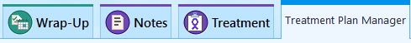
- Show the Treatment Plan Manager title and the protocol selected.

- Show the Toolbar Menu:
  - Add Future Plan: Allows providers to queue another protocol. A patient can only have one active treatment plan at a time.
  - Advance Next Plan: Allows providers to go to the next treatment plan.
  - Put Plan on Hold: Allows providers to “lockdown” the treatment plan in cases of a patient getting admitted or toxicity/complications. It is used rarely us here.
  - Send Plan: Pharmacists can send the entire treatment plan to a provider to their In Basket.
- Show the Prior Authorization icon, the Dollar Bill Sign.
- Click the Show button.
- Click Days.
Point Out Treatment Plan Levels:
- Treatment plans are organized as follows:
  - Green = Cycles
  - Purple = Treatment Days, or days the patient will receive these orders.
  - Orders are organized in sections and medications are arranged in order of administration.

Demonstrate Treatment Plan Levels:
- Click the double-chevron for Day 1, Cycle 1.
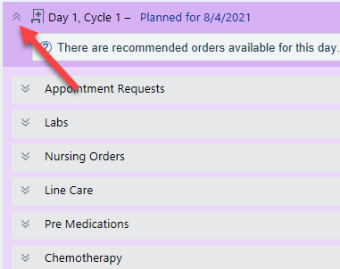
- Open each section 1-by-1:
  - Appointment Requests (future orders)
  - Labs (future orders)
  - Nursing Orders
  - Pre-Medications
  - Chemotherapy
  - Emergency Medications

External Treatment & Cumulative Dose Tracking
Scenario: Eva is scheduled to receive her first infusion treatment today. Before you release any pre-treatment orders, you need to check to see if she is nearing her lifetime maximum dose for the plan chemotherapy agents.
- In this activity you'll review the patient’s lifetime dose of chemotherapy. DEMO ONLY
- Click the Lifetime Dose Tracking button from the Treatment Plan Manager toolbar.
- Here you can see a list of the tracked chemicals the patient has received along with a cumulative dose.
- The Maximum Dose column indicates the lifetime threshold for a specific drug.
- Expand the administration for Doxorubicin to see information about tracked chemicals administered on the MAR.
- Document that the physician ordered 75 mg/m2 for the patient and that Eva received 125 mg seven days ago at 10:30 AM. Accept
- You can enter the name of the facility in comments
- Hover cursor over the percentage for Doxorubicin
- Pharmacists will also manually update these fields when patients receive care from an external facility.

Outpatient Infusion Visit
General Workflow of an Infusion Visit
- A physician authorizes an order by signing it.
- Signing and authorizing a treatment plan order allows pharmacy to prepare the chemotherapy and other infusion medications in advance of the patient's infusion appointment, which streamlines treatment.
- When the patient arrives for their infusion visit, an infusion nurse releases the order to activate it and sends it to the pharmacy for verification and preparation.
Chemotherapy Consents
- Departments will be using written consent forms that will be scanned into Epic.
- These scanned documents will live in the Media tab in Chart Review.
- They should still be following their current method for obtaining consents in the
Requirements for Suggested Infusion Charging
- Upon completion, Infusion charges that are documented by RN’s are calculated in the Wrap Up activity.
- Users can then go into the charge capture activity to add the suggested charges to be filed.
  - For the suggested charges to appear the following steps must be taken in this order:
    - An IV line must first be added
    - Medications are then to be released
    - The line must then be linked to meds
    - Medications administered must be started and stopped in the appropriate sequence.

Add an LDA
Before releasing the treatment plan orders nurses will document the placement or access of a Peripheral IV or Port respectively.
- Go to Rooming Activity
- Click LDA’s
- Click
- In the search field search for PIV
- Use the Avatar to place the PIV on the right forearm
- In the Properties section document the following:
  - Document the date and time you first evaluated the port:
- Date: t
- Time: n
- Size: 18 G
- Insertion Attempts: 1
- Click Accept
  - Assess the Line
- Check 1st box: No redness, swelling or pain dressing intact
  - Close
    - Will save automatically without clicking close

Document Oncology Assessments
The Oncology Assessments can be documented from the Rooming Activity.
Toxicity Assessment Flowsheet
- Click the Rooming Activity Tab
- Click Toxicity Assessment
- This Assessment is required and must be fully completed.
  - Point out how it defaults to the current date and time
  - Document required information.
- Enter Venous Access Device: No.
- Enter No/denies Pain
- Click into the first row for Diarrhea enter Grade 1
- Continue to enter Grade 0 for the remaining rows in this flowsheet
Once done filling out the form, click Close to save. explain that you can either click the file button or changes will automatically save when you navigate away from the flowsheet
Pre-Chemo
- Still in the Rooming activity tab
- Click the Pre-Chemotherapy Checklist
  - Can check to show all choices.
- Click the Yes for most, New drug first chemo: Yes
  - Click Flag – (add comment)
- Second Nurse Verified Calculations
  - Second Nurse should verify under her log in on her computer.
Once done filling out the form, explain that you can either click the Close button or changes will automatically save when you navigate away from the assessment form.

Releasing Pre-Treatment Orders for the Day
Before you release any pre-treatment orders, you need to check to see if these orders have been signed. The Infusion nurses will release labs, nursing orders and line care.
Click This Visit:
The Visit Report can be found is in the sidebar
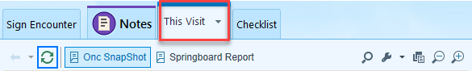
  - On the Oncology Snapshot report, you can see the Oncology History
  - On the Springboard report you will have some of the latest lab values
  - In the treatment plan navigator
- Open the Treatment Plan navigator section.
Explain that the nurses can clearly see which labs that are to be drawn on which day and which plan the orders came from.

- Select the check box for each of the following order categories:
  - Labs
- The calendar icon lets you know when the order was sent to the Work queue.
  - Nursing Orders
  - Line Care
- Click the Release Selected button
  - Will see green check with arrow.
Synopsis Overview:
- Open Synopsis activity.
  - Synopsis is an overview of the patient's lab results, medical administrations, vitals, and other relevant patient data.

Synopsis Overview
- Point out different Synopsis Reports (Med Onc, Onc Nurse and Rad Onc)
  - Recent / current information pulling from flowsheet data and from other areas of the patient’s chart.
  - Can graph vitals up to 4 items
  - Patient Spotlight
- Up to 4 items can be push-pinned
For treatment to be given, the patient must meet the parameters listed in the Treatment Plan.
  - Open the patient’s sidebar and open the Springboard Report.
  - Compare the treatment conditions in the treatment plan using the Springboard Report from the sidebar.
If the patient does not meet treatment parameters → Nurses should not give treatment and contact the provider to notify them of lab values and discuss next steps.

Releasing Treatment Orders

Scenario: Now that I have verified the patient meets treatment parameters today, I will release the chemotherapy medications to send to the Pharmacist’s verification queue.
- Return to the Treatment activity.
If the patient does not meet treatment parameters, nurses should not give treatment and contact the provider to notify them of lab values and discuss next steps.
The section below explains the difference between signing and releasing orders.
Signing | Releasing
Authorizing: equivalent to writing a Signature on a script in the paper world. | Activate: ready to proceed with the order.
Can be done far before treatment. The Sign button is available for unsigned orders throughout the treatment plan. | Done when the patient is present on the day of treatment.  The Release button is available only for signed orders in the current treatment day.
Can sign an entire cycle at a time. | Can release only the current day's orders.
Most often done by oncologists. | Most often done by nurses, this action sends a request to the pharmacy for medications to be mixed.

Required Fields Click the summary sentence to open the order composer to answer question for your patient: (administer over: ex:30 Min)
Continue until you have satisfied all Required Fields.
  - Notice that the Benadryl does not have a but you can’t sign the order with a range dose.
  - Click Check Signed
- Click Release Selected
- The Order Start Times Window allows you to specify when treatment plan medications will be given.
  - The Order Start Times window allows nurses to modify due times for all medications at the same time.
- Accept current start times
- If you get a warning about medication authorization:
If a patient is here for treatment but treatment has not been authorized:
- The nurse should not give the treatment.
- They should speak with their nurse manager or prior auth staff on the next steps.
- If they try to release a medication without prior authorization, a soft stop warning will appear.
- However, for the purposes of training, we will click Accept.
- Point out the Release icon
  - The green check mark with the arrow by the order

Nursing Notes
- Since Nurses are documenting their assessments while Rooming it is important that information documented in Oncology Assessments is not duplicated within the note.
- When you document using your Assessments, it is recommended because it allows reports to be run on the information documented.
- Click Nursing Notes in the Table of contents
- Compose a short note in the Note Sidebar on the Right and Accept
Can see in chart review on the notes tab

Document Medication Administration
Once medications are released, they can be seen in the Medication Administration Record (MAR). The MAR is used to document the administration of all treatment plan orders.
Point Out:
- For medications to be triggered for charging, infusions need to be linked to an LDA.
- Jus Point Link Lines button on the top toolbar

Administer Chemotherapy
- Pre-Medications:
- Document chemo combination Emend|Decadron
  - Override Verification warning if needed
  - Point out action of New Bag and correct admin time
  - A stopped time is required.
- Ask: Why do we have to document a stopped time for an infusion?
  - Must verify that you have recorded the correct time the medication stopped infusing.
  - Remember stopping the running infusion also allows suggested infusion charges to populate in the charging activity.
  - This has implications for billing and intake/output
    - Why isn't this infusion automatically marked as completed?
- Document Stopped time for chemo infusion on the MAR
- Chemotherapy:
- Document DOXOrubicin click the blue due
  - Can be link in the administration form Not Linked
  - A dual sign off must be done in real time.
  - Dual = can't be the same person
- Complete Dual Sign off for chemo injection/infusion administration.
  - Use ID: TRN11145 Password: Logins
    - Drops to Completed Medications
- Emergency Med:
- Document Benadryl Click in the intersection of the column and row cell under the Blue hour for the current hour
- Click Line Not Linked and choose PIV
  - Drops to Completed Medications
  - What question do you have about the MAR?

Complete a Treatment Day
The Nursing staff will complete a patient’s treatment day and documentation.

Remove the PIV
- Just demo do not Click Accept. We can keep the line for Therapy Plans
- Go to Rooming Activity
- Click Pencil link LDA Section
- Fill out the Remove date, time
  - Date: t
  - Time: n
  - Removal Reason: Therapy Completed
  - Accept and Close

Wrap Up Documentation
Scenario: I have completed all my documentation. I just have a few more tasks to complete before I am ready to complete this visit.

- Go to the Wrap up Activity

Patient Instructions
The system should suggest patient instruction based on the chief complaint.
- Add Breast Cancer in Women
  - Scroll to see entire instruction
- Click Add to Patient Instructions
- You will see it listed under Selected Documents
- Go back to Wrap Up
- You can click the back arrow

Communications
- Click Communication section
Communication Management is where you go to draft a letter. Eva needs a work excuse letter.
- Click New Communication
- Recipient: Patient
  - Search AWH-Return to Work
  - Click in the Letter and press F2
  - Left to pick and Right Stick for Work + F2
  - At the *** (wildcard) type return date +F2
  - Left to pick and Right Stick for Work for with or without restrictions.
  - Click Send Now (to print letter)

Preview AVS
This is where you can preview or print the After Visit Summary

Charge Capture
To file the appropriate charges for the day
- Click the Charge Capture section
Some infusion charges are calculated automatically based on MAR documentation.
- File the appropriate charges for the day
- View the This Visit sidebar to see medications administrated for the day

Education
Nurses can document education provided to the patient about plan of care
- Click Education from the Activities tab
  - Education tab
  - Use the square check boxes to check off the education given to the patient
  - Click Document
  - Red stop sign with exclamation point Make selections
    - Or, in the bottom left click Apply Defaults and answers will be auto selected based on common choices
    - Applying defaults will not choose a Learner, that must always be chosen
  - Click File
  - The circles next to the education topics will be green indicating they have been documented
- Click the check boxes for the education given, click Resolve
  - Reason: Education Completed
  - Resolve
  - The resolved education will move from the Active section to just being under All

Complete the Therapy Day
- Click the Treatment tab and go to the Treatment Plan section.
- You want to make sure that you mark Eva’s current treatment day as complete.
  - Check that the provider has released the schedulable orders for the upcoming treatment day.
  - You can Run Upcoming treatment days that don’t have an appointment report to confirm that the appointment has been correctly scheduled.
- Click Complete Day
- The next Treatment Day should now be showing in the Treatment Plan navigator section.

Creating and Administering a Therapy Plan

Therapy Plan Overview
- Nurses can queue up and sign a Therapy Plan
- Edit Plan to make changes
- Begin Treatment to document the Treatment
- Therapy plans and treatment plans are similar but have several key differences.
  - Therapy plans and treatment plans are created for each patient from protocols.
  - Treatment plans are for managing chemotherapy.
  - Treatment Plans and supportive plans are used both within the inpatient and outpatient settings.
  - Therapy Plans are only for outpatient orders.
  - Therapy plans are used for non-chemotherapy standing orders that occur repeatedly over time.
  - Providers can enter and sign orders for a patient's entire therapy at once, and plans can continue indefinitely.
    - A therapy plan is available until it's discontinued, which means it will stay on the patient's chart until someone manually removes it
  - Therapy plans can replace PRN plans and one-time orders

Therapy Plans – Begin Treatment 1
We are going to Begin Treatment 1 for the Line Care Nursing Communication in the Treatment Plan
Go to Treatment Plans
Go to Line Care Therapy Plan
- Click Begin Treatment 1
- Click Start Plan
- Select IV access care orders
- Click Release
- Order Start Times can be changed here Accept
- Associated Problem
- Accept at the warning box
  - All orders have been released. Row color turns to tan.
- Go to MAR to Administer.

Edit an Order - Therapy Plan
- Click the More Activity down arrow and favorite Therapy Plan
- Select Anemia
- Under Available Click iron dextran (INFED) Infusion
- Plan start date: T
- Lead provider: Haque, Niaz M
- Associate: Problem
- Assign Plan
- Sign Plan
- Associate
- You must be on Edit Plan to edit an Order
- Modify the dose for Pre-Med Benadryl to 50 mg
- Click the summary sentence.
- Choose 50 and Accept
- Sign the new Benadryl order
- Go to the Treatment Tab
- Begin Treatment 1
- Release
- Accept
- Sign
- Orders due have been released and completed.

Add an Order - Therapy Plan
Eva’s cancer has spread to the bone and her provider has applied a therapy plan to treat her bone weakness. In addition, her lab results have come back, and she has low potassium levels. After a call with the provider, you need to add a PRN potassium to her therapy plan orders.
- Go to Therapy Plan
- Select Electrolytes
- Under Available Click Potassium Chloride Infusion
- Plan start date: T
- Lead provider: Haque, Niaz M
- Associate: Problem
- Assign Plan
- Complete Required Fields
- Sign Plan

- Click in the box to add a new order 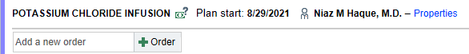
- Search for “Lidocaine Topical soln”
- Make sure you are ordering in the correct order mode (during visit Bed)
Order Schedule:
- Category: Nursing Orders
- Interval: PRN
Order Details:
- Point out Instruction at bottom
- Accept
- Sign Plan
- Can Remove by clicking X
- Click the Treatment Tab
- Click Begin Treatment 1
- Check the Potassium chloride infusion
- Release
- Row banner is tan, Orders are complete

Administer Blood
- Select Blood Transfusion Therapy Plan.
- Under Available Plans Select Red Blood Cell Transfusion
- Plan start date: T
- Lead provider: Haque, Niaz M
- Associate Problem: Lump or mass in breast
- Assign Plan
- Complete Required Fields
  - F2 to complete wild card *** = 1 |2hrs| visit
- Sign Plan
- Enter Information: Order mode and Ordering Provider: Haque, Niaz M
- Accept
- Click Treatment Tab
- Click Begin Treatment 1
- Release
  - Order will change to tan color and indicate Complete: All due order have been released.
DEMO ONLY
Click Transfusion Report Click Hyperlink to Release 1 UnitClose
Document Pre-Transfusion Documentation
Point Out Blood Administration Form on the Flowsheet Activity

Modifying, Deferring or Cancel Treatment Plan
[Jan Patient]

Defer Treatment
Demonstrate Deferring a Day
Defer: Also known as postponing, pushing-back or delaying a treatment day. Defer is the epic terminology used to indicate we need to change the date for clinical reasons.
Scenario: Jan’s ANC value is low, but not enough to merit cancelling treatment. Her oncologist tells you to postpone her treatment day to allow time for her to recuperate.
- Open the Synopsis activity to review her lab values.
- Go to Treatment Plan Activity, verify you are viewing current treatment day.
    - Click Edit Plan to enter the Treatment Plan Manager.

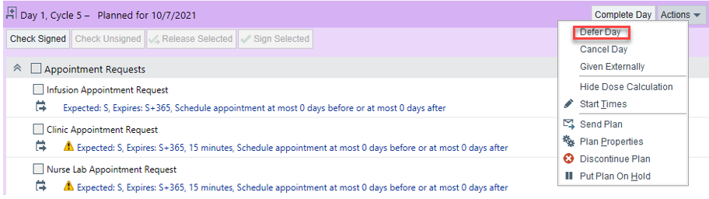
- Click Defer Day

- Enter Click the Calendar or ex: type: T+10 + M+2 for the new date
- The Adjust future dates option is selected by default Point Out, which means that all future days and cycles in the plan will be pushed back, so that the structure of the regimen remains intact.
- Enter a reason: Tx parameters Not Met other than Low ANC/Low PLT
- You may have to select the diagnosis
Point Out Deferring a Day
- The original treatment day is grayed out but remains visible so that other clinicians understand that a change has been made to the treatment schedule.
- Point out the reason for deferring in parentheses
- Once deferred the oncology schedulers will get a new request in their work queue for scheduling.

Cancel Treatment
Cancel: Also known as skipping a treatment day. This is typically used when there are consecutive treatment days and continuous deferment will affect the entire treatment.
Jan’s ANC value remains low, so you need to cancel treatment.
- Open the Synopsis navigator section and review her lab values.
- Go to Treatment Plan Manager, verify you are viewing current treatment day
- Select Cancel Day
- Enter Cancel Day reason: Low ANC
You will not be able to act on any of the orders once the day is cancelled. Hold is not typically used at Aspirus.

Day 0 - Labs
  - Physicians can add Day 0 to cue up labs for the patient’s treatment day.
  - Click on Day 1, Cycle 1
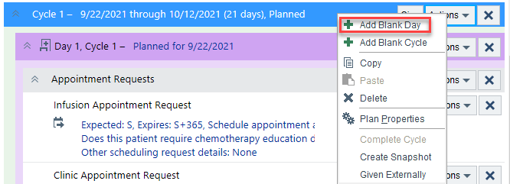
  - Click Action and select Add Blank Day
  - Day Number ‘0’ , date auto populate 7 days
  - Accept for Day 0 Cycles
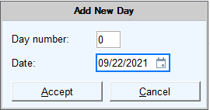
  - Add Day 0 to Cycle 1, Choose other cycles to add and Accept
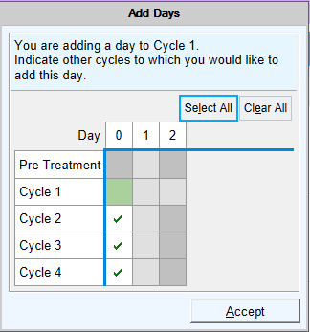

  - You now have Day 0 Cycle 1 and Click Accept
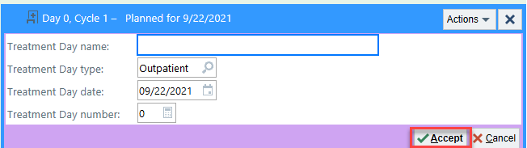
  - Click Action and Select Add Order
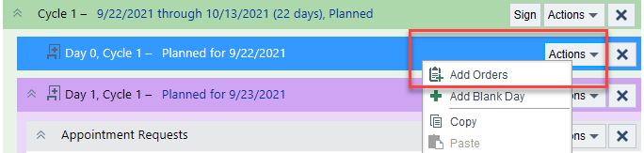
  - Search for your Lab an Click Add
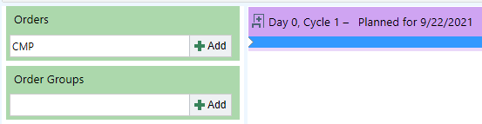
Accept the lab outpatient lab with the house icon
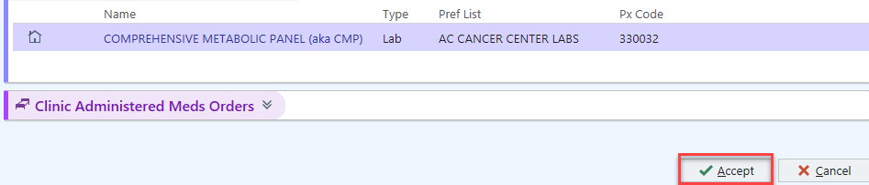
  - Accept Day 0, Cycle 1 Lab
  - The Lab has been added to Day 0, Cycles. Indicate other days to which to add this order

