Provider Training Companion

# Navigating the Schedule

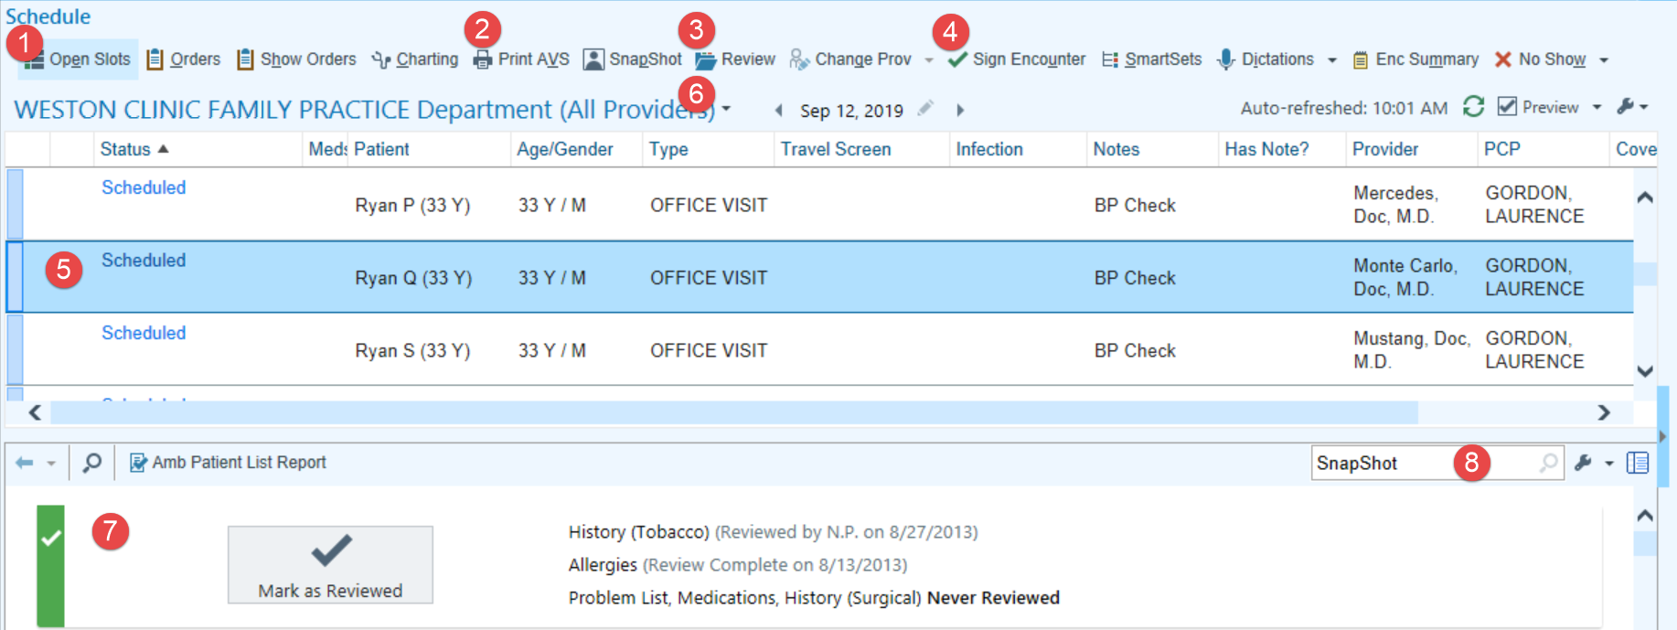

|  |
| --- |
| 1. Used to see where you have openings in your schedule. |
| 1. Can be used to quickly print a patient’s After Visit Summary (AVS). |
| 1. Allows us to review a patient’s record before they have arrived. |
| 1. This allows you to finalize the documentation for the visit once everything necessary has been charted. |
| 1. To open a visit from your schedule, double-click the appointment. You can tell when a patient has been checked in because the status changes to Arrived. |
| 1. To see a schedule in a different department and your personalized schedules, Click  to the right of the department's name, enter the name of the department in the **Dept** field. Click  to the left of his department's folder under the drop down and select the name of the provider whose schedule you would like to see. |
| 1. The SnapShot report provides a little bit of information about a patient before their chart is open. |
| 1. The wrench is used to add additional schedule reports. |

# Personalize Your Schedule

Personalize your schedule to see the patient information you find most useful. Consider adding or removing columns and changing the order in which they appear to suit your personal preferences.

1. Open the Schedule activity and select a folder under cid:image001.png@01D4D7F8.A1E35B00
2. Click  above the folder list to personalize your schedule.
   1. To reorder your columns, select one in the Selected Columns list and click  or  to move it.
   2. To add a column, select it from the Available Columns list and click  to include it in your schedule.
   3. To remove a column, select it from the Selected Columns list and click .
3. Click Accept when finished.

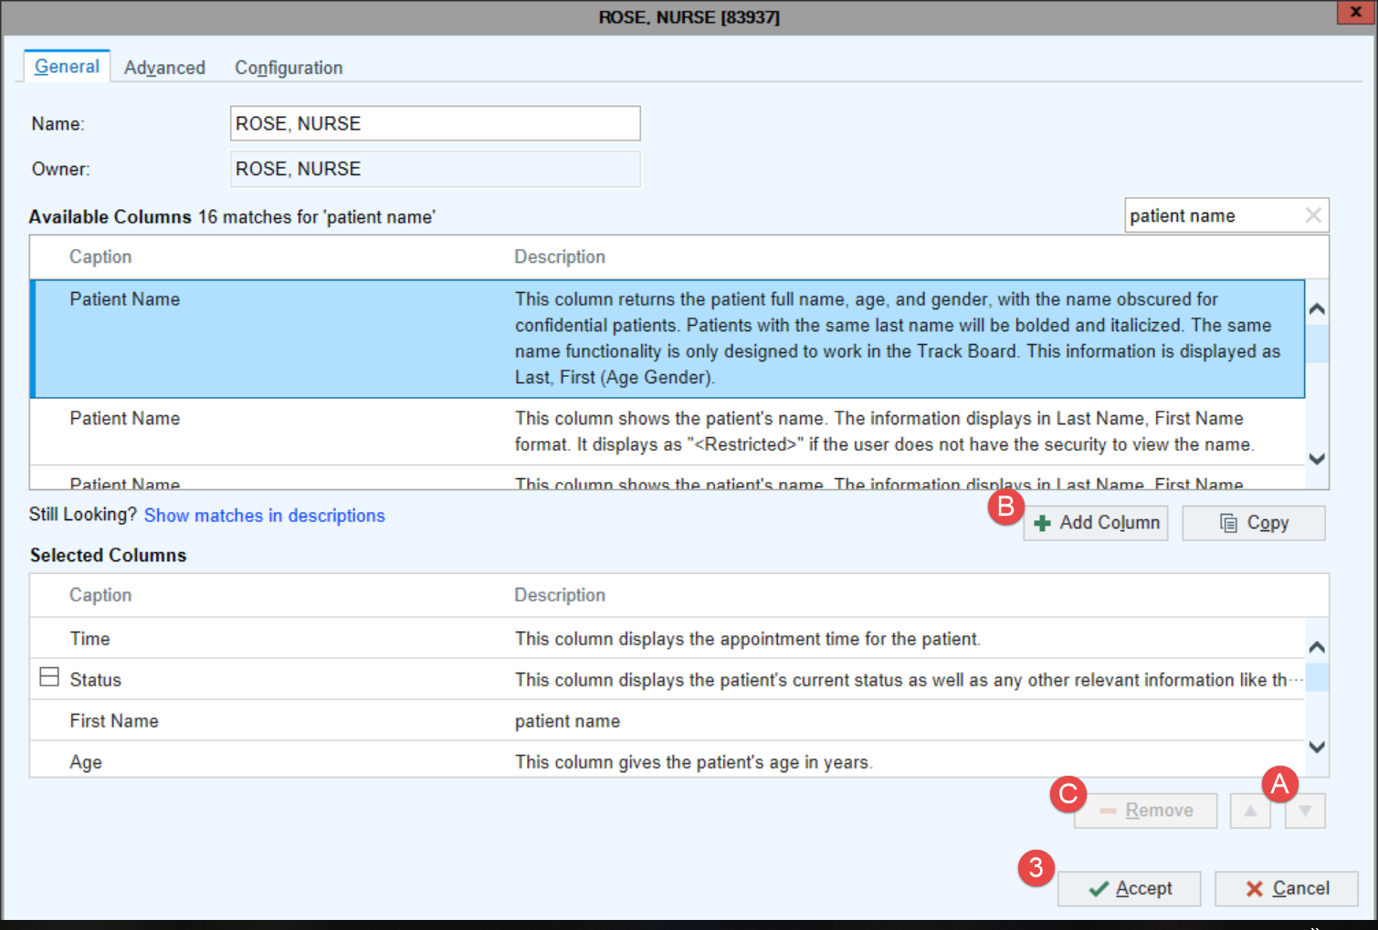

# Personalize your Schedule Report Toolbar

Add, remove, or rename buttons on your Schedule report toolbar so you can quickly find the reports you use most often, such as the last progress note or results from a visit.

1. Click  on the report toolbar. The Add or Remove Buttons from Toolbar window opens.
2. In the Report field, enter the report that you want to appear as a button on the toolbar.
3. In the Button Name field, enter a name for the report. Enter a brief name, if possible, so more buttons can fit on the toolbar.
4. Continue to add reports in the Add or Remove Buttons from Toolbar window as needed.

* Use the  and  buttons to change the order in which the buttons appear on the toolbar.

1. Click Accept. The report buttons appear on the toolbar.

Some examples of reports you might want to include here are:

* Rooming Report: Shows everything documented during the rooming process, including vitals and notes.
* Last Progress Note: Shows the last note for a patient, so you can see it before you go into the room.

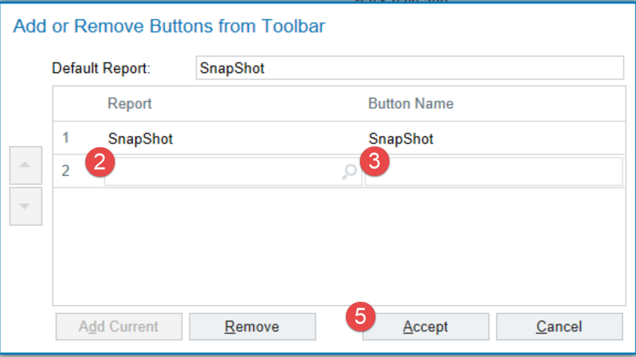

# Chart Review Tabs

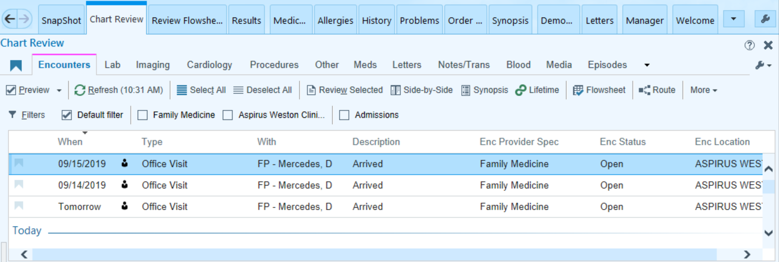

|  |  |
| --- | --- |
| Encounters | All patient encounters. |
| Lab | List of labs including future labs, final resulted labs, and the date/time they were ordered. |
| Imaging | XR, CT, MRI (MR), DEXA, VAS, and US images and studies. |
| Cardiology | EKG, Echos, Stress Test, Holters, and Cath Reports. |
| Procedures | Sleep studies, PFTs, and Biopsies. |
| Other | Discharge instructions, diet orders, DME orders, and consult orders. |
| Meds | A list of the patient’s current and historical medications. |
| Letters | Letters and forms. |
| Notes/Trans | Dictated, transcribed, or typed notes and instructions. |
| Blood | Blood product administrations. |
| Media | Aspirus based scanned documents and annotated images. |
| Episodes | Work Comp, Wound, OB, Therapy, and Anti-Coag. |
| Misc Report | AC Medication List, Code Status, and WH - Immunization Summary. |
| HX/Off Premise Records | Medical records from outside organizations. |
| Referrals | External and internal referrals. |
| LDAs | Lines, Drains & Airways (LDAs). |

# Rooming Navigator



|  |  |
| --- | --- |
| Connect | Connect to the patient in video visits |
| Verify Rx Benefits | A nightly process checks and displays any coverages and prescription benefits. If there are multiple coverages, check with the patient regarding which coverage is active. If the patient was an add-on appointment you must run the query manually. |
| Visit Info | Used to document the chief complaint(s). Comment field allows for free text. |
| Vital Signs | Document vitals, pain score, OB/Gyn status, and tobacco use. |
| Patient Reported Vitals | Allows for Externally documented vital signs |
| PEG Pain Screening Tool | Expanding on pain score, when pain is present at visit. |
| Hearing/Vision | Document the results of hearing or vision screening. |
| Enc Documents | HIPAA forms, Advanced Directives, and After Visit Summaries or a few other documents scanned in for this visit. |
| Allergies | Medication, environmental, or food allergies. |
| Medications | Used for medication review. Allows for documentation of Taking, Taking Differently, or Not Taking. |
| Goals | Patient goals are managed and updated by PCMH coordinators at Aspirus. Many of these goals are diet and lifestyle goals that can be tracked overtime. |
| Nursing Notes | Free text area where nursing staff documents information related to the current visit. |
| Care  Everywhere | If a patient has visited a non-Aspirus clinic or facility that is also on Epic, Care Everywhere informs us of Outside Records that can be imported into the Aspirus Enterprise and incorporated into the patient’s chart. |

# Screening Navigator

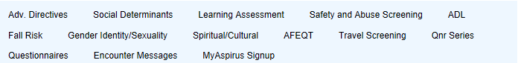

|  |  |
| --- | --- |
| Adv. Directives | This area allows for documentation regarding whether the patient has an advanced directive on file or is interested in filling one out. |
| Social Determinants  of Health | Provides a more complete patient story for patients who are at risk of negative health outcomes. |
| Learning  Assessment | Preferred method and barriers of learning. |
| Safety and Abuse Screening | Documenting safety and concerns at home. UP staff will see information under Community Resource section. |
| ADL | Assessing the ability of the patient to complete activities of daily living. |
| Fall Risk | Assesses if the patient has fallen in the past 12 months. Will only be able to document if the patient is > 65 years old. |
| Gender Identity/Sexuality | Identifies the patient’s preference for gender identity and sexuality. |
| Spiritual/Cultural | Document spiritual/cultural practices that effect care |
| AFEQT | Screening questionnaire for atrial fibrillation. |
| Travel Screen | Only appears if the patient has traveled outside of the U.S. in the last 30 days as documented by registration staff. |
| Qnr Series and Questionnaires | Pre-completed patient questionnaire information will populate here. |
| Encounter Messages | Routing history of that encounter. |
| MyChart Sign-up | Used to enroll the patient for MyAspirus while in the exam room. |

# Entering Past Medical History

1. Open the History activity.
2. From the navigator, select the appropriate section(s) to update the patient's history. Substance & Sexuality includes tobacco and alcohol use.
3. Use the  Add field to look up a new history item.
4. Click on  to add a medical history item to the problem list.
5. Click C:\Users\u10494\AppData\Local\Temp\SNAGHTMLd56230.PNG Mark as Reviewed at the bottom of each section.

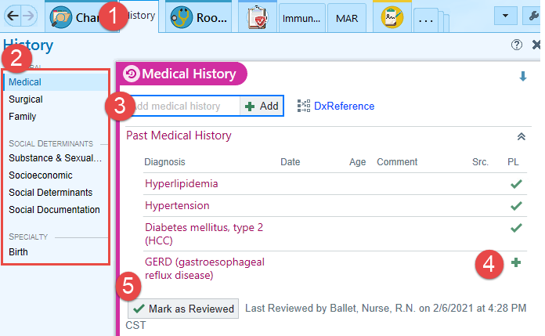

1. When adding a new medical or surgical history item, a pop up box will appear asking for additional details.
2. In the Family History section, use the green plus sign  beside the family member’s name to look up a new problem.
3. To indicate a family member has no known problems, click the check box beside **No Known**.
4. Add a family member’s name using the **Name** field, and to indicate that a family member is deceased, click in the Status column until Decsd appears.
5. To add a family member who doesn't appear in the family history table, click Add Family Member  and select a relative, such as **Maternal/Paternal** Aunt.

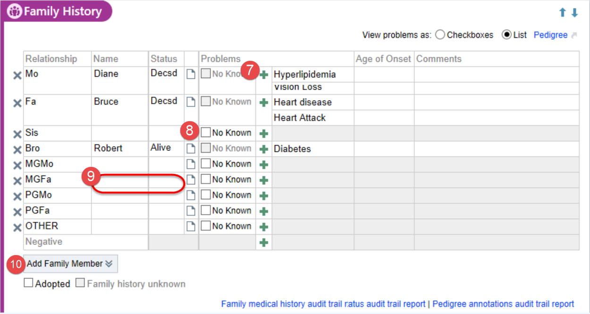

# How to Add a Pharmacy

In the Medications & Orders section within the Plan activity, if the patient has a preferred pharmacy, it appears at the bottom of the section.

cid:image001.png@01D5096B.E4C983A0If you need to change or add a pharmacy, follow these steps:

1. **Click here to select a pharmacy**.
2. The Suggested tab of the Pharmacy Search window includes a list of pharmacies the patient prefers and has recently used. Select one and click Accept.
   * Click  to add a pharmacy to the preferred list. Click C:\Users\u10494\AppData\Local\Temp\SNAGHTML2b929e.PNG to remove a pharmacy from the preferred list.
3. If necessary, you can search for another pharmacy in the **Name** field.
4. The **Patient and clinic’s nearby** ZIP Codes check box is defaulted. To expand your search, uncheck this box.
   * 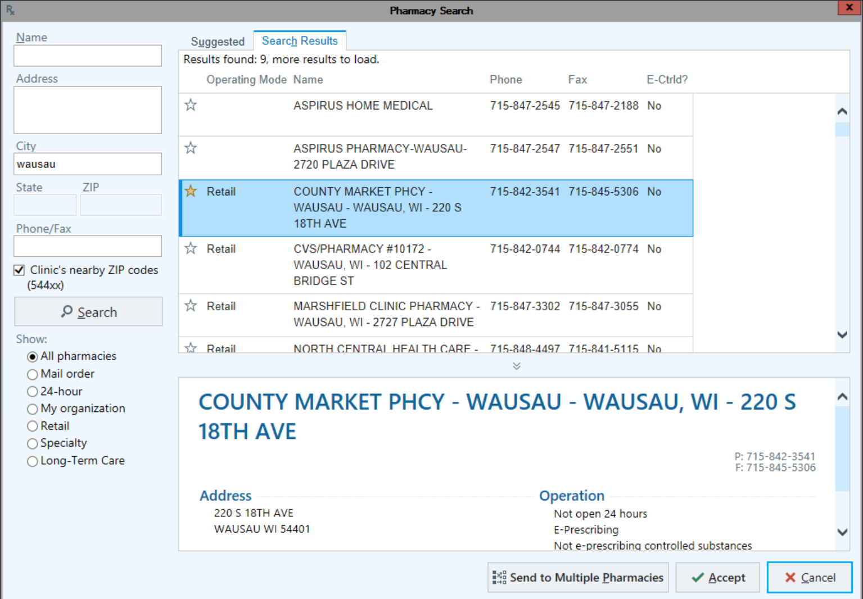When trying to find a pharmacy type in the first few letters of the pharmacy, and the first few letters of the city name.

# Review Formulary Information While Writing Prescriptions

When placing medication orders, you can see what the patient's insurance covers, see the patient's copay levels, and select alternatives to non-formulary medications when appropriate.

1. In the Medications & Orders section, search for a medication.
2. In the window that appears, review the information in the **Copay, Coverage,** and Formulary, columns.

One of the following icons appears in the Formulary column for each medication if the patient has a pharmacy benefit plan.

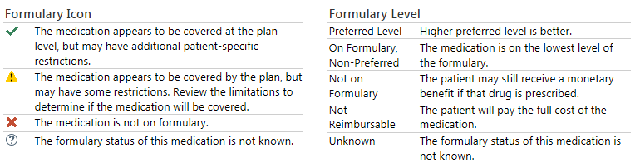

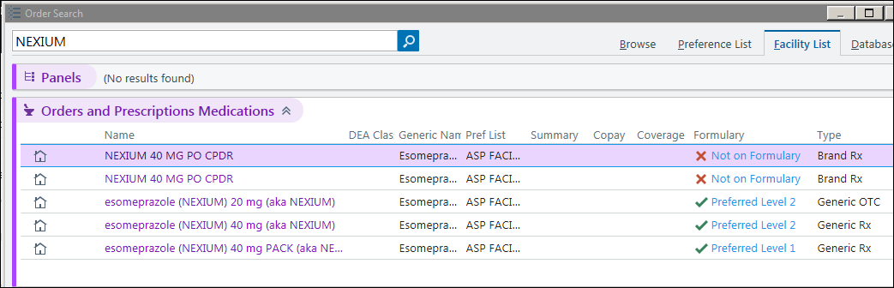

# E/M Modifier Codes

In order to document that specific services have been completed there are a handful of **Additional E/M codes** that specialty providers should be aware of.

As a part of the Clinical Value Program reports are run to ensure that providers are meeting their goals for CVP (Clinical Value Program). When codes are entered in the Additional E/M codes field reports can be run to make sure that the goals are being met.

To enter these codes, go to the **Level of Service** section of the **Wrap-Up** activity and select **Click to add.**

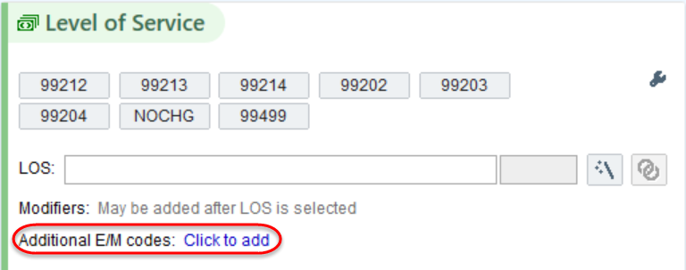

# Requirements to Close an Encounter

To sign the visit, click **Sign Visit.** If there are still items that need to be documented an alert will appear. To be brought to where the documentation needs to be completed, click the link.

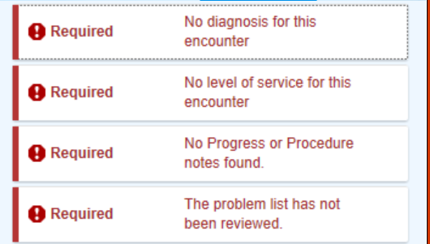

Here are items that must be completed before a visit can be signed:

* Chief Complaint
* Visit Diagnosis with a primary diagnosis indicated
* A Note signed by the encounter provider
* Level of Service (LOS)
* All orders must be signed (if applicable)
* Any clinic administered medication must be documented (if applicable)
* Marked Problem List as Reviewed

# **SmartTools**

SmartTools help you to quickly document information. There are four types of SmartTools.

|  |  |
| --- | --- |
| SmartTools Toolbar | * You can use SmartTools in places such as notes, patient instructions, and letters. * If you see these buttons, the field is SmartTool-enabled |
| SmartText | * Templates or blocks of text used for writing a note * Created for you by Clinical Informatics Reps * Use the **Insert SmartText** field to find a SmartText |
| SmartPhrase | * Sentences, phrases, or paragraphs * Can be user created or system created * Type: .*name of phrase* to populate into the note |
| SmartLink | * Information linked from within the patient’s chart * Type: **.**<*name- of-phrase>* to populate into the note |
| SmartList | * Predefined list of choices * Designated by braces { } * To activate Press F2 * Blue: multiple choices * Yellow: single choice * Left click to pick; Right click to stick * Stay within the box when clicking |

# Additional SmartTools Terminology and Tricks

|  |  |
| --- | --- |
| Wildcard | * *** = wildcard * A placeholder reminding you to document something. * To address press F2 and start typing to replace the *** with your free text. |
| F2 | * The Key used on your keyboard to move to the next SmartList or Wildcard. |

# Create Your Own SmartPhrase

If you often type the same sentences, phrases, or paragraphs while charting, turn them into your own SmartPhrase.

1. In a SmartTool-enabled field, type the text you want to save as a SmartPhrase. Don't include any patient-specific information.
2. Highlight the text and click . The SmartPhrase Editor opens with your text in the Content tab.
3. Make any necessary edits.
4. Enter a short, intuitive name for your SmartPhrase in the Name field. This is the abbreviation you'll use to use the phrase.
5. Enter a summary of your SmartPhrase in the Short Description field.
6. Click Accept. The SmartPhrase is now available for use.

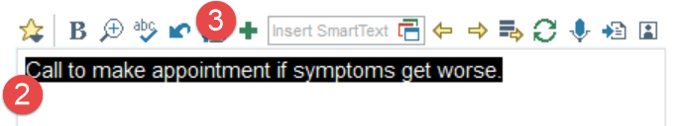

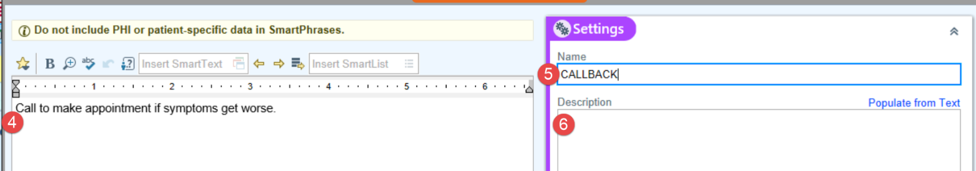

# See a List of all SmartPhrases and SmartLinks

1. When you are writing a note click  to open the SmartLink/Phrase Butler.
   * Any SmartPhrases you've created will appear at the bottom of this window.
2. Use the **Filter** tab to select the SmartTools you want to see. For example check the box next to System SmartPhrase to see all available phrases.
3. Type a word in the search field and press Enter.
   * Icon indicates a SmartPhrase and icon indicates a SmartLink.
4. Click  to mark links and phrases as favorites.
5. Double-click a SmartPhrase or SmartLink or click Add and Close to insert.

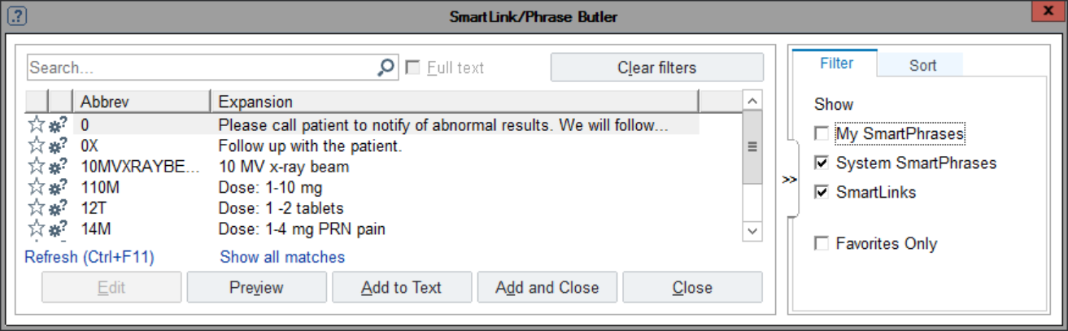

# Take Ownership of Nursing Staff Notes

Some clinics utilize a workflow in which the nurse uses the **Notes** activity to start a note and the provider then takes ownership of the note that was started by the nurse.

To continue the note that the nurse started:

* Click **Notes**.
* Click **Edit**.
* When the note opens, click **Make Me Author**. You now have ownership of the entire note.
* Complete the note as you normally would and when the visit is signed the note will be listed with your name as the author.

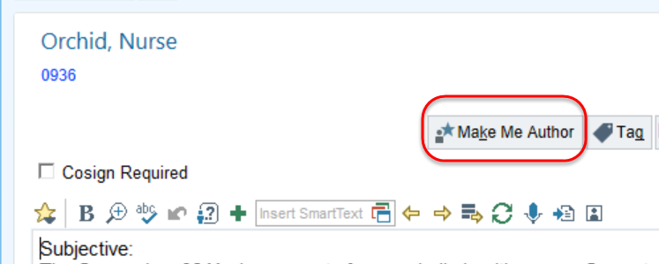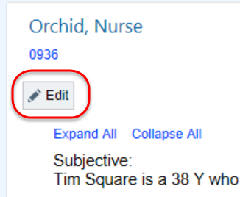

# In Basket Toolbar

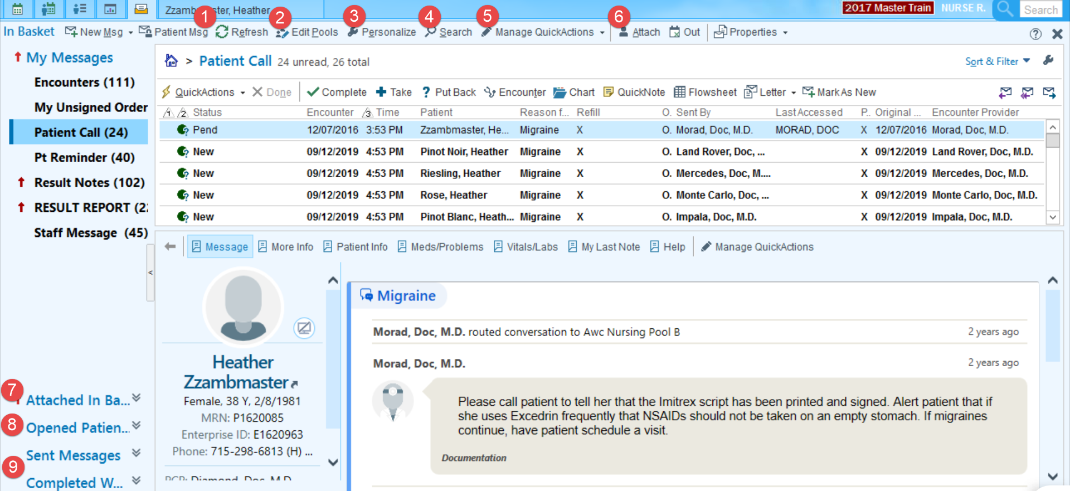

|  |
| --- |
| 1. The Refresh button causes the system to refresh immediately. |
| 1. The Edit Pool button is useful for managing the pools you are checked into. |
| 1. Settings allow you to personalize the order in which the In Basket folders appear. |
| 1. Use the Search button to find messages easily. |
| 1. Manage QuickActions allows you to address messages faster by having preset actions set up for messages like Rx Requests, Results notes, QuickNotes, Letters, and more. |
| 1. Attach allows you to grant access and attach to other users In Baskets to help cover the work. |
| 1. **Attached In Baskets** appears if you're attached to your provider’s In Basket. |
| 1. **Opened Patients** appears if you have a patient's chart or visit open so you can view messages specific to that patient. |
| 1. Go to the **Sent Messages** or **Completed Work** to find past messages. To act on a message that was previously completed, click Move to My Messages to work on it later. |

To learn more about the various In Basket Folders, please reference the [In Basket Folder Descriptions](http://aspirusintranet/Uploads/Public/Documents/EMR-Tipsheets/Ambulatory%20and%20Inpatient/2015/In%20Basket%20Folder%20Descriptions.pdf) TipSheet.

# How to Address Different Types of In Basket Messages

|  |  |  |  |
| --- | --- | --- | --- |
| Type of Message | **Why did I get it?** | **What can I do with it?** | **How to remove it?** |
| Cosign - Clinic Orders | Another clinician has placed an order that requires your signature. | Sign: Cosign the order.  Decline: Send the message to an administrator, if it was sent to you by mistake and you are not sure who should review it.  Encounter: Open the encounter and make any necessary changes, such as discontinuing the order.  Reassign: Send the message to another clinician, if it was sent to you by mistake. | Click Sign |
| Cosign Notes | Another clinician has completed a note requiring your review and signature. | **Attest:** Cosign the note with an attestation.  **Cosign:** Cosign the note as written.  **Encounter:** Edit/Addend the encounter associated with the currently selected message. | Click Attest or Cosign |
| Chart Cosign | Another clinician has completed an encounter and requires your co-signature. | **Sign:** Cosign the chart.  **Encounter:** Edit/Addend the encounter associated with the currently selected message.  **QuickNote:** Add a progress note to the encounter and optionally send it to another clinician or pool of users. Look for or create a QuickAction that automatically drafts the note with your preferred text and recipients.  **Defer:** Forward a message to administration for reassignment and remove the message from In Basket. | Click **Sign** or **Defer** |
| Transcription | Your dictated note is ready for review and completion. | **Edit/Route:** View or edit the currently selected transcription.  **Sign:** File the transcription in the selected message(s) in the patient’s record.  **Sign/Close:** Sign the transcription and the selected message to file into the patient record and close the associated encounter.  **Sign/Fwd:** Sign the transcription and forward the message to another person for additional review.  **Reject:** Reject transcription and forward to a pool with a reason for rejection. | Click **Edit/Route**, **Sign**, or **Sign/Close** |

|  |  |  |  |
| --- | --- | --- | --- |
| Type of Message | **Why did I get it?** | **What can I do with it?** | **How to remove it?** |
| Result Report | The results for a patient’s test in which you were the Authorizing Provider. | Result Note: Add a note to the results or to the corresponding visit. Look for or create a QuickAction that automatically drafts the result note using your preferred text and recipients.  Results Rel: Release the results to the patient's MyAspirus account through the MyAspirus Results Release activity. This allows you to review, write a note to the patient, and release the result.  Web Rel: Review result from the In Basket and release the result to MyAspirus.  Reflex: Create a reflex order from the currently selected order message.  **Telephone Call:** Document a telephone call when contacting the patient directly for their results.  Letter: Write a letter. Look for or create a QuickAction that automatically drafts the letter using your preferred text and recipients.  **QuickNote:** Add a progress note to the encounter and optionally send it to another clinician or pool of users. Look for or create a QuickAction that automatically drafts the note with your preferred text and recipients. | Click Done |
| Pt Advice Request | A patient sent your clinic a question from MyAspirus. | MyCht Enc: Open a MyChart encounter where you can reply to the patient and do additional charting (like place orders, add a note to the patient's chart, and send a response to the patient's MyAspirus account).  Telephone Call: Document a telephone call when contacting the patient regarding their question. | Click MyCht Enc or Done |
| Rx Request | A patient has contacted your clinic to renew an existing prescription that needs your approval. | Approve All: Approve all requested medications and sign the orders.  **Approve and Route:** Approve all medications in the selected message and display notes and routing form.  Edit Rx Approve or refuse requested medications and change any of the medications' order details. If necessary, you can add a note to the patient's chart, send a response to your staff, and close the encounter.  Refuse All: Refuse all requested medications.  **Refuse and Route:** Refuse all medications in the selected message and display notes and routing form.  QuickNote: Add a progress note to the encounter and optionally send it to another clinician or pool of users. Look for or create a QuickAction that automatically drafts the note with your preferred text and recipients. | Click Approve All, Refuse All, or Edit Rx |

|  |  |  |  |
| --- | --- | --- | --- |
| Type of Message | **Why did I get it?** | **What can I do with it?** | **How to remove it?** |
| My Open Charts | You opened an encounter two or more days ago that needs to be completed and closed. | Encounter: Open the encounter, complete any missing information, and close the encounter.  QuickNote: Add a progress note to the encounter and optionally send it to another clinician or pool of users. Look for or create a QuickAction that automatically drafts the note with your preferred text and recipients.  Sign Encounter: Close the encounter if your documentation is already complete. | Click **Encounter** or **Sign Encounter** |
| Patient Calls | A patient called your clinic, and you might need to follow up on the call. | Complete: Remove the message from your In Basket if someone else is following up on the call.  Encounter: Open the encounter to review the patient's information, do some charting, and close the encounter.  QuickNote: Add a progress note to the encounter and optionally send it to another clinician or pool of users. Look for or create a QuickAction that automatically drafts the note with your preferred text and recipients. | Click Complete |

# How to Log Into the PLY/Sandbox Environment

The PLY/Sandbox environment is a place to practice workflows and complete guided practices. It is refreshed daily to allow multiple users to take advantage of this resource. Information you document or orders placed will likely not be there the next time you visit the Sandbox.

1. From the Aspirus Intranet, hover over Work Tools and Resources and click **Citrix**.

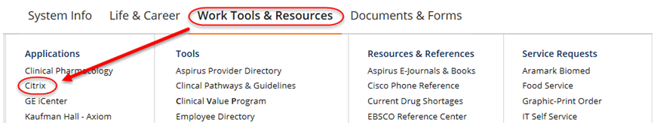

1. Log-in to **Citrix** with your Epic User name and Password.



1. Single click on each of the following folders to find the proper epic PLY19 Environment.

* 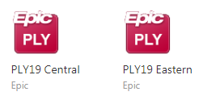Click Epic 🡪 Training 🡪 Playground (choose either Central or Eastern)

