|  |
| --- |
| Logo, company name  Description automatically generated  Epic OPTIME  Perioperative Department  Surgical Nurse Guided Practice |

Table of Contents

**Introduction** 5

Educational opportunities 5

**Logging into epic** 6

**preop documentation** 6

finding patients 6

assign bay 7

pre-op staffing 7

case tracking events 8

allergies 9

history 9

home medications 10

orders 10

acknowledge orders 11

vital signs and Id band 11

peripheral Iv 12

medication administration 13

preop checklist 14

INDEPDENANT PRACTICE #1: assessments 15

INDEPENDENT PRACtICE #2: education 16

delays 18

PRE-OP ACUITY 18

patient ready 18

verify 19

**intraprocedure documentation** 20

finding patients 20

staff 20

INDEPENDENT PRACTICE #3: visitors 21

counts 21

in or time 22

timeout 22

INDEPENDENT PRACTICE #4: FIRE SAFETY TIMEOUT 23

INDEPENDENT PRACTICE #5: PROCEDURE TIMEOUT 23

preop skin 23

positioning 24

patient prep 24

equipment 24

supplies 25

ONE TIME supplies 26

implants 27

ONE TIME IMPLANTS 27

intraop meds 28

SPECIMENS 28

independent practice #6: closing count 28

DRESSINGS 29

nursing diagnosis 29

post0-op skin 29

procedure 29

independent practice #7: final count 30

out of or time 30

VERIFY 30

**pacu** 31

arrival 31

acknowledge orders 31

vital signs and aldrete score 31

independent practice #8: Assessments 32

independent practice #9: medication administration 32

independent practice #10: intake and output 33

patient meets d/c criteria 33

verify 33

**phase ii documentation** 34

arrival 34

acknowledge orders 34

independent practice #11: vitals signs and assessments 35

MEDICATION DETAIL 36

follow-up appointment 36

discharge instructions 37

remove iv 37

d/c phase ii 38

discharge patient 38

**IF YOU HAVE TIME: pre-op phone call** 39

IF YOU HAVE TIME #1: finding pre-op phone call patients 39

IF YOU HAVE TIME #2: outgoing call 40

IF YOU HAVE TIME #3: pre call checklist 40

IF YOU HAVE TIME #4: allergies 40

IF YOU HAVE TIME #5: education 41

IF YOU HAVE TIME #6: mark call complete 41

**Introduction**

Educational opportunities

Classroom training is one piece of your Epic education. Other opportunities to learn more before go-live include:

* **E-learning:**
  + E-Learnings can be rewatched.
  + There are also recommended after class e-Learnings to reference.
* **Independent practice** - Schedule time for practice sessions after class
  + Access our **Epic Playground** environment and continue your self-exploration through guided exercises found in this workbook.

*At your workstation, you have a Training Tent Card with your login information that will be needed for today’s training.*

If you have questions at any time, please don’t hesitate to ask.

***Any preliminary questions before we get started?***

**Logging into epic**

From your Surgical Nurse Training Login Sheets, enter the **User ID** that starts with **TRN** into the User ID box. Your password is **logins**; then click on the **Log In** button. The Message of the Day will display. Customarily, this will display upcoming system downtimes. Be aware of what is in the Message of the Day. Click **OK.**

**preop documentation**

finding patients

**PATIENT**:  **Caitlyn**

 **SCENARIO**: Caitlyn is here for surgery today. She’s arrived to Pre-op. It is time for you to review her chart.

**TRY IT OUT:**

1. Click the **Find** button on the Status Board

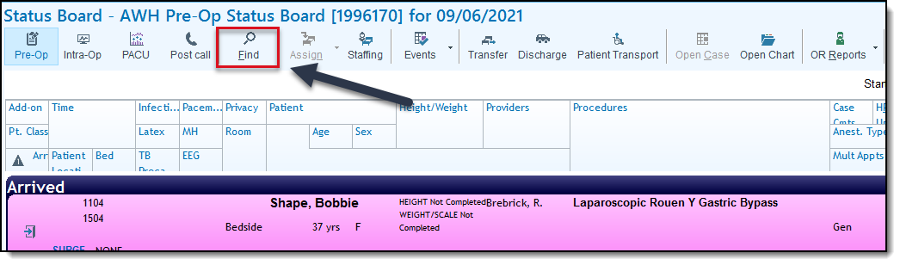

1. In the field that opens in the lower left, type the “last name, first name” of your Caitlyn patient and press **ENTER**.

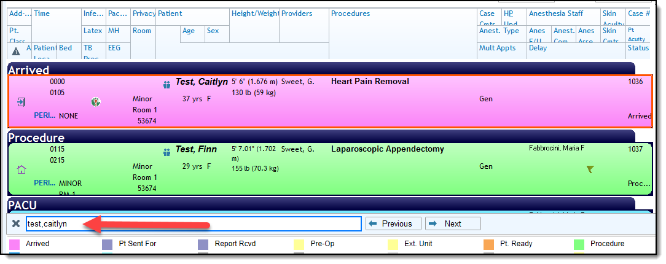

assign bay

 **SCENARIO**: After bringing Caitlyn back to Pre-op, we assign her to a bay.

**TRY IT OUT:**

1. Right click your patient’s row
2. Choose **Assign**

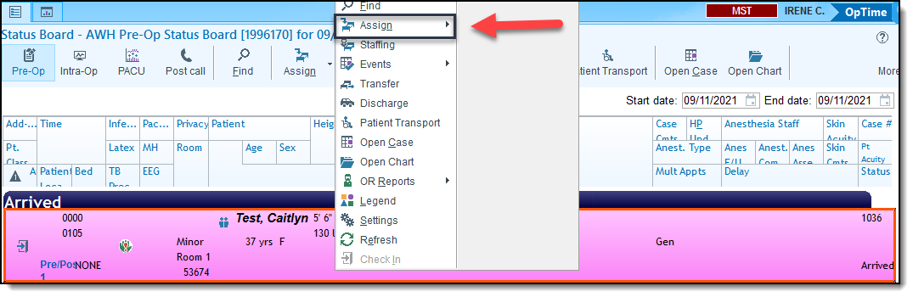

1. Select an available **Pre/Post** room

pre-op staffing

 **SCENARIO**: You assign yourself as the nurse caring for Caitlyn.

**TRY IT OUT:**

1. Double-click to open Caitlyn’s chart
2. When prompted to **Create a Log**, click **Yes**.

**NOTE – Creating a Log starts your Pre-op documentation. Only click Yes if the patient has arrived and you want to start your documentation. If the patient hasn’t arrived and you only want to review the patient’s chart, click No.**

1. Navigate to the **Log** tab across the top.
   * As you work through your documentation you will be toggling between the **Log** and the **Periop Navigator** tabs across the top.
   * Think of the **Log** as information specific to the case i.e. Times. The **Periop Navigator** is where you will live for assessments.
2. Click the **Pre-op** tab
   * You are brought to the Pre-op Navigator. Each section allows you to document specific information related to the case. Utilize the checkboxes to keep track of your work.

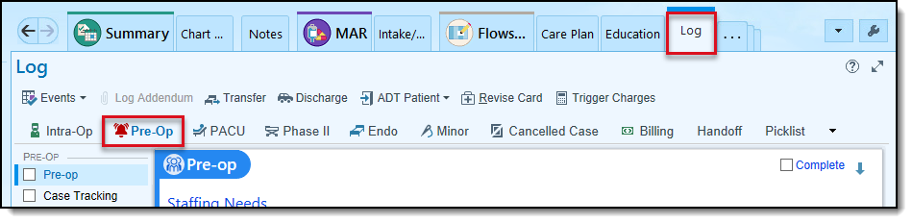

1. Within the **Pre-op Staff** field, type .me in **Pre-op Staff** to document your nurse’s name

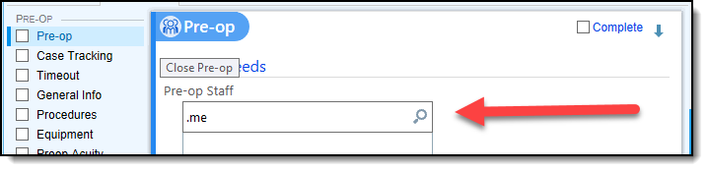

case tracking events

 **SCENARIO**: We need to update the time Caitlyn arrived to Pre-op.

**TRY IT OUT:**

1. Navigate to the **Case Tracking Events** section.
2. Document Caitlyn is in **Pre-op** by clicking **Now** in the **Pre-op** field**.**

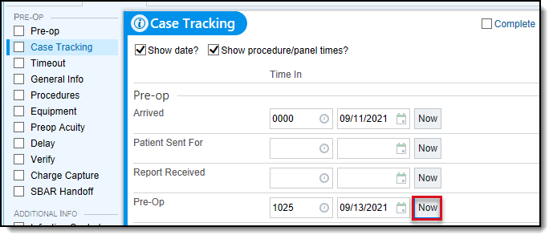

allergies

 **SCENARIO**: We review Caitlyn’s allergies. We see she is allergic to Latex. She also tells us she is allergic to Pollen. It gives her a headache.

**TRY IT OUT:**

1. Click **Allergies**
2. In the **Add a new agent** field, search for **Pollen**
3. Select **Pollen (Hayfever)**
4. Add the following details:

|  |  |
| --- | --- |
| Field | Information to Enter |
| Reaction | **Headache** |
| Severity | **Medium** |
| Reaction Type | **Allergy** |

1. Click **Accept**
2. Click **Mark as Reviewed.**

history

 **SCENARIO**: We review Caitlyn’s history. She confirms she has a history of headaches and heart pain. She also tells us she was never a smoker and had a tonsillectomy when she was a child. Caitlyn also mentions she has a history of Asthma. We will add this, since we don’t see it on her chart.

**TRY IT OUT:**

1. Open the **History** section.
2. Document the following:

|  |  |
| --- | --- |
| Field | Information to Enter |
| Asthma | **Yes** |

1. Click **Mark as Reviewed** at the bottom of the section.

home medications

 **SCENARIO**: In addition to labetalol, Caitlyn is taking Tylenol for pain. She stopped taking it yesterday.

**TRY IT OUT:**

1. Click **Home Meds**
2. In the **New Prior to Admission Med** field, search for **Tylenol** and press **ENTER**.
3. Select **acetaminophen (Tylenol) 325 mg**
4. Document the following details:

|  |  |
| --- | --- |
| Field | Information to Enter |
| Dose | **325 mg** |
| Frequency | **Every 6 hours as needed** |

1. Click **Accept**
2. Click **Mark All Unselected Yesterday** to document Caitlyn’s last dose was yesterday.
3. Document a **Med List Status of RN Complete**
4. Click **Mark as Reviewed**

orders

 **SCENARIO**: We review the orders placed by Caitlyn’s doctor.

**TRY IT OUT:**

1. Click the **Orders** tab across the top.



1. Select the **Sign & Held** tab
   * When a surgeon places Pre-op orders, they will be signed and held. We will need to release them to make them active.
2. Select the **Click Here to Release Signed and Held Orders** link.
3. Select all orders under the **Signed and Held Orders – Pre-op** header.
   * When physician’s place order, they will assign a Phase of Care. A phase of care is a tag on the orders telling us when they should be carried out i.e. Pre-op, PACU, etc.
4. Click **Release** and **Close**

acknowledge orders

 **SCENARIO**: We acknowledge Caitlyn’s orders

**TRY IT OUT:**

1. Navigate to the **Summary** tab

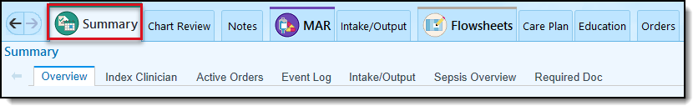

1. Under **Orders to be Acknowledged**, click **Acknowledge All.**

vital signs and Id band

 **SCENARIO**: We record a set of baseline vitals.

**TRY IT OUT:**

1. Go to the **Periop Navigator** > **Periop Admission** tab

* This is where we will document our assessments.

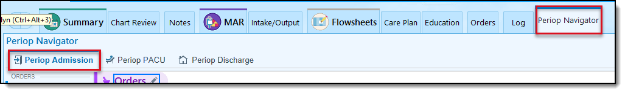

1. Open the **Armband Applied** section.
2. Under **Arm Band Applied**, select **ID**
3. Open the **Vital Signs** section.
4. Document the following:

|  |  |
| --- | --- |
| Field | Information to Enter |
| BP | **120/80 (TIP: Type a space between 120 and 80)** |
| Resp | **20** |
| Pulse | **90** |
| Temp | **98.6** |
| Height | **5f6i** |
| Weight | **130lb** |

peripheral Iv

 **SCENARIO**: After inserting a peripheral IV, we document the placement.

**TRY IT OUT:**

1. Open the **LDA Avatar** section.
   * You are brought to the avatar. **NOTE:** LDA stands for Lines, Drains and Airways
2. Click the **Peripheral IV** button.
3. Select the location of the IV on the avatar
4. Enter a **Placement Date**: T
5. Enter a **Placement Time**: N-20 for 20 minutes ago.
6. Enter a **Size**: 20G
7. Click **Accept**
8. Hover over the PIV to document an assessment.
9. Click **Assess**

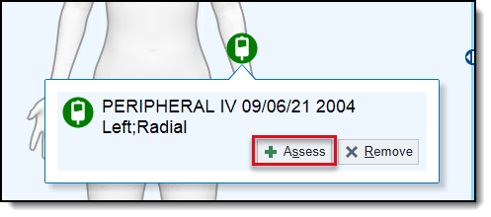

1. In the **Site Assessment** field, select **No redness, swelling or pain, dressing intact**
2. Enter a **Dressing Status** of **Dry and Intact**
3. Click **Accept.**

medication administration

 **SCENARIO**: You’ve just released Caitlyn’s pre-op orders and have inserted a peripheral IV. Next, you’ll document that you started her on some LR.

**TRY IT OUT:**

1. Open the **MAR**
   * In real life you would scan your meds using a barcode scanner or Rover. In training we do not have a scanner available.
2. Click on due time for lactated ringers infusion
3. Click **Continue Administration** through the Medication not verified

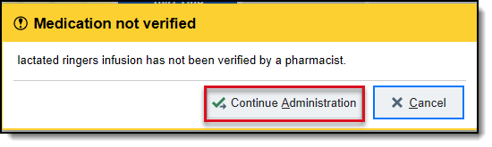

1. Select the **Peripheral IV** button to link the LR to the PIV you just inserted

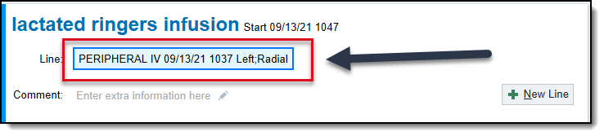

1. Click **Accept**
2. Verify that the **MAR Action** is **New Bag** and the Time and Rate are appropriate

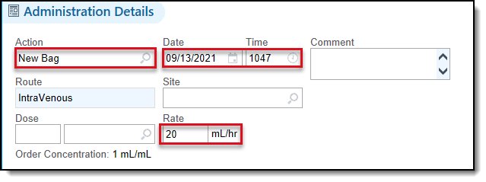

1. Click **Accept**

preop checklist

 **SCENARIO**: You fill out the Pre-op Checklist

**TRY IT OUT:**

1. Navigate back to **Periop Navigator** > **Periop Admission**

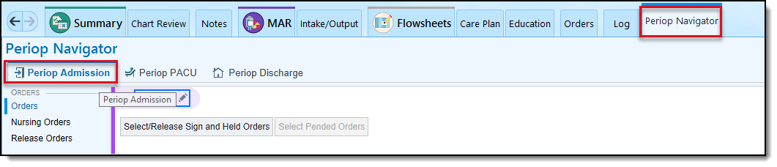

1. Open the **Pre-op Checklist** section
2. Document the following:

|  |  |
| --- | --- |
| Field | Information to Enter |
| Belongings at Bedside | **Clothing** |
| Clothing | **Dress** |
| ID Band Applied | **Yes** |
| Consents Confirmed | **Yes** |
| Does the patient have an implanted device | **Not applicable** |
| Preop Lab/Test Results Available | **In Chart** |
| Pre-op COVID test completed per policy | **Yes** |
| LMP | **T-6** |
| Pregnancy Lab Collected | **Yes** |
| Allergies Reviewed | **Yes** |
| H&P Verified | **Yes** |
| NPO | **Yes** |
| Time of Last Oral Intake | **2300** |

INDEPDENANT PRACTICE #1: assessments

 **SCENARIO**: You complete a Head to toe and skin assessment.

**TRY IT OUT:**

1. Open the **Plan of Care** section
2. Document the **Pre Procedure Plan of Care Goal** is met
3. Open the **Head to Toe** section.

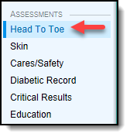

1. Document anything you would like to for Caitlyn
2. Open the **Skin** section.
3. This is the Scott Triggers assessment, document whatever you would like
4. Open **Cares and Safety**.

**NOTE: Document any Precautions you took here, such as Fall Risk.**

1. Document anything you would in this section.

|  |  |
| --- | --- |
| Related image | Continue to Independent Practice #2 |

INDEPENDENT PRACtICE #2: education

 **SCENARIO**: You gave Caitlyn several Pre-operative Instructions. You document this in the Education section. Think back to your Hospital Nurse training for this section.

**TRY IT OUT:**

1. Open **Education**
2. Under Assessment, select **Create New**

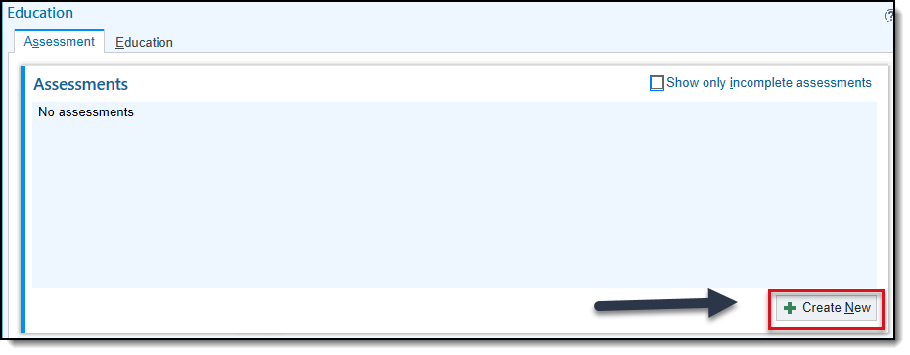

1. Document the following for the Learning Assessment:

|  |  |
| --- | --- |
| Field | Information to Enter |
| Primary Learner | **Patient** |
| Barriers to Learning | **None** |
| Preferred Language | **English** |
| Preferred Method of Learning | **Demonstration** |
| Previous Knowledge | **No experience** |
| Assessment Answered by Relationship | **Patient** |

1. Click **File** to save the new learning assessment
2. Select the **Education** tab
3. Select **Add Title**

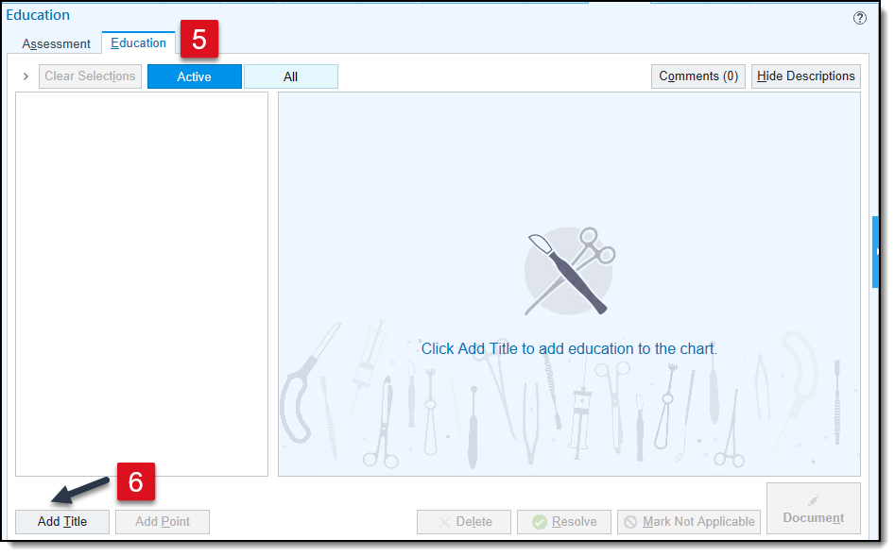

1. Search for **ASP PRE-OP PATIENT EDUCATION**
2. Select all applicable check boxes
3. Click **Accept**
4. Select the Preoperative Instructions checkbox to select all the topics educated
5. Click **Resolve**
6. Enter a **Reason**: Education Complete
7. Click **Resolve**

|  |  |
| --- | --- |
| Image result for stop sign logo | Stop here and wait for instructor directions. |

delays

 **SCENARIO**: Caitlyn’s case was delayed. Her surgeon was in another case.

**TRY IT OUT:**

1. Return to the **Pre-op Log.** Click **Log > Pre-op**

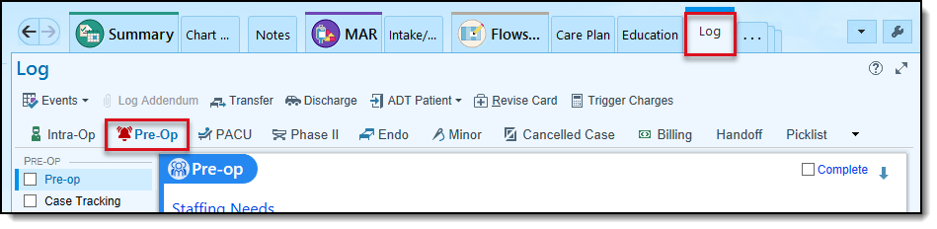

1. Open the **Delay** section.
2. Enter a **Delay Type** of **Surgeon/Physician**
3. Enter a **Delay Reason** of **Surgeon in other case/OR**
4. Enter a **Length** of **20**

PRE-OP ACUITY

 **SCENARIO**: We calculate a Pre-op Acuity score for Caitlyn

**TRY IT OUT:**

1. Open the **Pre-op Acuity** section.
2. Document a few items to calculate Caitlyn’s acuity.

**NOTE: If a case is cancelled in Pre-op, a charge is calculated based on acuity. Leadership can report on acuity for staffing increases, if needed.**

patient ready

 **SCENARIO**: All Pre-op documentation is complete. Caitlyn is ready to go back to the OR.

**TRY IT OUT:**

1. Open the **Case Tracking** section.
2. Document a time of **Now** in the **Patient** **Ready** row.

**NOTE: Document a time for Patient Ready when your documentation is complete and the patient is ready to go to the OR.**

verify

 **SCENARIO**: We sign off on our documentation.

**TRY IT OUT:**

1. Open the **Verify** section.
   * This checks for any documentation that you have not completed. TIP: Use the hyperlink to jump to incomplete sections
2. Click **Verify** as “your RN” button.
3. Enter “logins” as a password and click **OK.**
4. Exit Caitlyn’s chart

**intraprocedure documentation**

finding patients

**PATIENT**:  **Caitlyn**

 **SCENARIO**: Caitlyn’s case is next up in the OR. We open her chat.

**TRY IT OUT:**

1. Click the **Find** button on the Status Board activity toolbar
   * A window appears at the bottom of the screen where you can search for a patient on the Status Board
2. Search for Caitlyn's last name, first name in search field and press **Enter.**

staff

 **SCENARIO**: Prior to the start of the case, we want to add all staff members present.

**TRY IT OUT:**

1. Double-click to open Caitlyn’s chart.
2. Open the **Staff** section
   * This is where you will be documenting all staff working on Caitlyn’s case.
   * Notice the Surgeon’s name is autopopulated from Scheduling
3. In addition to the surgeon, document the following people are in the OR: Circulator and Scrub Person.
4. To add the Circulator, click the **Add Me** button.
5. Confirm a role of **Circulating Nurse** and click **Accept**.
6. To add the Scrub Person, click the **Click to add** hyperlink.
7. Select any available staff member.
8. Document the Circulator and the Scrub arrived now, by clicking the **Now** button in the **Time In** column for each of their rows.

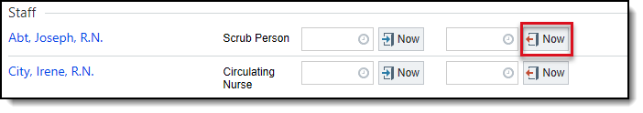

**NOTE - By entering the staff here, you will save yourself time later and let everyone else know who is involved in this case.**

INDEPENDENT PRACTICE #3: visitors

 **SCENARIO**: Tom Jones, a visitor, is here to inspect equipment.

**TRY IT OUT:**

1. In the Staff section, click **Add visitor** button, to the right of the search field.
2. Select a **Type** of Vendor.
3. Document the following:

|  |  |
| --- | --- |
| Field | Information to Enter |
| Visitor Name | **Tom Jones** |
| Comments | **Here to inspect equipment** |

1. Click **Accept.**

**IMPORTANT: Anyone in attendance during the case who is not in the Epic database should be added as a visitor. This includes reps and students.**

|  |  |
| --- | --- |
| Image result for stop sign logo | Stop here and wait for instructor directions. |

counts

 **SCENARIO**: Now that you've documented everyone's arrival time, you'd like to get started with your counts.

**TRY IT OUT:**

1. Open the **Counts** section.
2. Click **Initial.**

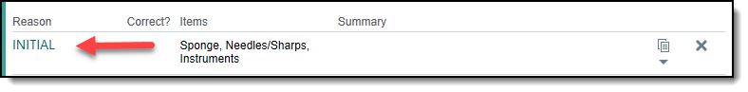

1. Document that you (the RN on your tent card) did the initial count for Sponges, Needles/Sharps and Instruments.
2. Document the scrub person you selected verified the count and it was correct.
3. Click **Accept**.

in or time

 **SCENARIO**: Caitlyn just arrived to the OR. We need to document the time she arrived.

**TRY IT OUT:**

1. Open the **Case Tracking** section.
2. Document an **In OR** time of 3 minutes ago by typing N-3

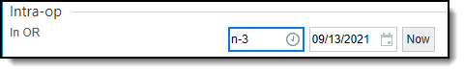

**NOTE – OR Time is calculated by documenting the In OR and Out of OR events.**

timeout

 **SCENARIO**: We perform a Preprocedure Verification timeout.

**TRY IT OUT:**

1. Open the **Timeout** section.
2. Click the **Preprocedure Verification** timeout
3. Click **Yes to all** buttons under **Correct Patient, Correct Site, Correct Procedure** and **Preprocedure Verification** sections.
4. Note that all the staff present participated in the timeout by clicking the **Select All.**
5. Be sure to select **Verified as logged in user** button
6. Enter your password of “logins” and click **OK**.
   * You should see the time stamp appear below the button after selecting verify



INDEPENDENT PRACTICE #4: FIRE SAFETY TIMEOUT

 **SCENARIO**: Document a Fire Safety Timeout

**TRY IT OUT:**

1. Document a **Fire Safety Timeout** in the same manner

|  |  |
| --- | --- |
| Related image | Continue to Independent Practice #5 |

INDEPENDENT PRACTICE #5: PROCEDURE TIMEOUT

 **SCENARIO**: Document a Procedure Timeout

**TRY IT OUT:**

1. Document the **Procedure** Timeout in the same manner.

|  |  |
| --- | --- |
| Image result for stop sign logo | Stop here and wait for instructor directions. |

preop skin

 **SCENARIO**: We assess Caitlyn’s skin.

**TRY IT OUT:**

1. Open the **Pre-op Skin** section.
2. Select a Site of Overall.
3. Document that the **Condition** is **Wrm/Dry/Intact**

positioning

 **SCENARIO**: We confirm Caitlyn was placed in the Supine position.

**TRY IT OUT:**

1. Open the **Positioning** section.
   * This information populates from the Preference Card.
2. Click the Procedure hyperlink to edit the position.
3. Select who was involved in positioning the patient
4. Click **Accept**.

patient prep

 **SCENARIO**: Caitlyn’s skin is prepped.

**TRY IT OUT:**

1. Open the **Patient Prep** section.
2. Document a **Site** of  **Chest**
3. Select a **Scrub Solution** of **Chlorhexidine**

equipment

 **SCENARIO**: We document settings for several pieces of equipment.

**TRY IT OUT:**

1. Open the **Equipment** section
   * This equipment came from the surgeon’s preference card
2. Click **Bovie**
3. In the **Electrosurgery Unit** field, type “Bovie Unit” and press **ENTER**.
4. Select an available unit and click **Accept**.
5. Select a **Pad Location Site** of **Outer Thigh**.
6. Complete the remainder of the form with settings of your choice

supplies

**PATIENT**:  **Caitlyn**

 **SCENARIO**: We document a series of supplies. First, we customize the section.

**TRY IT OUT:**

1. Open the **Supplies** section.
   * These supplies came from the surgeon’s preference card
2. Click the wrench icon and make sure you have the **Mfg#** box checked and click **Accept**

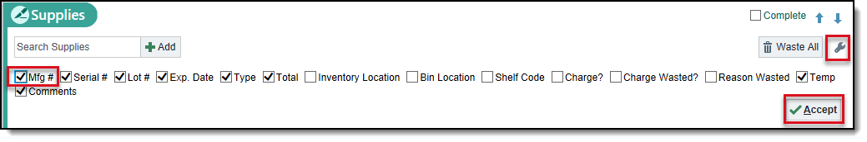

 **SCENARIO**: You dropped the SUT VCL 18IN 2-0 UD TIES BRDCTD and need to document that you wasted it.

**TRY IT OUT:**

1. Hover to the right of the **Wasted** column for the **SUT VCL 18IN 2-0 UD TIES BRDCTD** supply. Click the UP arrow once.
2. Click on the supply hyperlink and enter a **Wasted reason** of “Contaminated”
3. Click **Accept**
4. Document some used and wasted supplies of your choice.

**NOTE: Some wasted items are charged for and some aren't, depending on the reason it was wasted. So it's important to document a wasted reason**

 **SCENARIO**: The surgeon also wants to use a SUTURE VICRYL 0-CTD OCT-1 8-18”.The manufacturer number is VCP740

**TRY IT OUT:**

1. In the **Search Supplies** field type VCP740.
   * Why does this work? VCP740 is manufacture number.
2. Document that you have used 2 SUTURE VICRYL 0-CTD OCT-1 8-18”.

ONE TIME supplies

 **SCENARIO**: In the middle of the procedure, the surgeon pulled out a brand-new suture from the pocket of his scrubs. You need to document this new supply in the patient's chart. The manufacturer number is MCP936H

**TRY IT OUT:**

1. Click in the **Search Supplies** field.
2. Search for this supply in the system using the reference number. Enter MCP936H and press ENTER.
   * No matches were found.
3. Click **One Time Supply**.

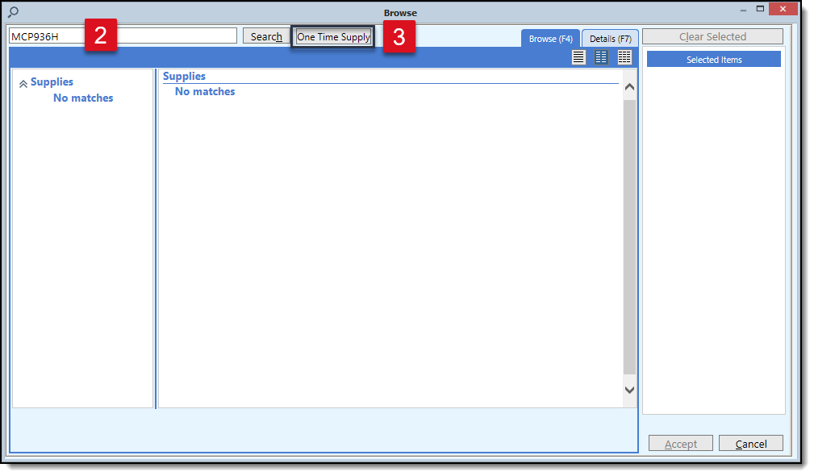

1. Enter a Supply name of “Suture”
2. Enter a **Manufacturer** number of MCP936H
3. Enter a **Manufacturer** of DePuy Synthes
4. Click **Accept.**

implants

 **SCENARIO**: Dr. Sweet implanted some mesh in the patient. The manufacturer number for the mesh is PMII.

**TRY IT OUT:**

1. Open **Implants** section
2. Search for a mesh implant by typing m.PMII in the **Search Implants/Trays** field.
3. Click the **MESH PRLN 6X3IN PP NABSB WVN SFT LF STRL** hyperlink
4. Enter any **Serial** and **Lot** number of your choice
5. Enter an **Expiration Date**: y+5
6. Enter an **Action** of **Implanted**
7. Enter a **Site** of **Chest**
8. Click **Accept.**

ONE TIME IMPLANTS

 **SCENARIO**: This is not clinically relevant; however, let’s pretend Caitlyn received a new tibial baseplate. The Manufacturer number is 5521-B-100

**TRY IT OUT:**

1. Open **Implants** section
2. Search the manufacturer number “5521-B-100”
   * It does not come up
3. Click **One time implant**
4. Fill in **implant name**, **Model / Cat no**, **lot number,** **expiration date**, and **manufacturer** of STRYORTHO
5. Select **Implanted** and fill in the **Site**
6. Click **Accept**

**NOTE: It is important to document as much information as possible so that charging information can be found on the backend. This will also allow the correct implant to be added to the database on the backend.**

intraop meds

 **SCENARIO**: Dr. Sweet used several medications during the case.

**TRY IT OUT:**

1. Open the **Intra-op Meds** section.
   * These came in from the doctor’s preference card.
2. Select the **Administer** button for **OSM - bupivacaine-EPINEPHrine (PF) 0.5%-1:200,000 I**
3. Enter **Given by:** Dr. Sweet
4. Enter the **Dose** of your choice
5. Click **Accept.**

**NOTE: The medications documented here will appear on the MAR for other users to see**

SPECIMENS

**Specimen documentation will remain on paper at Go Live.**

independent practice #6: closing count

 **SCENARIO**: Before the surgeon closes, you need to perform the closing count

**TRY IT OUT:**

1. Navigate to the **Counts** section
2. Select **Closing**
3. Note that the Surg Tech did the count and your Irene nurse verified it and the count was correct

|  |  |
| --- | --- |
| Image result for stop sign logo | Stop here and wait for instructor directions. |

## DRESSINGS

 **SCENARIO**: Several dressings were applied.

**TRY IT OUT:**

1. Open the **Dressings** section.
2. Click the **Chest** button with the green plus sign
   * This came from when you entered Patient Prep
3. In **Dressings Used** field search for **Gauze**.
4. Click **Accept**

nursing diagnosis

**TRY IT OUT:**

1. Open the **Nursing DX** section.
2. Document Nursing Diagnoses and Outcomes of your choice

post0-op skin

 **SCENARIO**: We assess Caitlyn’s skin post-op.

**TRY IT OUT:**

1. Open the **Post-Op Skin** section.
2. Select the **Overall** button.
3. Select a **Condition** of **Warm, Dry, Intact**

**NOTE: This will document an incision for others, such as the PACU nurse to assess and document on**

procedure

 **SCENARIO**: Next, we need to document the incision closure information.

**TRY IT OUT:**

1. Open the **Procedures** section at the top.
2. Click on the hyperlink for **Heart Pain Removal**
3. Enter an **Incision closure** of **Deep and Superficial Layers**
4. Click **Accept**

independent practice #7: final count

 **SCENARIO**: Now you need to complete the final count.

**TRY IT OUT:**

1. Think back to the steps that we took to do the closing count and document the final count on your own. Keep the following in mind:
2. Your Irene nurse does the count and your Scrub Tech verifies the count
3. The count is not correct!
4. Document that the physician was notified, the room was searched, and x-rays were taken at the current time.

|  |  |
| --- | --- |
| Image result for stop sign logo | Stop here and wait for instructor directions. |

out of or time

 **SCENARIO**: Caitlyn is ready to move out of the OR.

**TRY IT OUT:**

1. Open the **Case Tracking** section.
2. Enter a time of **Now** for **Out of OR.**

VERIFY

 **SCENARIO**: We sign-off on our documentation.

**TRY IT OUT:**

1. Open the **Verify** section
   * It looks like you forgot to document the Procedure Start and End Time events.
2. Click the **Case Tracking Events** hyperlink to document these events now.
3. Return to the **Verify** section.
   * Notice, you no longer get a warning about the missing event time.
4. If you still get a warning, hit the **Refresh** button.
5. Click **Verify**
6. Enter your password
7. Exit the Patient Workspace.

**pacu**

arrival

**PATIENT**:  **Finn**

 **SCENARIO**: Finn has arrived to PACU. We document her arrival details.

**TRY IT OUT:**

1. Find your Finn patient on the **Status Board**
2. Right click and Assign her to a PACU bed, then open her chart
3. Open the PACU tab in the Log
4. Document yourself as the Recovery staff
5. Open the **Case Tracking** section.
6. Click **PACU**:  **Now**

**NOTE: PACU Time is calculated from PACU to Meets D/C Criteria.**

acknowledge orders

 **SCENARIO**: We acknowledge Finn’ orders.

**TRY IT OUT:**

1. Go the **Summar**y tab.
2. Acknowledge the anesthesia orders placed by Dr. Charles Boornazian
3. Click the **Acknowledge All** link

vital signs and aldrete score

 **SCENARIO**: We document a set of vitals and an Aldrete Score

**TRY IT OUT:**

1. Click **Periop** Navigator
2. Click **Periop PACU** tab
3. Document a set of Vital Signs
4. Enter a **Sedation Scale Used**: Aldrete PACU
5. Enter values of your choice

independent practice #8: Assessments

 **SCENARIO**: We perform several assessments.

**TRY IT OUT:**

1. Click **Pain**
2. Enter Pain assessment of your choice
3. Click **Head to Toe**
4. Enter assessment of your choice
5. Click **LDA Avatar**
6. Hover over the Wound and PIV to document an assessment.

|  |  |
| --- | --- |
| Related image | Continue to Independent Practice #9 |

independent practice #9: medication administration

 **SCENARIO**: Finn is in pain. We give her some Dilaudid.

**TRY IT OUT:**

1. Open the **MAR**
2. Click a time for **HYDROmorphone (DILAUDID)0.5 mg** injection
3. Click **Continue Administration**
4. Click the **Peripheral IV** button
5. Click **Accept**
6. Document a **Pain Assessment**
7. Click **Accept**

|  |  |
| --- | --- |
| Related image | Continue to Independent Practice #10 |

independent practice #10: intake and output

 **SCENARIO**: We documents Finn’ Intake/Output.

**TRY IT OUT:**

1. Return to the **Periop Navigator**
2. Click **Periop PACU**
3. Click **I/O**
4. Enter volume for LR
5. Update anything else you would like

|  |  |
| --- | --- |
| Image result for stop sign logo | Stop here and wait for instructor directions. |

patient meets d/c criteria

 **SCENARIO**: Finn is ready to be moved out of PACU.

**TRY IT OUT:**

1. Click **Case Tracking**
2. Enter a time for **Meets D/C Criteria**

**NOTE: If the patient was going to a Med/Surg unit you would use the Transfer to Nursing Unit case tracking event**

verify

 **SCENARIO**: We sign off on the record now.

**TRY IT OUT:**

1. Click **Verify**
2. Click **Verify as “your RN” button**
3. Enter logins as a password

**phase ii documentation**

arrival

**PATIENT**:  **Meaghan**

 **SCENARIO**: Meaghan just entered Phase II. You complete her arrival details in the system.

**TRY IT OUT:**

1. Right click Meaghan from the Status Board and Assign her to a Pre/Post bay
2. Open the **Periop Phase II Log**

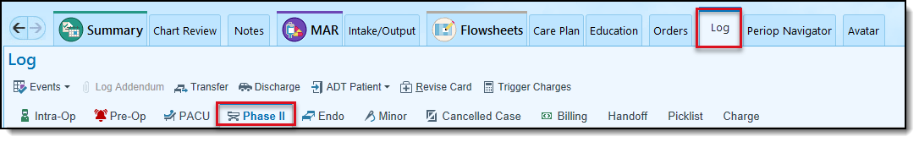

1. Document yourself as the Phase II staff by typing .me in the **Phase II Staff** field.
2. Click **Case Tracking** > **Phase II: Now**

**NOTE: Phasee II Time is calculated from Phase II to D/C from Phase II**

acknowledge orders

 **SCENARIO**: We acknowledge Meaghan’s discharge orders.

**TRY IT OUT:**

1. Go the **Summar**y tab.
2. Acknowledge the orders by clicking the **Acknowledge All** link.

independent practice #11: vitals signs and assessments

 **SCENARIO**: Meaghan is getting ready to go home. You document any last assessments, as well as, return her clothing. You also completed her Plan of Care and documented all goals were met.

**TRY IT OUT:**

1. Click **Periop Navigator**
2. Click **Periop Discharge** tab

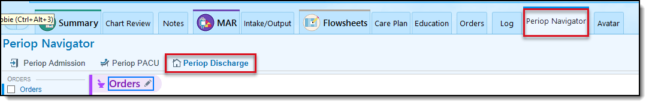

1. Click **Head to Toe**
2. Enter assessment of your choice
3. Click **Plan of Care**
4. Post Procedure Goal: Met
5. Click **Cares/Safety**
6. Update as you would like
7. Click **Belongings**
8. Document **Belongings Sent Home**: Clothing
9. Document **All Belongings Accounted For**: On Discharge

|  |  |
| --- | --- |
| Image result for stop sign logo | Stop here and wait for instructor directions. |

MEDICATION DETAIL

 **SCENARIO**: We need to indicate how Meaghan should take medications when she returns home.

**TRY IT OUT:**

1. Open the **Medication Details** section.
2. Select the boxes in the Medication Detail section to indicate how medications should be taken.
3. Use buttons to instruct patient on when to take different medications
4. Can add comments, include information on last/next dose

follow-up appointment

 **SCENARIO**: Meaghan should follow-up with Dr. Sweet in 2 weeks. We enter this information in the system.

**TRY IT OUT:**

1. Open the **Follow-up** section.
2. Add a Follow-up appointment with the following details:
   * **With:** Dr. Gary Sweet
   * **How**: Go to
   * **When**: 2 Weeks
   * **Why**: For wound re-check

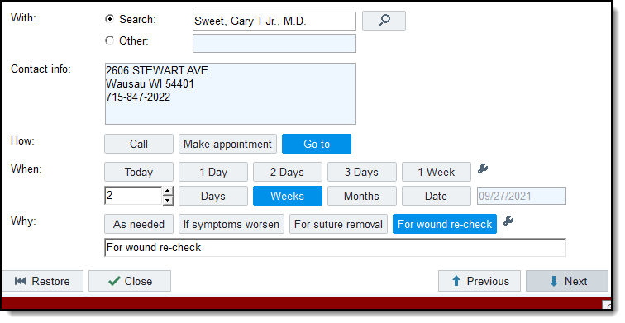

discharge instructions

 **SCENARIO**: We prepare Meaghan’ discharge instructions.

**TRY IT OUT:**

1. Open **Discharge Inst**
2. Click Go to **Referenced/Attachments**

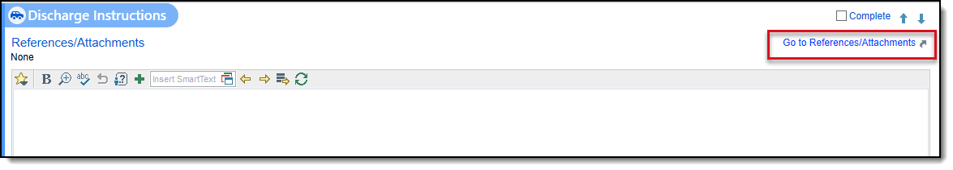

1. Click **Additional Search** tab
2. Search for “lap app”
3. Place a check box next to Laparoscopy Appendectomy Adult Care After Easy-to-Read (ENGLISH)
4. Your selected reference displays for review
5. Exit the section by clicking the X in the upper right.
6. Select **Reviewed** button
7. Go to **Preview AVS**
8. The discharge instruction you selected are in the AVS

**NOTE: This is where you will see Dr’s discharge instructions for the patient, meds ordered for home and that they were sent, follow up appointments. Print and review when ready for discharge and all instructions on real patients**

remove iv

 **SCENARIO**: You removed Meaghan’ IV at the current time.

**TRY IT OUT:**

1. Go to the **LDA Avatar**
2. Hover over the PIV
3. Click **Remove**
4. Enter **Removal Date** and **Time**
5. Open the **Running Infusions** section to make sure there are no running infusions. Navigate to the MAR to stop the LR if it is running using the **Open MAR** button in the upper left corner.

d/c phase ii

 **SCENARIO**: Meaghan is ready to be discharged from Phase II.

**TRY IT OUT:**

1. Navigate to the **Phase II Log**
2. Open the **Case Tracking Events** section.
3. Enter a time for **D/C Phase II**
4. **Verify** your charting

discharge patient

 **SCENARIO**: Meaghan is ready to be discharged.

**TRY IT OUT:**

1. Click **Discharge**
2. Click **Discharge** on the left
3. Enter a **Discharge Date:** T
4. Enter a **Discharge Disposition**: Discharge to Home
5. Enter a **Destination**: Home
6. Click continue through any warnings

**NOTE: It is important to Discharge all patients when they leave the hospital so that new patients can be admitted.**

**IF YOU HAVE TIME: pre-op phone call**

IF YOU HAVE TIME #1: finding pre-op phone call patients

**PATIENT**:  **Jason**

 Jason is scheduled for surgery in two days. You call him to remind him of a few things before surgery.

**TRY IT OUT:**

1. Find the **OR Reports** button on the Status Board
2. Click the **Master Daily Schedule**
3. Scroll and choose the **Inpatient Master Daily Schedule**
4. Set it as **My default** and click **Run**

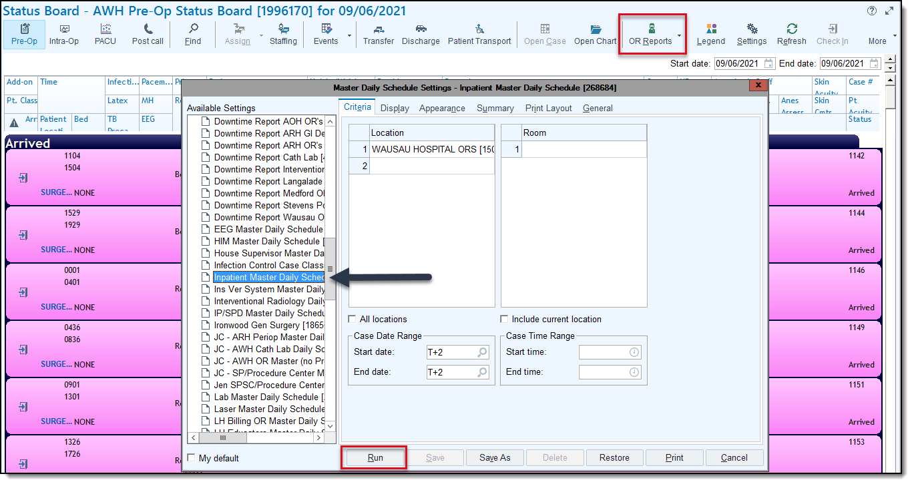

1. Open your Jason patient’s chart

**NOTE: You can click the Patient header to sort alphabetically**

IF YOU HAVE TIME #2: outgoing call

We document an outgoing call.

**TRY IT OUT:**

1. Document an **Outgoing Call**:
   * **Relationship**: Self: Patient name
   * **Phone**: Home #
   * **Comments box**: Patient called and discussed preprocedure education
2. Click **Accept.**

IF YOU HAVE TIME #3: pre call checklist

We confirmed the date of the procedure and arrival time with Jason, as well as, a post-op telephone number.

**TRY IT OUT:**

1. Click **Pre Call Checklist**.
2. Enter a **Date of Procedure**: t+2
3. Enter a **Arrival Time**: 0630
4. Enter a **Height:** 5f8i
5. Enter a **Weight**: 160lb
6. Enter a **Postop Telephone Number**: 715 – 555 - 6347

IF YOU HAVE TIME #4: allergies

Jason tells you he is allergic to Sulfa antibiotics. He gets anaphylaxis

**TRY IT OUT:.**

1. Open the Allergies section.
2. Add Sulfa antibiotics as an allergy.
3. Document a Reaction of Anaphylaxis.
4. Document a Reaction type of Allergy and a Severity of High.

IF YOU HAVE TIME #5: education

We provided Jason with some pre-operative instructions. We document this in the Education section.

**TRY IT OUT:**

1. Select **Education**
2. Under **Assessment**, select **Create New**
3. Fill in that Jason is the Primary Learner, with no Barriers to Learning, his Preferred Language is English, he likes Reading, Discussion and Demonstration, has No experience in Previous Knowledge and that the assessment was answered by him
4. File the new learning assessment
5. Select the **Education** tab
6. Select **Add Title**
7. Search for **ASP Pre-call PARC** patient education
8. Select the Preoperative Instructions, Nausea and Vomiting Management and Surgical Site Infection check boxes
9. Click **Accept**
10. You’ve educated Jason on all these topics during your phone call
11. Select the Check box on Preoperative Instructions (PARC) to choose all the topics educated
12. Click Resolve
13. Choose Education complete and select Resolve

IF YOU HAVE TIME #6: mark call complete

We completed our call with Jason. We mark it complete.

**TRY IT OUT:**

1. Return to the Pre Call Navigator
2. Document Yes in Call Complete? Section and Close the section

**CHECK YOUR WORK**

1. Have the allergies updated in the Storyboard?
2. Can you see your Outgoing calls you documented in Contacts?
3. Congratulations! You’ve completed a Pre Call!
4. Exit Jason’s Chart