Aspirus Hospital Provider Quick Start Guide

Table of Contents

Creating Patient Lists 2

Adding System Lists 3

Chart Review Tabs 4

General Provider Workflow Cheat Sheets 5

SmartTexts for Note Templates 7

Aspirus Order Sets 7

Admission Medication Reconciliation 8

Transfer Order Reconciliation 11

Try It Out 11

You Can Also... 12

Discharge Medication Reconciliation 13

Top Tipsheets 14

Create a SmartPhrase 14

Create a SmartPhrase on the Fly 15

Create a SmartPhrase from a SmartText 15

Save Favorite Orders to Preference List 17

Create Order Panels to Save to Preference List 19

Create Multiple Versions of an Order Set 20

How to Access Citrix from Offsite 21

# Creating Patient Lists

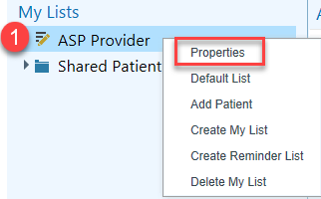Creating your own My List allows you to access your patients’ charts more easily.

#### Try It Out

Your default My List can be personalized and updated in a variety of ways.

1. **Right-click** on the default list and select **Properties**.
2. Update the name of your My List to a title that makes sense to you.
3. Default columns will automatically be added in the **Selected Columns** section.
4. You can add additional columns by using the **Search** field.
5. Click **+Add Column** after you highlighted the option that you like. The newly added columns will be added to the bottom of the Selected Columns list.
6. If you want to rearrange or remove any of the selected columns, use the remove and up/down icons.
7. Click Accept to save your changes.

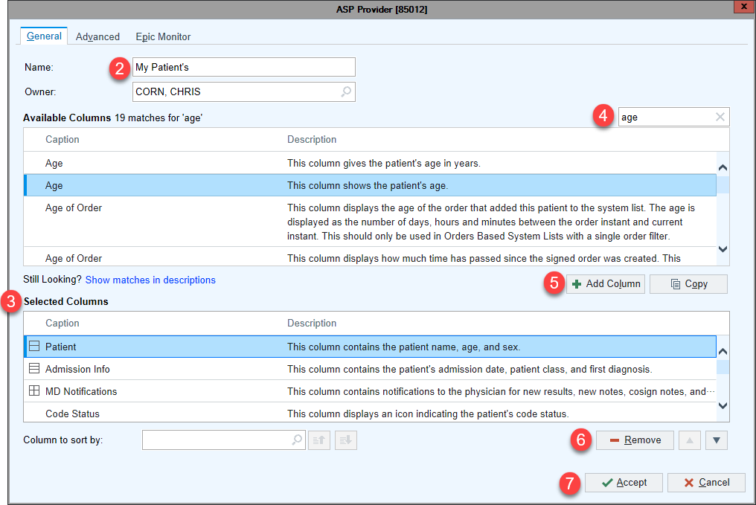

#### Did You Know?

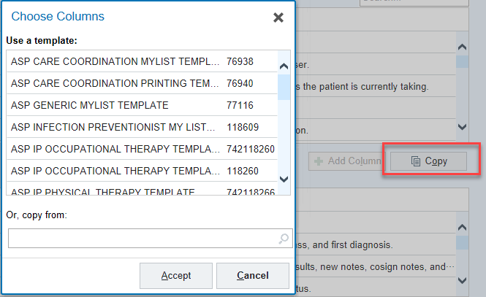The **Copy** button in the My List Properties gives more column template options and is very helpful if you want to start with a basic set of clinical role-based columns. It is also a great tool when you feel like cleaning up your My List, yet don’t want to search for each column individually.

# Adding System Lists

A system list needs to be added to your My List to see patients. Adding the All My Patients list allows you to view which patient’s you have been assigned to.

#### Try It Out

1. In the Available Lists, open **System Lists**.
2. Open **All My Patients**.
3. Right-click the **All My Patients** list, then **Send to** and pick the desired My List. Note: The list may still be titled with the old default name. This is OK, as it takes the system a few minutes to recognize the personalized name.
4. 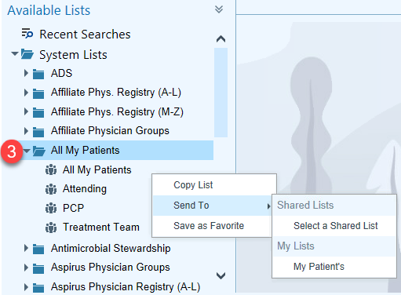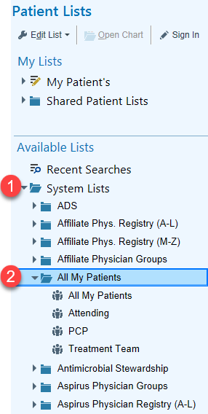In your My List, you will now be able to see the patients that you are assigned to as a member of the treatment team.



*Note: The All My Patients list will display in the My List when it is opened.*

# Chart Review Tabs

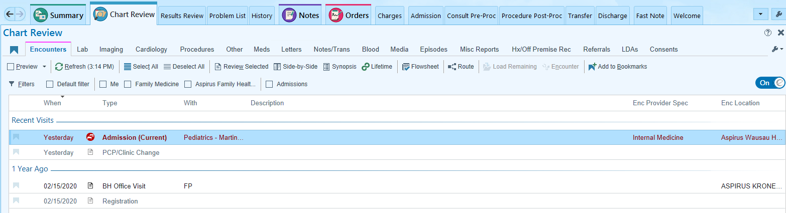

|  |  |
| --- | --- |
| Encounters | All patient encounters. |
| Lab | List of labs including future labs, final resulted labs, and the date/time they were ordered. |
| Imaging | XR, CT, MRI (MR), DEXA, VAS, and US images and studies. |
| Cardiology | EKG, Echos, Stress Test, Holters, and Cath Reports. |
| Procedures | Sleep studies, PFTs, and Biopsies. |
| Other | Discharge instructions, diet orders, DME orders, and consult orders. |
| Meds | A list of the patient’s current and historical medications. |
| Letters | Letters and forms. |
| Notes/Trans | Dictated, transcribed, or typed notes and instructions. |
| Blood | Blood product administrations. |
| Media | Aspirus based scanned documents, annotated images, Plan of Care Snapshots |
| Episodes | Work Comp, Wound, OB, Therapy, and Anti-Coag. |
| Misc. Report | AC Medication List, Code Status, and WH - Immunization Summary. |
| HX/Off Premise Records | Medical records from outside organizations. |
| Referrals | External and internal referrals. |
| LDAs | Lines, Drains & Airways (LDAs). |

# **General Provider Workflow Cheat Sheets**

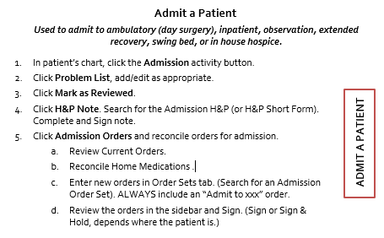

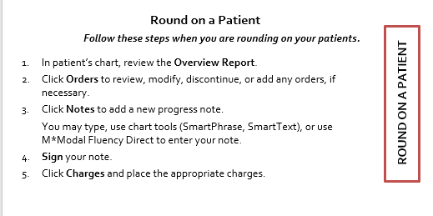

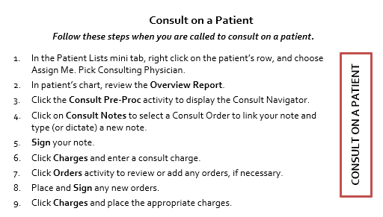

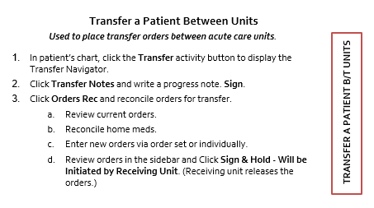

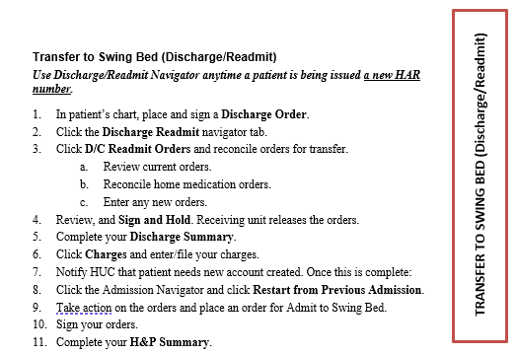

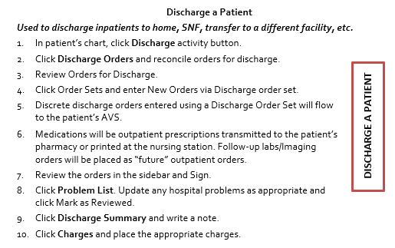SmartTexts for Note Templates

Epic has many SmartTexts available to get you started on your notes. You can search for SmartText anywhere you see this field:



Take a look at some examples below:

* Admission H&P
* H&P Short Form
* Consult General
* Progress Note IP General
* Discharge Summary

# **Aspirus Order Sets**

The order set list below is not a comprehensive list. It only identifies a few common order sets. You can search by keyword to view more available order sets.

**Admission Order Sets -**

Admission Orders

General Pediatric Admission

COPD

Pneumonia

Acute Coronary

ICU

**Discharge Order Set** -

ASPIRUS Discharge Orders

Admission Medication Reconciliation

To maintain a complete and accurate list of medications, it is important to reconcile medications upon admission. Ensuring the patient gets an accurate medication list at discharge begins with accurate Admission Med Rec.

#### Try It Out

1. Within the **Admission Navigator**, open the **Admission Orders** section. The Admission Med Rec will open.
   * The navigator sections guide you through the steps of admission medication reconciliation.
   * The orders sidebar on the right shows you a summary of your ordering decisions and orders that still need reconciliation.



Review Home Medications

1. The first step in Admission Med Rec is **Review Home Medications**. Prescriptions from previous visits and patient-reported medications appear here. To determine if this step has already been completed by nursing, check the **Med List Status** field. If nursing has not completed this step and you would like to complete admission med rec, providers also have access to update the patient’s home medications.
   1. To document the last time the patient took each medication, click a time button (**Today, Yesterday, Unknown,** etc.).
   2. To add a patient-reported medication to the list, look it up in the **New Prior to Admission Med** field. Document the time of the last dose and click **Accept**.
   3. To remove a medication the patient indicates they were **NOT** taking at home from the patient’s home med list, click , enter a reason, and click **Accept**. If nursing is completing this step, they will flag any medications for provider removal.
   4. To add a comment about a medication, click . The comment appears highlighted in yellow.
2. To indicate to other clinicians that the home medications are up to date, select **Provider Complete** in the **Med List Status** field and click  **Mark as Reviewed**.

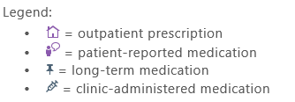

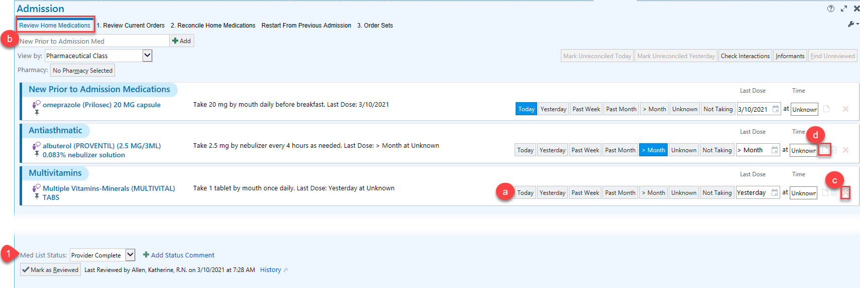

1. Review Current Orders

1. In the Review Current Orders section, determine which orders to continue during admission.
   1. To continue an order as written, click **Continue**.
   2. To discontinue an order, click **Discontinue**.
   3. To continue an order with changes, click **Modify** and edit the order details. Click  **Accept** when finished.
   4. To reorder a completed medication, click **Reorder**.

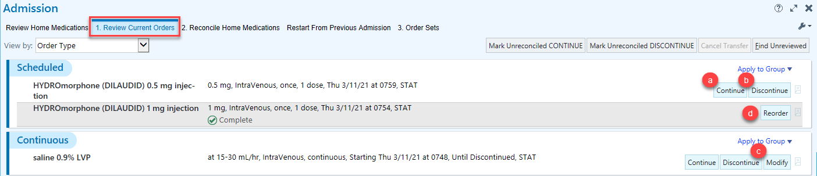

2. Reconcile Home Medications

1. In the Reconcile Home Medications section, determine which home medications to order for the admission. If the patient…
   1. should continue to receive the medication while admitted, Click **Order** (a new inpatient order will be written).
   2. should not receive the medication while admitted, click **Don’t Order** (hold during admission).
   3. should receive an alternative medication, click **Replace** and enter the new medication.
   4. was **not taking** the medication prior to admission, click **Remove**.

\***NOTE**: If the patient’s home med list is updated after the provider has completed the admission med rec, the provider will be alerted and will need to go back and reconcile the updated medication(s).

# 

3. Order Sets

1. In the Order Sets section, search for individual orders and Order Sets in the **Place new admission orders or order sets** field or select a Suggested/Favorite Order Set in the Order Sets section.

Review and Sign

1. In the Orders Sidebar, review all of the ordering decisions.
2. If you need to edit the details of an order, click the order name.
3. Once you have reviewed the orders:
4. Click  **Sign** if the patient is already admitted to the hospital nursing unit.

OR

1. Click  **Sign or Sign & Hold – Will Be Initiated by Receiving Unit** if the patient is not yet on the nursing unit**.** The orders will be released by the nurse on the receiving unit when the patient arrives.

Transfer Order Reconciliation

Reconcile a patient’s current orders, home medications, and place new orders for transfer within the Transfer Navigator. Order Reconciliation is required for level of care transfers within the same facility.

Try It Out

1. From the **Transfer Navigator**, click **Orders Rec**.

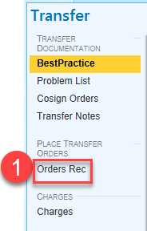

1. From the **Review Current Orders** tab, determine which orders to continue on the unit the patient is being transferred to.
   * To continue an order as written, click **Continue**.
   * To discontinue an order, click **Discontinue**.
   * To continue an order with changes, click **Modify** and edit the order details then click  **Accept**.
   * To take action on all remaining unreconciled orders, use the **Mark Unreconciled CONTINUE** or the **Mark Unreconciled DISCONTINUE** buttons in the header.
2. The **Reconcile Home Medications** tab allows you to review the patient’s home medications.
3. 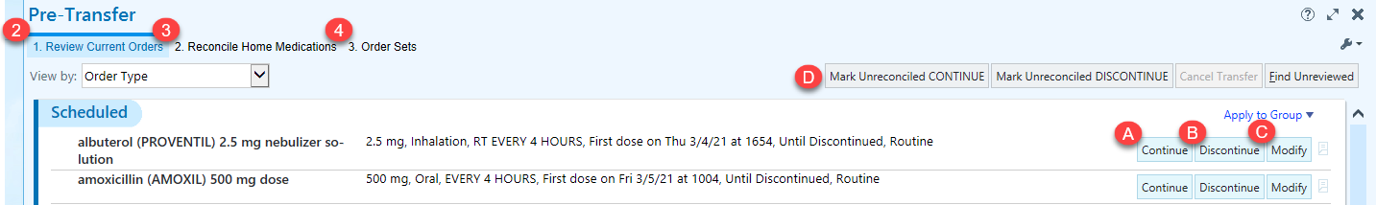Enter any new orders or Order Sets for transfer via the **Order Sets** tab.
4. Click  **Sign & Hold – Will be Initiated by Receiving Unit.**



1. At this point you’ve signed and held your transfer orders for the patient. The orders are not active until they are released by the nurse on the receiving unit when the patient arrives.

You Can Also...

* If you want an order to become active NOW regardless of whether the transfer has happened, use the **Orders** activity.
* If you need to modify one of the orders you just signed and held, you can do so by:
  1. Open the **Orders** activity.
  2. Click the **Signed & Held** tab.
  3. Click **Click Here to Release Signed and Held** **Orders**.

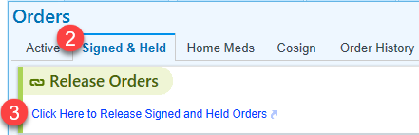

* 1. Under the **Signed & Held Orders – Orders Placed During This Admission** heading, click **New** next to the order you wish to modify.
  2. Click **Modify**.
  3. Edit the order details and click **Accept** when finished.
  4. 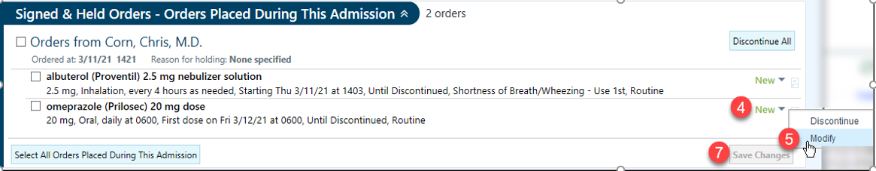Click **Save Changes**.
  5. Select a **Reason for Holding** the order and click  **Accept**.

# **Discharge Medication Reconciliation**

#### Try It Out

1. In the **Review Orders for Discharge** section, home medications appear in the left column, with corresponding inpatient orders in the right column.
2. Use the buttons to take reconciliation actions on the orders:

*  Continue: Instruct the patient to continue taking the medication. *No new prescription is created.*
*  Change: Change details about the medication. *For home meds, this creates a new prescription.*
*  Stop: Instruct the patient to discontinue taking the medication.
*  Prescribe: Create a new prescription from an inpatient order.
*  Don't Prescribe: Don't prescribe an inpatient order.

1. If an inpatient order created from a home medication is identical to the home medication order, it's listed as **Continued for Admission**. If a patient has multiple similar home medications, **Continued for Admission** appears next to the home medication the identical inpatient order was created from. The space next to the other similar home medications is blank.
2. If an inpatient order has differences in dose, route, or frequency from a home medication, the differences are highlighted in yellow. If an inpatient order has different administration instructions from a home medication, both orders appear with no highlighting.
3. 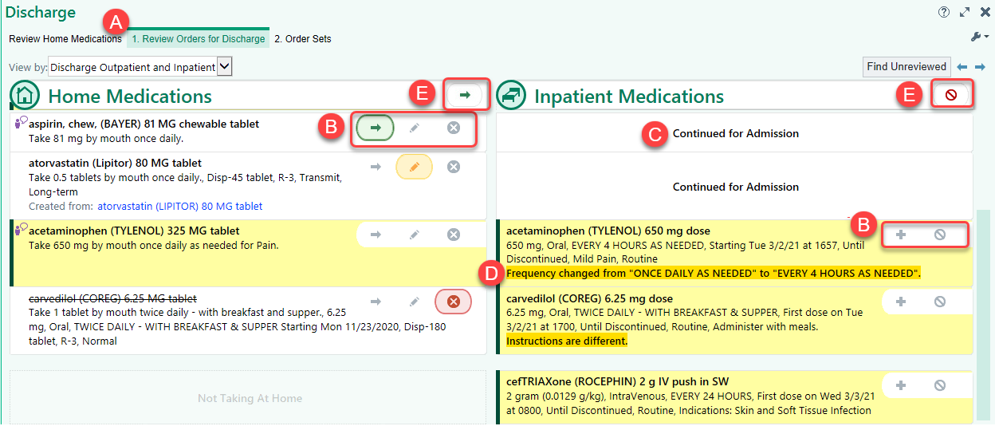To take action on all unreconciled orders in a column, use the **Continue or Don’t Prescribe** buttons in the header.

# Top **Tipsheets**

For a comprehensive list of the most up to date Tipsheets, go to the:

1. Aspirus Intranet 🡪 Work Tools & Resources 🡪 Resources & References 🡪 EMR Info Center 🡪 EMR Tip Sheets
2. If you are in **Epic**, My Dashboards > Provider Home > Provider Learning Home > Tip Sheets > EMR Tip Sheets

### Create a SmartPhrase

If you often type the same phrase or sentence while charting, create a SmartPhrase to save time in the future. A SmartPhrase allows you to insert specific text in notes, letters, In Basket messages, and many comment fields by typing a short abbreviation.

#### Try It Out

1. To create or edit a SmartPhrase, click **Epic**.
2. Click **My SmartPhrases**.

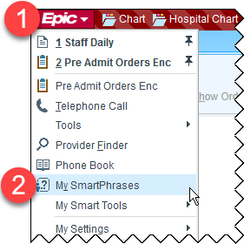

1. To create a SmartPhrase, click **New**.

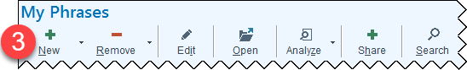

1. In the **Name** field, type a name for your SmartPhrase. This is the name you will type to insert the SmartPhrase in a note. You cannot include spaces or symbols and the name will appear in all caps.

**Note:** It is helpful to name your SmartPhrase by starting with your initials followed by the name of the phrase (example RGSOAP).

1. Type the context of your SmartPhrase.
2. Type a brief description of your SmartPhrase in the **Description** field.
3. **Sharing** – Not only can you create your own SmartPhrases, but you can also share them with your colleagues. You can add people as Users here. You can check the “Can Edit” box to give them editing capabilities.

**Note:** Any edits completed by a User will change it for all.

1. Click **Accept**.

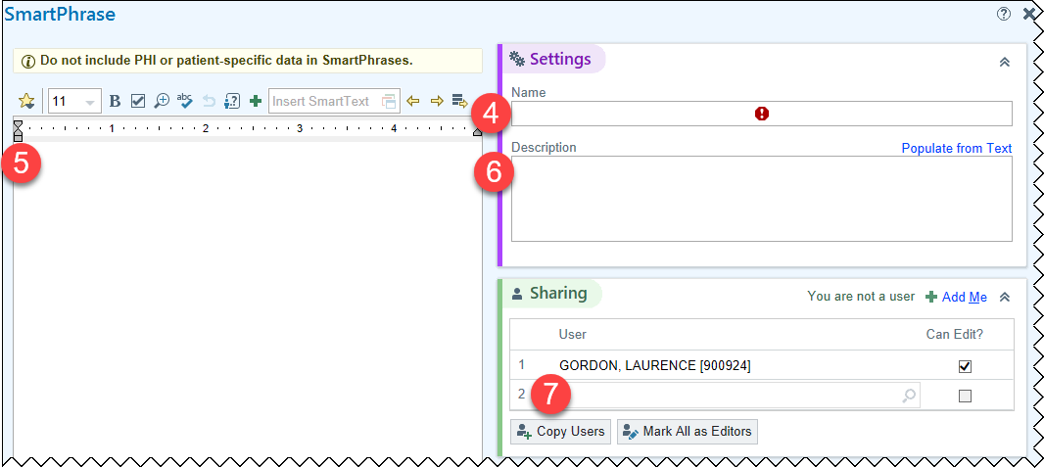

### Create a SmartPhrase on the Fly

1. **Highlight** the text you want to save as a SmartPhrase from your note.
2. Click the **green plus sign** from the SmartTools toolbar.

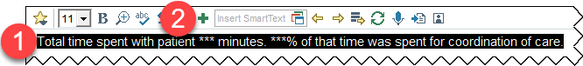

1. Click **Continue** from the SmartPhrase Editor pop-up.
2. In the **Name** field, type a name for your SmartPhrase.
3. Type any additional text in the content sectionif needed.
4. Type a brief description of your SmartPhrase in the **Description** field.
5. Click **Accept**.

**Note:** Please make sure there is not any patient specific information included in the text you are about to save.

### Create a SmartPhrase from a SmartText

1. Click **My SmartPhrases**.
2. Click **New**.
3. In the **Insert SmartText** field type the name of the template.
4. Make any necessary edits to the text in the content section.
5. In the **Name** field, type a name for your SmartPhrase.
6. Type a brief description of your SmartPhrase in the **Description** field.
7. Click **Accept**.

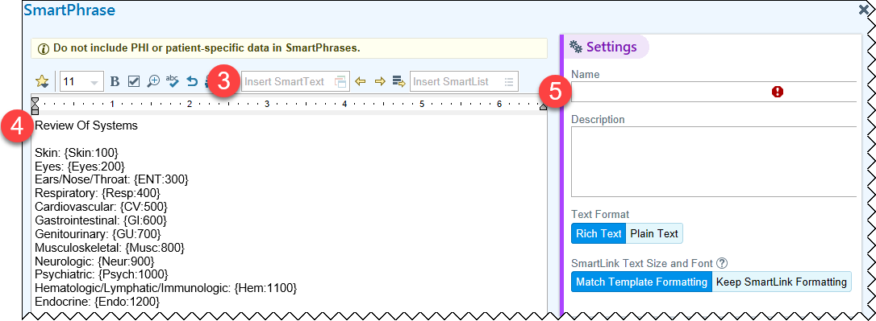

### Save Favorite Orders to Preference List

You can save orders that are difficult to find or that are placed frequently to your preference list for quick access in the future.

#### Try It Out

1. Before the order is signed, hover over the order name to see the star on the right side of your screen.
2. Click the **star**.

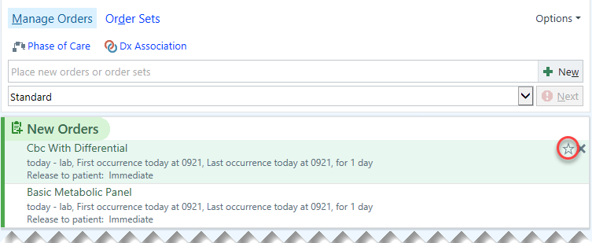

1. You may change the **Display name** to how you would like the order name to appear on your preference list.
2. Address the details of the order according to how you would like the order saved on your preference list.
3. Click **Accept**.

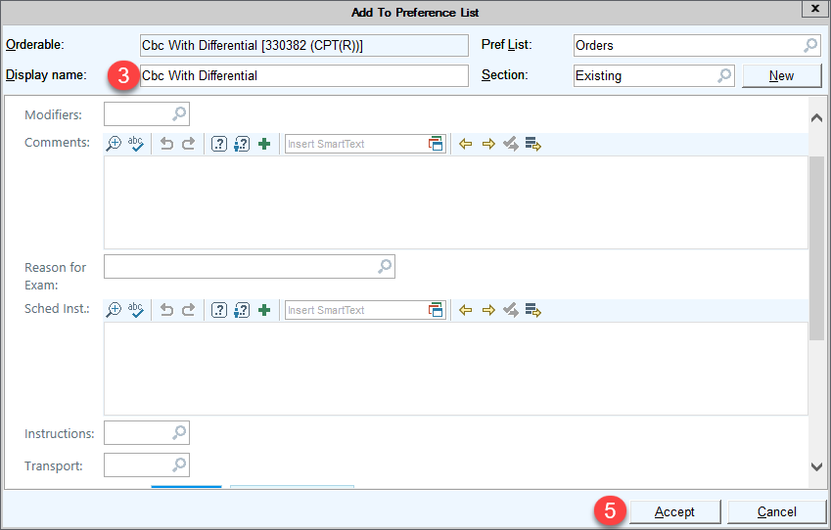

1. A question will appear asking if you wish to Apply order details from preference list entry to current orders?

* **Yes** – the new order details you just entered will replace the current order.
* **No** – the details will stay the same on the current order.

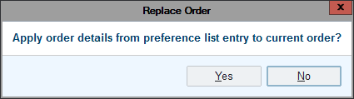

#### You Can Also...

Access your favorite order from your preference list with one click.

1. In the Orders Sidebar, click on the **New** icon.

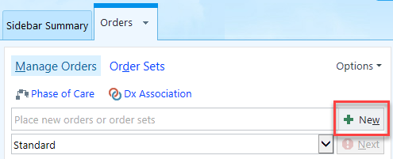

1. 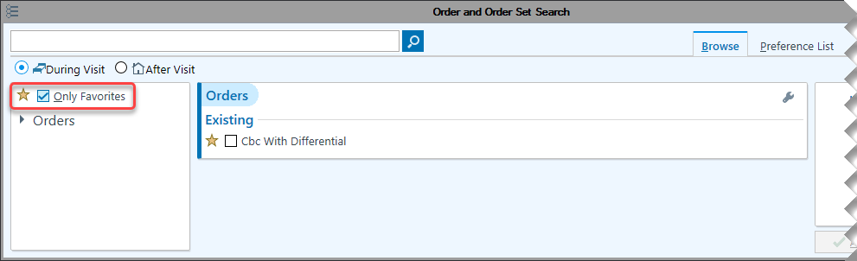In Preference List Browser, make sure **Only Favorites** is checked.

### Create Order Panels to Save to Preference List

You can save multiple orders that are difficult to find or that are placed together frequently to your preference list as an order panel.

#### Try It Out

1. After adding the orders you would like in the **Orders** activity, click **Options**.
2. 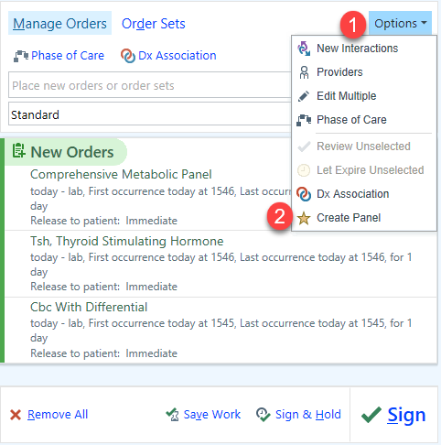Choose **Create Panel**.
3. Enter a **Display name**.
4. Edit order details by clicking the link below the order name.
5. Choose which orders are pre-selected.
6. Click **Accept**.

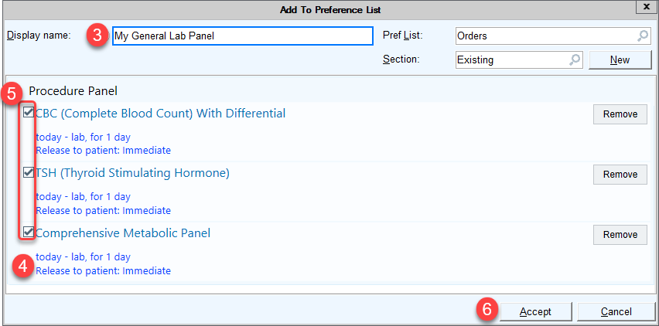

#### Try It Out

Clinicians can remove orders from one of their user order panels but must create a new panel if they want to add orders.

**NOTE:** There are a few limitations on what clinicians can build: user order panels cannot contain a mix of inpatient, outpatient, and clinic-administered medication orders, and they cannot contain other panels.

### Create Multiple Versions of an Order Set

You can now have different Order Sets for variants of the same problem, saving you time when editing orders. For example, you could create specific Order Sets for clinical situations such as MRSA or Pseudomonas. The base order set remains available.

#### Try It Out

1. Open an Order Set.
2. Click **Manage User Versions**.
3. Click **Create a Version Based on This Version**.

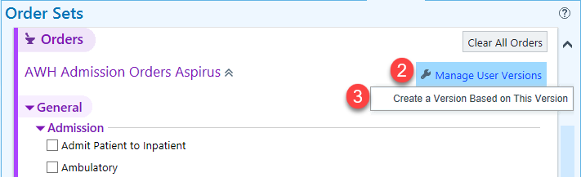

1. In the **Version Name** field, enter a name for your custom Order Set.



1. **Select** the orders you want to include in this version of the Order Set.
2. Make changes to the order details by clicking the **blue text hyperlin**k.



1. Repeat steps 5 & 6 as you are working through the order set.
2. Click **Accept** when all customizations are completed.
3. Repeat the above steps to make an additional User Order Set.
   1. Once you have multiple versions created, they will display under your Favorites.

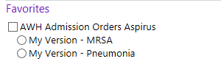

### How to Access Citrix from Offsite

1. **Go to** [http://www.aspirus.org](http://www.aspirus.org/Main/Home.aspx)



1. **Scroll** to the bottom of the screen.
2. Select **Affiliates** link.

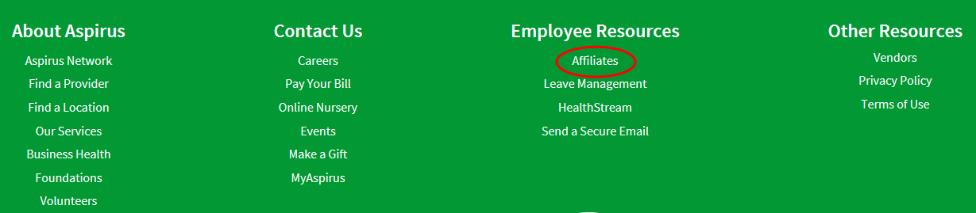

1. **Enter login information** at Citrix screen. This will initiate the Two Factor Authentication process.

