**How to Log Into the Playground Environment**

The Playgournd environment is a place to practice workflows and complete guided practices. It is refreshed daily to allow multiple users to take advantage of this resource. Information you document on will likely not be there the next time you visit the Playground.

Try It Out

1. From the **Aspirus** **Intranet**, hover over **Work** **Tools** **and Resources** and click **Citrix**.

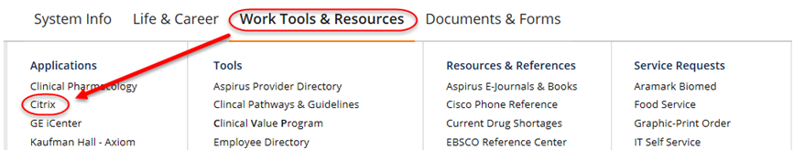

1. Log-in to **Citrix** with your **Aspirus User name** and **Password**.



1. Single click on each of the following folders to find the Playground Environment.

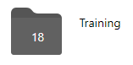

1. Log in using the **User ID** and **Password** from your **Virtual Training Class tent card**.