**Hospital Surgeon Guided Practice**

Table of Contents

**Hospital Surgeon Guided Practice** 1

**Chart Basics** 2

**Review the chart** 2

**Write a Note** 4

**Editing Your Note** 5

**Pre- admit Hospital Orders** 5

5

**Pre-procedure Workflow** 7

**Placing New Orders** 10

**Modifying and Discontinuing Orders** 11

**Consult workflow** 12

**Admission workflow** 12

Problem List 13

Allergies 13

History 13

Admission Orders – Review Home Medications 13

Admission Orders – Review Current Orders 14

Admission Orders – Reconcile Home Medications 14

Admission Orders – New Orders 14

Expected Discharge 15

H&P Note 15

Charges 15

**Transferring a Patient** 16

Order Reconciliation 16

**Discharging a Patient** 16

Discharge Orders – Review Orders for Discharge 16

Discharge Orders – Order Sets 17

Problem List 18

Discharge Summary 18

Enter Charges 18

**Chart Basics**

|  |
| --- |
| **Scenario**  Patient: **Peyton** – admitted yesterday for pneumonia  Because this is the training environment, you will need to create your All My Patients list first.   * + 1. Click the **System Lists** in the Available Lists section.      * + 1. Choose the All My Patients list with the puppy foot next to it and right-click and Send to ASP Providers list.     2. Now you can search for your patient/s as described below. Be sure to **Assign Me** to every patient so they show up on your All My Patients List.   Because this is the training environment, you will have to search for your patients in the patient search bar by choosing **Aspirus Patients in any beds – WH, LH, M...** Make sure you choose the patient with the exact name listed on your Classroom Information Sheet/Tent.     * Focus: Chart Review, Writing Notes, Editing Notes, Deleting Notes |

**Review the chart**

**Open Peyton’s Chart** by double-clicking.

For this patient, **Dismiss the BPAs** at this time. In the real world, you will address any BPAs that appear.

*If you get a Welcome screen, click the X in the upper right to close it.

The **Summary** activity tab provides details about your patient’s current hospitalization. Epic utilizes reports to present patient information to you.

* + Your two default reports are Overview and Index Provider.

The Overview report is detailed information about your patient. You can also review Notes from Clinical Staff.

* + Take a moment and **scroll through this report**.
    - **Explore the Vitals and I&O reports**.
      * Switch the view to see what the graphs and tables look like.

**Click on the Index Provider tab**.

* + The Index Provider report groups reports represented by hyperlinks. Click on a specific hyperlink to review information about your patient.
    - Under the Vitals and Flowsheet Data section, **click on Vitals report**. This report displays historical vitals.

**Click on Chart Review**.

* + If you want to review past AND present information about a patient, use the Chart Review activity.
  + Take a moment to **click through the tabs in Chart Review**.
    - Note how when you single-click on an item, a summary report populates to the right.

**Click Results Review. (NOTE: lab results will not be available in Epic until February 27, 2022. All labs will be on paper in the patient’s chart on the unit. Criticals will be called to the unit/physician.)**

* + The Results Review activity shows a summary of a patient's lab and imaging results organized into groups.
    - This activity defaults to displaying all results. However, if you want to see a specific group of results, just click on that group.
    - If you need to see the Reference Range, hover over the result or click on the Ref Range button in the toolbar.
    - Notice the results are initially bolded. When you have finished reviewing results, you can click on the Time Mark button. This will remove the bolding from your results. The next time you review results, only new results will be bolded.

**Click Problems Activity** for the Problem List.

* + The Problem List allows you to view a patient’s current medical problems, record new medical problems, and document resolved problems.
  + Add a problem here of Pneumonia and fill in all the Meaningful Use* items and Accept.
    - *Meaningful use items are Present on admission and the Principal Problem determined.
  + Click **Mark as Reviewed** to indicate that area of the chart is updated to the best of your knowledge at this time.

**Click History Activity tab.**

* + **Click on each of the sections** to review the patient’s history.
  + **Click Mark as Reviewed for each.**

**Click Notes** **Activity tab.**

* + If you want to review or create Notes for a patient’s current hospitalization, you can do so in the Notes activity.
  + The Notes activity is organized by tabs just like Chart Review. However, the difference is that the Notes activity only focuses on notes. You can review All Notes, or you can focus/filter on a specific type of note, for example, an H&P Note.

**Write a Note**

Click on the **New Note** button.

You need to identify the type of note to create.

* + Click on the **magnifying glass** in the **Type** field in the right pane.
  + Double-click on **Progress Notes**.

To make documenting notes easier, Epic has created SmartTools to assist you.

* + SmartText are created by Aspirus administrators.
  + SmartPhrases are created by Aspirus or you.
  + To search for a generic SmartText, **click in the Insert SmartText field.**
  + Enter **progress note** and press **Enter**. Graphical user interface

    Description automatically generated with low confidence
  + Double-click **Progress Note IP General AWH.**

With your cursor located at the beginning of your note, use the F2 key on your keyboard to complete each SmartTool.

* + **Press F2** to navigate through the note. (Remember, you can also use the small yellow arrows in the note toolbar to navigate through this note.)
  + Type some **Subjective** information of your choice.
  + **Press F2 again**. This next SmartTool is a SmartList which presents a list of choices.
    - A SmartList might have a blue or yellow background. A blue background allows you to pick multiple selections, and yellow background allows for only one selection.
    - This SmartList has a blue background. **Make your selections** by clicking with your left mouse button. When you are done making your selections, press your right mouse button while within the SmartList to insert into your note.
    - **REMEMBER: left-click to pick and right-click to stick.**
  + **F2 to the next list and select a couple of systems** with your left mouse button. Press your right mouse button to insert into your note.
  + You are automatically forwarded to the next SmartList.

The next SmartList has a yellow background. Remember, you are allowed only one selection. On your own, complete the Physical Exam.

**Complete the remainder of the note**.

* + Notice that patient information was automatically pulled into your note. That means SmartLinks are included in this SmartText. SmartLinks are key words that pull in information from the patient’s chart. i.e. Labs, imaging results, etc.

Always **press F2** one more time when you are done to ensure you have completed all the SmartTools. You will see an error message if not all the SmartTools have been completed in the note. Put your cursor at the top of the note and hit F2. It will take you to the ‘missed’ area. You cannot sign the note until all of these are addressed. (Wildcards (***) may also be deleted)

Click on **Sign when complete.**

**Editing Your Note**

**Select your note from the Notes activity**.

Click the **Addendum** button.

Make a change to the note.

Click **Sign.**

**Pre- admit Hospital Orders**

**Scenario:** Jace is in the office and needs to schedule an admission to the hospital for 2 weeks from now.

* Use the magnifying glass to search in

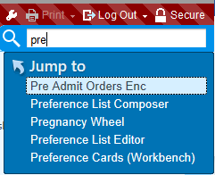

Upper right corner of the Patient List

Screen.

* Click on **Pre Admit Orders Enc**
* Enter Jace patient’s name from Classroom Information Sheet/Tent in the **Patient Lookup** window.
* The navigator opens



* Add or update anything you think needs to be done for the **Allergies, History, Problem List**.
* **Click on Order Sets**
* Enter a preop order set.
  1. Use **AWH Preoperative General Surgery**
  2. **Open** the order set
* Enter **Procedure Details**
* Click the **blue hyperlink**

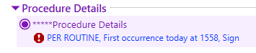

* 1. Free text a **procedure date** **and Procedure details (joint replacement)**
* Enter an Admission order
  1. Select **Admit Patient to InPatient**
  2. Enter a **Reason for Admission** – joint replacement aftercare or any other for your specialty
  3. **Hospital Unit** – Med/Surg Intermediate
* Order a **preop antibiotic** of your choice in the medication section
* Address any red stop signs in the order set – i.e. Pre-op anesthesia guidelines
* Order a **one-off/order** under Ad-hoc Orders (ex. Zofran or Tylenol)
  1. Address any red stop signs then Accept the order
  2. Click the **Phase of Care button and indicate when the orders should be released. (click Preop for all).**



* Click **Sign and Hold Orders**
  1. Enter Sign and Hold reason of **Pre-procedure** and a **Procedure** to associate orders (joint hip)

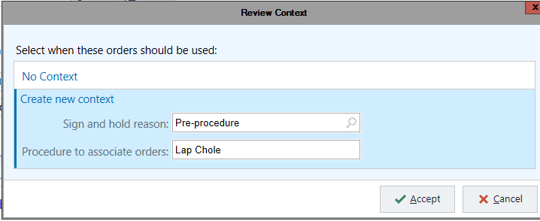

* 1. Your orders are now ready for when the patient presents to Pre-op
* **Exit** the patient’s chart

**Pre-procedure Workflow**

**Scenario**

Patient: **Mavis – abdominal pain presenting to the hospital for her scheduled procedure**

You can pull Mavis from the Status Board as she is already arrived in Pre-op.

1. Open the **Status Board** workspace tab

1. Set your Status Board (if not already set)
   1. Choose AWH* Intraop Status Board (at go-live, you will see your facility listed here)
   2. Click the **My default** check box in the bottom left.
   3. Select **Run**
2. Find and Double-click on **your** Mavis patient’s name from the Tent card to go into her chart.
3. Click on the **Consult – Pre – Proc Activity tab.** (this may open automatically)
4. Review **Problem List, Allergies and History by Marking as Reviewed.**
5. Select **H&P Update**
6. Fill out the Smart text
   1. Place cursor in the writing space and click **F2**
   2. Click “There are no changes that are relevant to the planned course of treatment.”
   3. Press **Enter** and **Accept** your note

*Note if the patient did not have an H&P completed within 30 days create a Short form H&P.

To do this click on H&P Note and enter “short” in the SmartText field and complete the note using F2



1. Select **Orders** Activity
2. Review preop orders

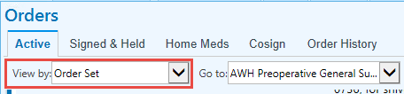

* 1. Sort by order set and

scroll to see AWH

Preoperative General

Surgery orders

1. The patient is ready for their procedure. **Exit** the chart.

**You have now completed the surgery on Mavis**

**Scenario: Complete post op documentation for Mavis**

1. If you closed the chart, open Mavis’s chart from the Status Board as you did above.
2. Select the **Procedure Post-Proc Activity**

**\***You must complete postop orders reconciliation on surgical patients, therefore, choose the appropriate tab for your patient. Review screenshot below:

1. Mavis had an outpatient procedure; she is going home; select the **Discharge Post-Proc** tab
2. Click on Postop note and the defaulted SmartText says **Immediate** at the top**.**

**\***If you are using an Epic template to create your longer procedure note within the same timeframe, you would complete an immediate post op note; only one note is required. Instead, choose **Procedure Notes.**

1. Place your cursor in the note workspace and **F2** to fill out all required sections.

Complete order reconciliation; all sections

1. Open **Orders Rec**
2. Choose which **Review Home Medications** Mavis should resume
   1. Select the **straight green arrow** to indicate a med should be resumed
   2. Choose the **pencil** to edit a med

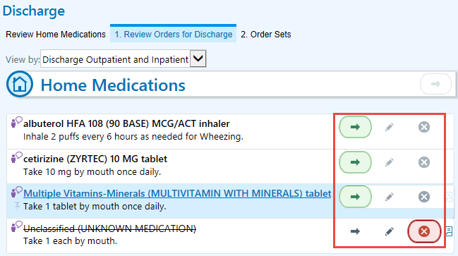

* 1. Click the **X** to stop med

1. Choose which **Inpatient Medications** Mavis should receive

Click the +or **X**

* To quickly discontinue all orders, select the top **X**

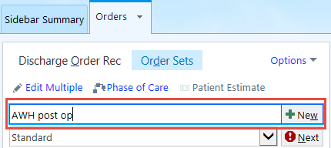

1. Place new orders for discharge
   1. Enter “**AWH post op”**
   2. Click **New**
2. Select a post op order set
   1. ex. **AWH Post op total knee or cataract**
3. Place orders of your choice
4. Orders placed noting ‘Will appear on AVS’(after visit summary) will go directly to the AVS

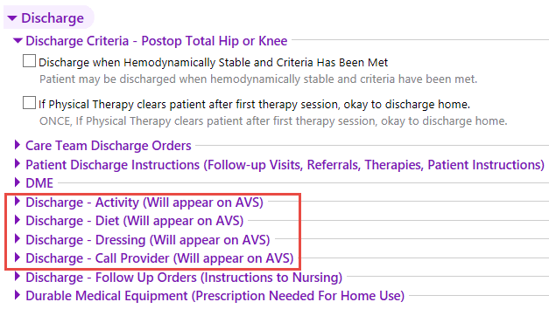

1. Place an **outpatient pain medication**
   1. Enter “**perc**” in the order search field
   2. Choose a medication and fill in any red stop signs (Percocet cannot have any refills)
2. Address any remaining stop signs or yellow yield signs with other orders (ex. Discharge Patient order)
3. **Sign** your orders, associate the diagnosis in the pop-up box, and add a Walgreens pharmacy in the next pop-up box. Close the chart.

|  |
| --- |
| **Scenario**  Patient: **Paul** –Rounding for Paul – add new orders.  Focus: Entering, Modifying, and Discontinuing Orders.  **Add your Paul patient to your All My Patients list and Assign Me**. Be sure to search in the Aspirus patients in all beds. |

**Placing New Orders**

1. **Click Orders button on Paul’s row, or Open Paul’s chart and Click Orders Activity.**
   * Dismiss any BPAs.
2. In the **Place new orders or order sets field,** type **Foley catheter to gravity** or use completion matching by only typing partial words.

1. Press **Enter.**
2. Double-click **Foley catheter to gravity**.
3. Notice that this order has more choices for Frequency. Find a different Frequency by clicking on the magnifying glass.
4. Notice the red stop sign in the Reason field. A red stop sign means that you are required to complete this field.
   * Select **Appropriate Perioperative Care**.
   * Click **Accept.**
5. Time to order a new medication. In the **Place new orders or order sets field,** type **Dilau**.
6. Press **Enter**.

We are looking for the oral Hydromorphone (DILAUDID) order.

* + The order is on our Preference List tab. If it was not, you would click the **Facility List** to check there.

1. Double-click to select the **oral** Hydromorphone (DILAUDID) order.

*Always **review the Route column** to ensure you have the correct route.

1. **Choose your Dose** and **PRN Reason.**
2. Click **Accept.**

Finally, let’s place a consult order.

1. In the **Place new orders or order sets field,** type **card con.**
2. Press **Enter.**
3. **Select Cardiology Consult**.
4. Click on the order in your sidebar to open the Order Composer.
   * Even though there are no red stop signs, it’s important to indicate in this order who you spoke to (provider to provider communication is required for consults) as using this field enhances communication with the nurses and the HUC.
5. Type **Luetmer** in the **To** field.
   * Press **Enter.**
   * **Click on Luetmer, Paul Aspirus Cariology Clinic, Wausau.**
6. Click **Accept.**
7. **Review** each order in your sidebar.
8. NOTE: If you need to delete an order, hover over the order and click the X. To favorite an order, click the white Star and accept the window that pops up.
9. Click **Sign**.

**Modifying and Discontinuing Orders**

**Orders Activity**

Change the patient’s Dilaudid order from 2mg to 4mg.

* + Click on **Orders.**
  + Locate the Dilaudid order.
  + Click **Modify** next to the order.
  + Click **4mg** for the Dose.
  + Click **Accept.**
    - Notice the Modified order is in the Orders sidebar.

Discontinue the Prilosec order.

* + Locate the order.
  + Click **Discontinue** next to the order.
    - Notice the Discontinued order is in the Orders sidebar.

Review the Orders for accuracy and click **Sign.**

* + Notice the orders in the Active tab are now updated.

Close the patient’s chart.

**Consult workflow**

**Scenario:** You are a cardiologist today and need to complete a consult for your **Paul** patient.

* In the **Available Lists** on the Patient Lists home screen, open the **System Lists folder** and choose the **Consults by Specialty** folder and find **Cardiology Consult List**. Open and you should see the Paul patient populated.
* Open Paul’s chart and choose the **Consult – PreProc** activity.
* You can review all the information in the top section, then **click on Consult Notes**.
* In the right panel, **click in the checkbox** next to the order for the consult. This associates your note with the consult and when the note is complete, Paul will fall off the consult list.
* In the **Insert SmartText** look up field, type ‘**consult**’. Choose the first Consult **General AWH note** and **Accept.**
* Navigate through the note using your F2 or yellow arrows and **sign the note**.

**Admission workflow**

* Patient: **Elliot** is in the ED and you are admitting him for appendicitis. Search for his chart in the same way you’ve done previously.

Focus: Using the Admission Activity Navigator.

* **Open Elliot’s chart.**
  + The first time you open an ED patient’s chart*, it opens to the Review Visit navigator. **Scroll through Elliot’s ED visit**.

*For ED patients only, the first time you open a chart, you will need to add the Admission navigator to the Activity bar. You only need to do this once is you star it.

* Click on the tab with the **down arrow** in your activities.
* Hover over **Admission** selection and click the white star to save it.
* Click on **it to open the Admission Navigator.**

## Problem List

* In the navigator, Click **Problem List.**
* In the **Search for new problem** field, type ‘**append’**.
* Press **Enter**.
* Double-click **Acute Appendicitis**.
* Check the box to mark it as the **Principal Problem.**
* **Present on Admission: Yes**
  + To add the diagnosis to the patient’s medical history, click on **Add to Hx**.
* Click **Accept.**
* Click **Mark as Reviewed.**

## Allergies

* Click **Allergies** in the navigator.
* Review the patient’s allergies.
* In the **Add a new agent** box type **Sulfa**.
* Press **Enter**.
* Double-click on **Sulfa Antibiotics**.
* In the **Reactions** box, click on the **magnifying glass**.
* Choose **any reaction**.
* In the **Reaction type** box, click on the **magnifying glass**.
* Choose **Intolerance**.
* Click **Accept.**
* Click **Mark as Reviewed**.

## History

* Click **History**.
* Review the patient history.
* Click **Mark as Reviewed**.
  + If you identify additional history, you can document it in this section.

## Admission Orders – Review Home Medications

* Click on **Admission Orders** in the navigator.

## Admission Orders – Review Current Orders

* Click **1. Review Current Orders**.
* Because Elliot is currently in the ED, review all the ED orders and decide which of these orders to continue to the IP unit. Please note that the orders sidebar states in red, **Review Current Orders is Incomplete**.
* On your own, go through each of the orders and document Continue, Discontinue, Modify or Reorder.
* Once the Status of the orders reflects **Review Current Orders is Complete** in green, you are ready to move on to Step 2.

## Admission Orders – Reconcile Home Medications

* Click **2. Reconcile Home Medications or Next at the bottom of the page.**
  + You must address each medication on the list and decide whether to Order, Don’t Order, Replace or Remove.
* **Albuterol** Nebulizer Solution: Click **Order**
  + **Inhalation**
  + PRN reasons: **Shortness of Breath/Wheezing – Use 1st**
  + **Accept.**
* **Multiple Vitamins-Minerals**: Click **Don’t Order**
* The next tab over is Restart from Previous Admission. Here, you have the opportunity to reorder meds from the patient’s previous admission. You are not required to reconcile these orders. They are only here for your convenience to choose if desired. Move past this tab.

## Admission Orders – New Orders

* Click **3. Order Sets**.
* In the **Place new admission orders** field, type **admission** and press **Enter**.
* Scroll down and double-click on **AWH Admission Orders.**
* In the General section, select **Admit Patient to Inpatient**.
  + Enter the Reason for Admission/Hospital Problem.
    - Search for **Appendicitis**.
    - Select the unit the patient is going to. Click **Med/Surg Intermediate Care**.
    - Select whether the patient should be sent to an overflow unit.
    - Click **Accept**.
* Taking into consideration that the patient is being admitted with Appendicitis, select more orders for this patient. Remember to fill in information when you see a red stop sign.
* At the bottom of every order set is an **Ad-hoc Orders** section. This is where you enter additional orders that are not listed in the order set.
  + Click on Ad-hoc Orders and **enter an order of your choice**. (Tylenol or other med)
* When you have the orders you need, click **Sign & Hold – Will be initiated by Receiving Unit.**
  + Once the patient transfers to that unit, the nurse will release the orders.

## Expected Discharge

* In the navigator, Click on **Expected Discharge**.
* Expected Discharge Date: **t+3** (or use the calendar icon)
* Expected Discharge Time: **Morning**
* Discharge Location & Destination: **Home**

## H&P Note

* Click **H&P Note**.
* Click in **Insert SmartText field**.
* **Type H&P**.
* Press **Enter**.
* Double-click on **Admission H&P**.
* Complete the H&P using F2 or yellow arrows on the toolbar to complete the note.
* When completed, click **Sign**.

## Charges

* Click **Charges**.
* Click **Inpt Admits.**
* Select **Initial Hospital Care Level 2**.
* Scroll down and click **Accept Charges**. If you are presented with a pop-up for diagnosis association, checkmark the appropriate one.
  + TIP: If you ever need to delete a charge, click the X on the right end of the row.

**You have completed the admission workflow. Congratulations!**

**Transferring a Patient**

|  |
| --- |
| Scenario   * Patient: **Edward,** transferring from ED to floor * Focus: Using the Transfer Navigator. |

## Order Reconciliation

* **Search for then Open Edward’s chart**.
* Click **Transfer** navigator.
* Click on **Orders Rec** section.
* Work through Order Reconciliation just like you did for the Admission process.
  + 1. Review Current Orders
  + 2. Reconcile Home Meds
  + 3. Order Sets (use the AWH Rounding Order Set) or add orders as appropriate outside of the order set. The transfer order is in the sidebar automatically to complete.
  + Sign all orders and close the chart.

**Transfer is complete!**

**Discharging a Patient**

|  |
| --- |
| Scenario   * Patient: **Peyton** * Focus: Using the Discharge Navigator. |

## Discharge Orders – Review Orders for Discharge

* **Open your Peyton patient.**
* Click **Discharge Activity**.
* In the Discharge Navigator, Click **Discharge Orders**.
* Step 1: Review Orders for Discharge
  + For this step, review what home medications the patient should resume and which inpatient medications should be prescribed.
* For Peyton’s **Home Medications**, click **Don’t Prescribe** the **Albuterol** and **Cetirizine**.
* **Click the arrow to Continue** the remainder of his **Home Medications**.
  + This automatically discontinues the associated inpatient orders so duplications don’t occur.
* For his **Inpatient Medications**, select the plus sign to **Prescribe the Codeine-Acetaminophen** order.
* For the remainder of the orders, click **Don’t Prescribe.**

## Discharge Orders – Order Sets

* Click **2. Order Sets**.
  + Enter the patient’s discharge orders. Please note that the Discharge Patient order is already defaulted in the sidebar. Complete the required/recommended information in the order.
* Notice the **Aspirus Discharge Orders** order set is already defaulted for you also under **Order Sets > suggestions**.
* Click **Open Order Sets**.
* Under the Discharge section, click **Discharge – Activity**.
* Select **Normal activity as tolerated**.
* Select **Do Not Drive while taking pain medication**.
* Open each section and place some orders.
* The last step is to review all of the discharge orders and Sign them.
  + Click **Sign-Print and/or E-prescribe Now.**
* If you see the Associate Diagnosis box, associate the order with the appropriate diagnosis and Accept.
* Click **the appropriate diagnosis** column heading.
* Click **Accept**.
* The **Pharmacy Search** box appears next. Since no one added a pharmacy to this patient’s chart, the system recognizes that there is no pharmacy for e-prescribing. Customarily, the nurse will document the patient’s pharmacy of preference during their admission process. However, the patient may request their prescriptions transmit to a different pharmacy.
  + - In the **Name** field, enter **Walgreens**.
    - Select any Walgreens that appears.
    - Click **Accept twice.**

## Problem List

* Back on the navigator, Click **Problem List.**
* **Resolve** Hypoxia.

## Discharge Summary

* Click **Discharge Summary**.
* Type **Discharge** in the SmartText search box, and press Enter.
* Double-click **Discharge Summary**.
  + Press [F2] key or yellow arrows to navigate through the note.
  + Remember: “Left to pick, right to stick!” (you can also double-click to stick)
* **Sign.**

## Enter Charges

* Click **Charges**.
* Click the **Inpt** **Discharge** heading.
* Click **Hospital Discharge Day More Than 30 Minutes.**
* Click **Accept Charges**.
* Close chart.

You have completed the Discharge Workflow!