Ambulatory Nurse Training Companion

# Navigating the Schedule

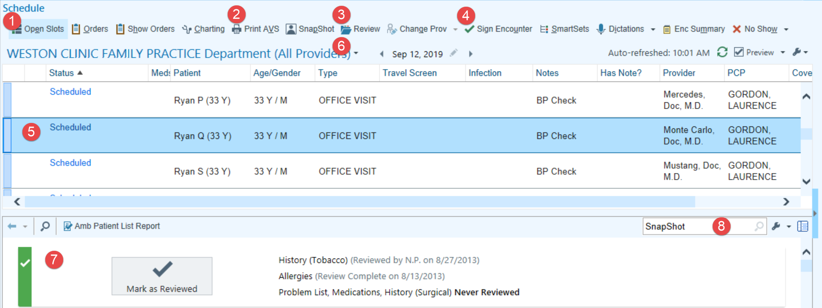

|  |
| --- |
| 1. Used to see where you have openings in your schedule. |
| 1. Can be used to quickly print a patient’s After Visit Summary (AVS). |
| 1. Allows us to review a patient’s record before they have arrived. |
| 1. This allows you to finalize the documentation for the visit once everything necessary has been charted. |
| 1. To open a visit from your schedule, double-click the appointment. You can tell when a patient has been checked in because the status changes to Arrived. |
| 1. To see a schedule in a different department and your personalized schedules, Click  to the right of the department's name, enter the name of the department in the **Dept** field. Click  to the left of his department's folder under the drop down and select the name of the provider whose schedule you would like to see. |
| 1. The SnapShot report provides a little bit of information about a patient before their chart is open. |
| 1. The wrench is used to add additional schedule reports. |

# Personalize Your Schedule

Personalize your schedule to see the patient information you find most useful. Consider adding or removing columns and changing the order in which they appear to suit your personal preferences.

1. Open the Schedule activity and Click  to the left of his department's **name**
2. Click  above the folder list to personalize your schedule.
   1. To reorder your columns, select one in the Selected Columns list and click  or  to move it.
   2. To add a column, select it from the Available Columns list and click  to include it in your schedule.
   3. To remove a column, select it from the Selected Columns list and click .
3. Click Accept when finished.

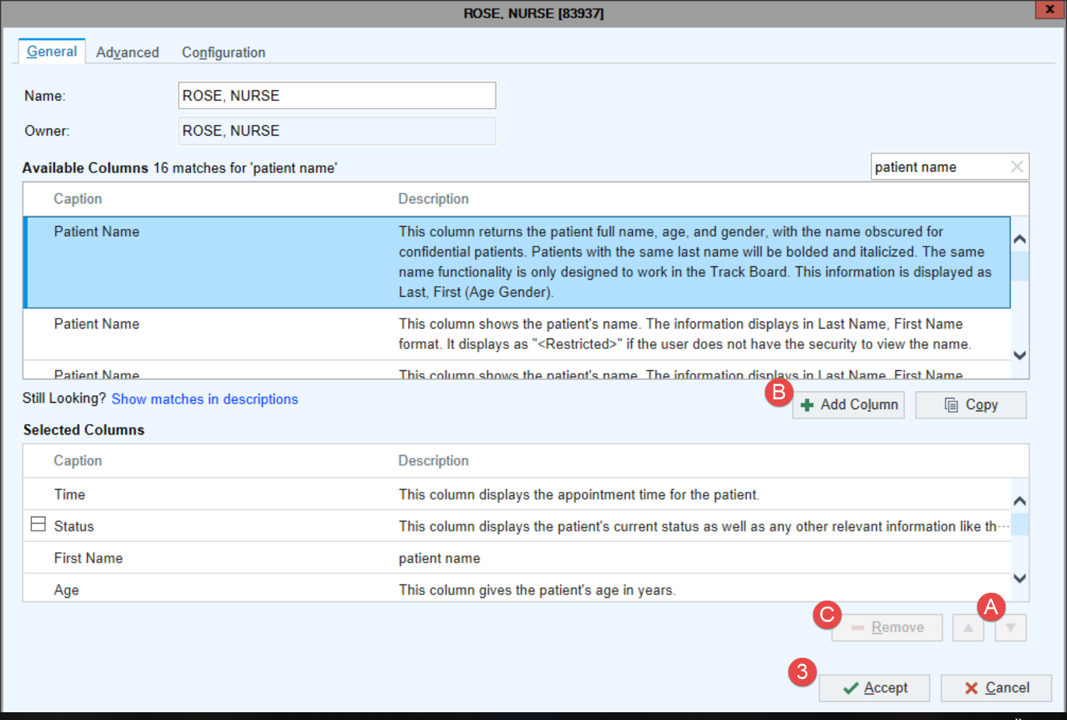

# Chart Review Tabs

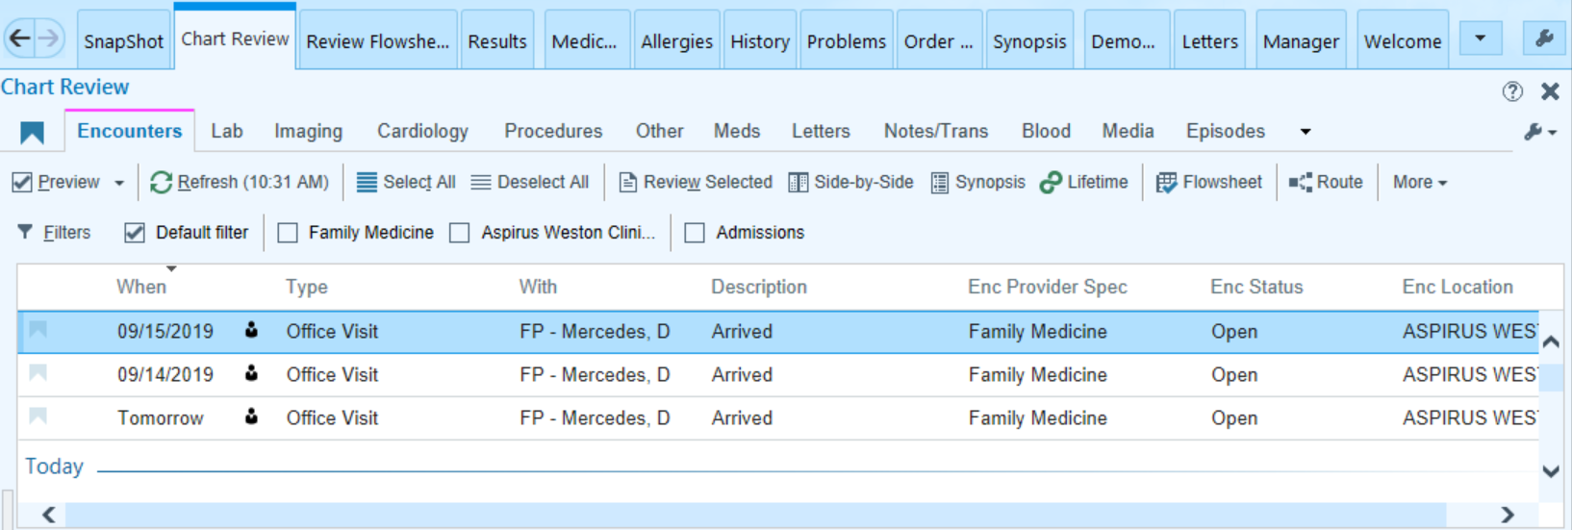

|  |  |
| --- | --- |
|  |  |
| Encounters | All patient encounters. |
| Lab | List of labs including future labs, final resulted labs, and the date/time they were ordered. |
| Imaging | XR, CT, MRI (MR), DEXA, VAS, and US images and studies. |
| Cardiology | EKG, Echos, Stress Test, Holters, and Cath Reports. |
| Procedures | Sleep studies, PFTs, and Biopsies. |
| Other | Discharge instructions, diet orders, DME orders, and consult orders. |
| Meds | A list of the patient’s current and historical medications. |
| Letters | Letters and forms. |
| Notes/Trans | Dictated, transcribed, or typed notes and instructions. |
| Blood | Blood product administrations. |
| Media | Aspirus based scanned documents and annotated images. |
| Episodes | Work Comp, Wound, OB, Therapy, and Anti-Coag. |
| Misc Report | AC Medication List, Code Status, and WH - Immunization Summary. |
| HX/Off Premise Records | Medical records from outside organizations. |
| Referrals | External and internal referrals. |
| LDAs | Lines, Drains & Airways (LDAs). |

# Rooming Navigator



|  |  |
| --- | --- |
| Connect | Connect to the patient in video visits |
| Verify Rx Benefits | A nightly process checks and displays any coverages and prescription benefits. If there are multiple coverages, check with the patient regarding which coverage is active. If the patient was an add-on appointment you must run the query manually. |
| Visit Info | Used to document the chief complaint(s). Comment field allows for free text. |
| Vital Signs | Document vitals, pain score, OB/Gyn status, and tobacco use. |
| Patient Reported Vitals | Allows for Externally documented vital signs |
| PEG Pain Screening Tool | Expanding on pain score, when pain is present at visit. |
| Hearing/Vision | Document the results of hearing or vision screening. |
| Enc Documents | HIPAA forms, Advanced Directives, and After Visit Summaries or a few other documents scanned in for this visit. |
| Allergies | Medication, environmental, or food allergies. |
| Medications | Used for medication review. Allows for documentation of Taking, Taking Differently, or Not Taking. |
| Goals | Patient goals are managed and updated by PCMH coordinators at Aspirus. Many of these goals are diet and lifestyle goals that can be tracked overtime. |
| Nursing Notes | Free text area where nursing staff documents information related to the current visit. |
| Care Everywhere | If a patient has visited a non-Aspirus clinic or facility that is also on Epic, Care Everywhere informs us of Outside Records that can be imported into the Aspirus Enterprise and incorporated into the patient’s chart. |

# Screening Navigator

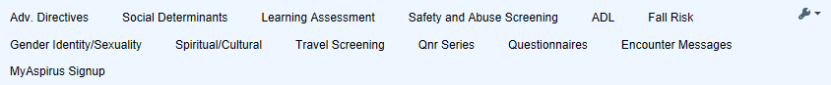

|  |  |
| --- | --- |
| Adv. Directives | This area allows for documentation regarding whether the patient has an advanced directive on file or is interested in filling one out. |
| Social Determinants | Provides a more complete patient story for patients who are at risk of negative health outcomes. |
| Learning Assessment | Preferred method and barriers of learning. |
| Safety and Abuse Screening | Documenting safety and concerns at home. UP staff will see information under Community Resource section. |
| ADL | Assessing the ability of the patient to complete activities of daily living. |
| Fall Risk | Assesses if the patient has fallen in the past 12 months. Will only be able to document if the patient is > 65 years old. |
| Gender Identity/Sexuality | Identifies the patient’s preference for gender identity and sexuality. |
| Spiritual/Cultural | Document spiritual/cultural practices that effect care |
| Travel Screen | Only appears if the patient has traveled outside of the U.S. in the last 30 days as documented by registration staff. |
| Qnr Series and Questionnaires | Pre-completed patient questionnaire information will populate here. |
| Encounter Messages | Routing history of that encounter. |
| MyChart Sign-up | Used to enroll the patient for MyAspirus while in the exam room. |

# How to Add a Pharmacy

In the Medications section within the Rooming activity, if the patient has a preferred pharmacy, it appears at the top of the section.

C:\Users\u10494\AppData\Local\Temp\SNAGHTML2c66ed.PNGIf you need to change or add a pharmacy, follow these steps:

1. Click “**Select the patient’s pharmacy**.”
2. The Suggested tab of the Pharmacy Search window includes a list of pharmacies the patient prefers and has recently used. Select one and click Accept.
   * Click  to add a pharmacy to the preferred list. Click C:\Users\u10494\AppData\Local\Temp\SNAGHTML2b929e.PNG to remove a pharmacy from the preferred list.
3. If necessary, you can search for another pharmacy in the **Name** field.
4. The **Patient and clinic’s nearby** ZIP Codes check box is defaulted. To expand your search uncheck this box.
   * 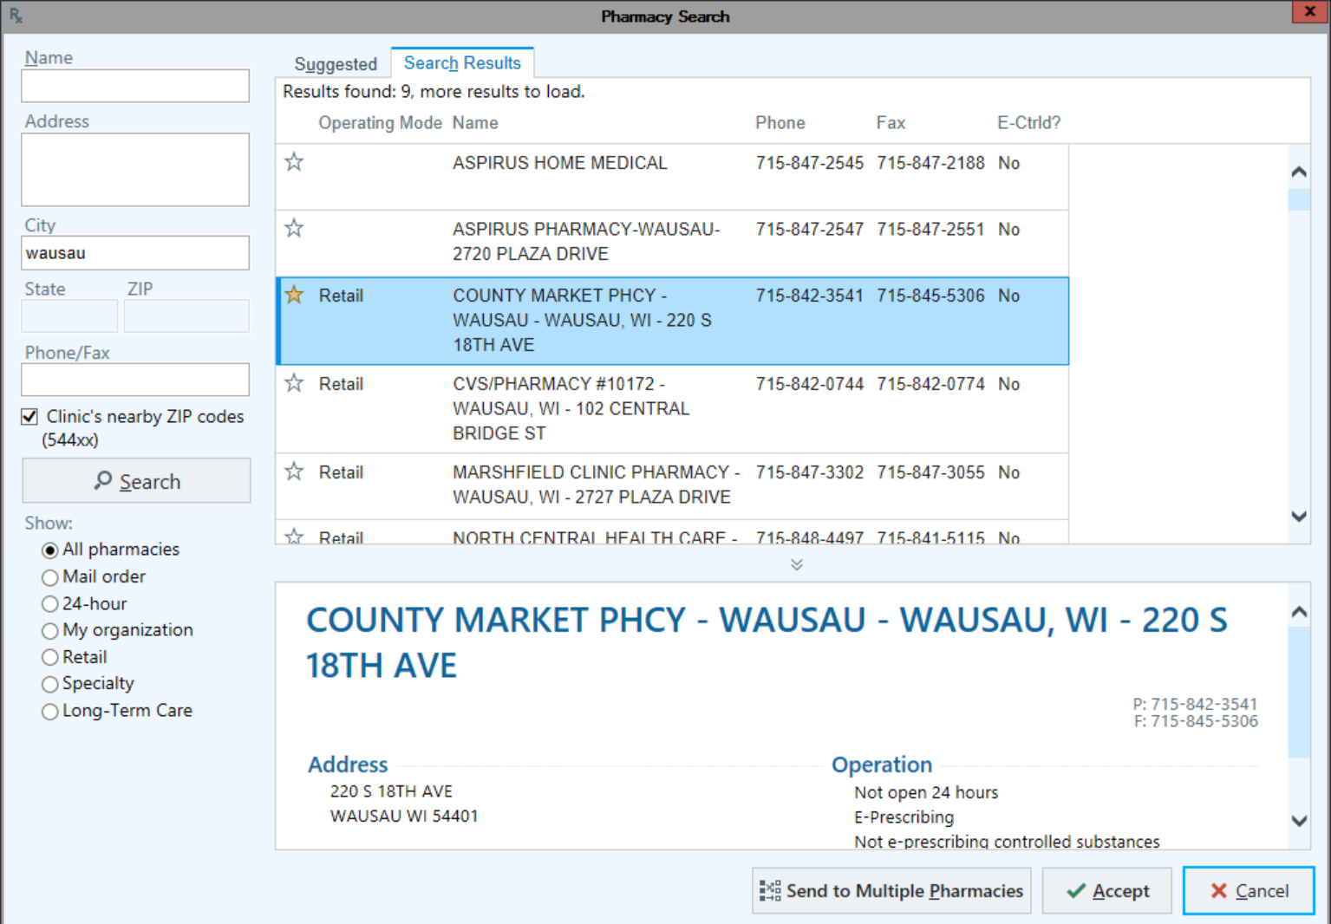When trying to find a pharmacy type in the first few letters of the pharmacy, and the first few letters of the city name

# Verify a Patient’s Pharmacy Benefits

The patient's coverage determines which drugs are on the formulary.

1. Open the Verify Rx Benefits section.
2. 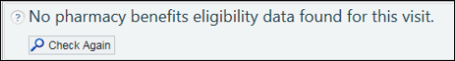A nightly process checks and displays any coverages and prescription benefits. If there are multiple coverages, check with the patient regarding which coverage is active. If the patient was an add-on appointment you must run the query manually. In this case, click  Check Again to get the patient's benefit information.
3. 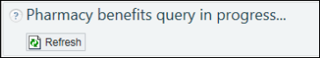To see the results from the query press **Refresh.**
4. If more than one coverage appears, select one by clicking  Use As Primary Coverage.
5. 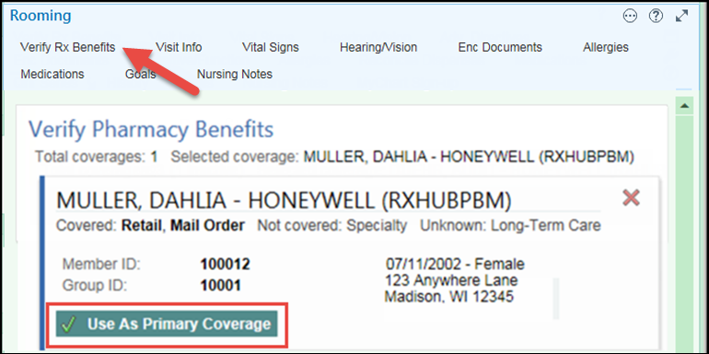Click  if you need to remove a coverage that does not apply.
6. Close this section in order to query correctly.

# **SmartTools**

**SmartTools help you to quickly document information. There are four types of SmartTools:**

|  |  |
| --- | --- |
| SmartTools Toolbar | * You can use SmartTools in places such as notes, patient instructions, and letters. * If you see these buttons, the field is SmartTool-enabled |
| SmartText | * Templates or blocks of text used for writing a note * Created for you by Clinical Informatics Reps * Use the **Insert SmartText** field to find a SmartText |
| SmartPhrase | * Sentences, phrases, or paragraphs * Can be user created or system created * Type: .*name of phrase* to populate into the note |
| SmartLink | * Information linked from within the patient’s chart * Type: .*name of phrase* to populate into the note |
| SmartList | * Predefined list of choices * Designated by braces { } * To activate Press F2   + Blue: multiple choices   + Yellow: single choice * Left click to pick; Right click to stick   + Stay within the box when clicking |

## Additional SmartTools Terminology and Tricks

|  |  |
| --- | --- |
| Wildcard | * *** = wildcard * A placeholder reminding you to document something. * To address press F2 and start typing to replace the *** with your free text. |
| F2 | * The Key used on your keyboard to move to the next SmartList or Wildcard. |

# Create Your Own SmartPhrase

If you often type the same sentences, phrases, or paragraphs while charting, turn them into your own SmartPhrase.

1. In a SmartTool-enabled field, type the text you want to save as a SmartPhrase. Don't include any patient-specific information.
2. Highlight the text.
3. Click . The SmartPhrase Editor opens with your text in the Content tab.
4. Make any necessary edits.
5. Enter a short, intuitive name for your SmartPhrase in the Name field. This is the abbreviation you'll use to use the phrase.
6. Enter a summary of your SmartPhrase in the Short Description field.
7. Click Accept. The SmartPhrase is now available for use.

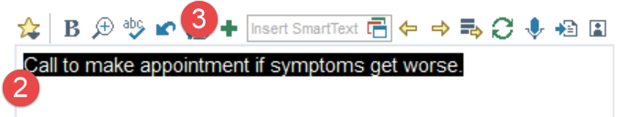

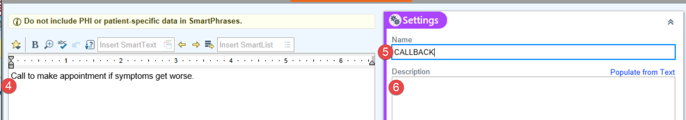

# See a list of all SmartPhrases and SmartLinks

1. When you are writing a note click  to open the SmartLink/Phrase Butler.
   * Any SmartPhrases you've created will appear at the bottom of this window.
2. Use the **Filter** tab to select the SmartTools you want to see. For example check the box next to System SmartPhrase to see all available phrases.
3. Type a word in the search field and press Enter.
   * icon indicates a SmartPhrase and icon indicates a SmartLink.
4. Click  to mark links and phrases as favorites.
5. Double-click a SmartPhrase or SmartLink or click Add and Close to insert.

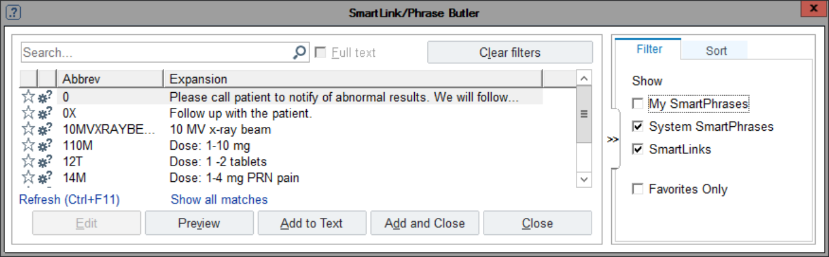

# Send a Letter to a Patient or Another Clinician

1. In the Wrap-Up activity, open the Communication Management section and click  New Communication.
2. Choose recipients for your letter by clicking the recipient buttons available.

* Search for another clinician using the  Add field.
* Icons next to the recipients' names indicate whether they'll receive the letter via In Basket, mail, or fax, or MyAspirus. Click patient’s name to change the routing method.

1. Select a letter template by clicking a button in the Letter section. If you don't see the template you're looking for, click Other to choose from a list of available templates.

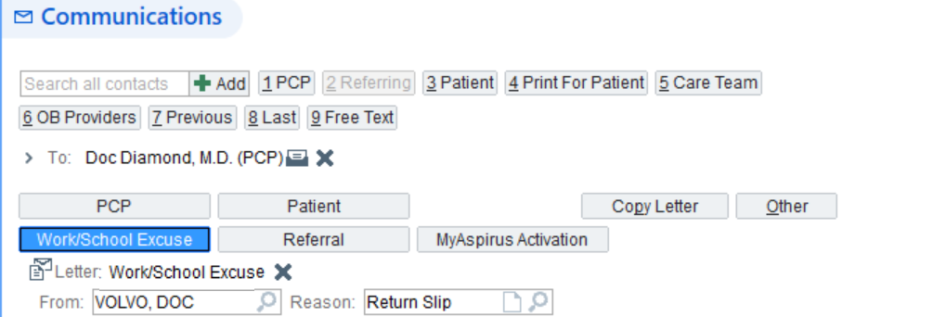

1. The Letter field shows the name of the template selected.
2. Review the letter text that appears and make any changes or additions.
3. Click one of the following buttons to close the Communication Management activity:

* Click  Send Now to immediately send your letter to In Basket or MyChart recipients or print it for mailing.
* Click  Route Now to immediately route your letter to support staff.
* Click  Pend to save your letter so you can work on it at a later time. The letter is not routed to anyone if you click this button.
* Click  Send upon Closing Encounter or  Route upon Closing Encounter to send or route the letter as soon as you close the encounter.
* If the provider selected the Wait for results or Wait for transcriptions check box, then a Letter Queue message in the In Basket message would remind the provider to send the communications when the needed information was present.



|  |  |
| --- | --- |
| Important Note | Click  to the right of the  New Communication button to personalize this section according to your preferences. For example, you can specify the letter templates you want to appear as buttons. |

# Dashboards

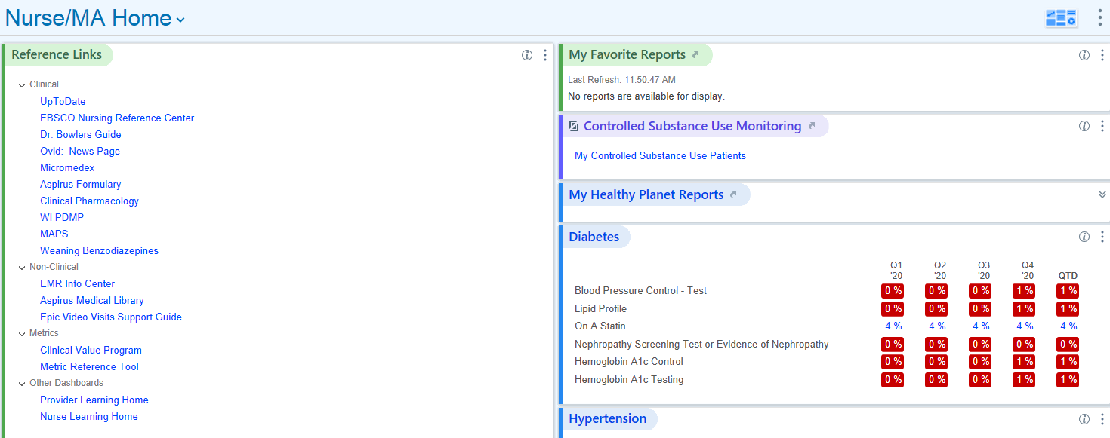

|  |  |
| --- | --- |
| Reference Links | Links to helpful resources and applications outside of Epic. |
| Today’s Visits | A glance at the schedules for your providers in your log-in department. |
| My Favorite Reports | This section displays any Reporting Workbench reports that are saved as your favorites. These reports should be re-run on a consistent basis to locate gaps in care. |
| Controlled Substance use Monitoring | A report of my controlled substance patients. |
| My Healthy Planet Reports | Primary care providers can use these reports to manage provider based patient panel. |
| Disease Specific Registry Dashboards | This area shows statistics displaying how well the providers in your department you are doing regarding different population health measures. |

# In Basket Toolbar

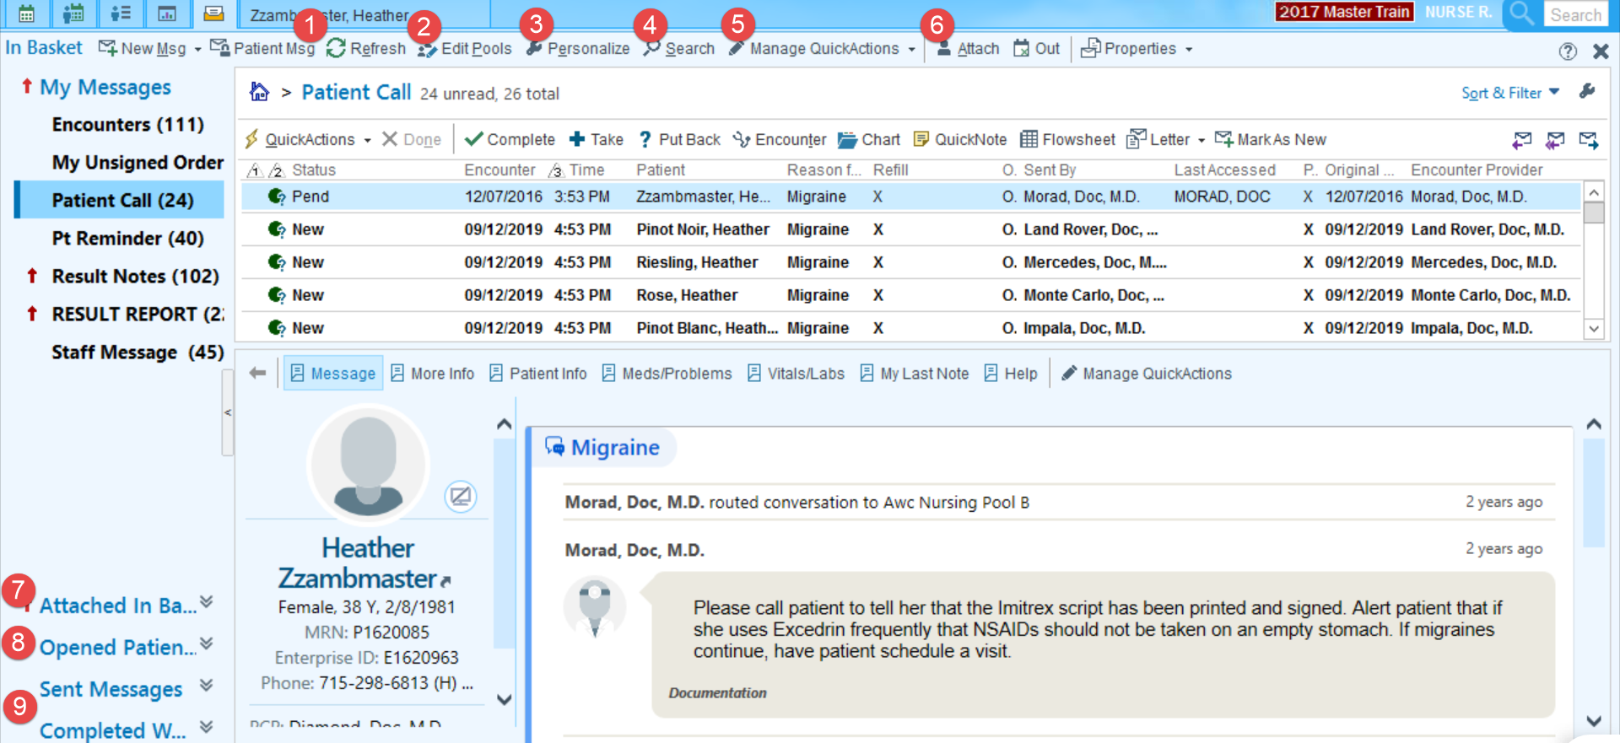

|  |
| --- |
| 1. The Refresh button causes the system to refresh immediately. |
| 1. The Edit Pool button is useful for managing the pools you are checked into. |
| 1. Personalize allows you to personalize the order in which the In Basket folders appear. |
| 1. Use the Search button to find messages easily. |
| 1. Manage QuickActions allows you to address messages faster by having preset actions set up for messages like Rx Requests, Results notes, QuickNotes, Letters, and more. |
| 1. Attach allows you to grant access and attach to other users In Baskets to help cover the work. |
| 1. **Attached In Baskets** appears if you're attached to your provider’s In Basket. |
| 1. **Opened Patients** appears if you have a patient's chart or visit open so you can view messages specific to that patient. |
| 1. Go to the **Sent Messages** or **Completed Work** to find past messages. To act on a message that was previously completed, click Move to My Messages to work on it later. |

To learn more about the various In Basket Folders, please reference the [In Basket Folder Descriptions](http://aspirusintranet/Uploads/Public/Documents/EMR-Tipsheets/Ambulatory%20and%20Inpatient/2015/In%20Basket%20Folder%20Descriptions.pdf) TipSheet.

# Card View

Test results, Rx requests, and patient communication messages from In Basket can be seen and addressed from Card View on the Schedule sidebar.

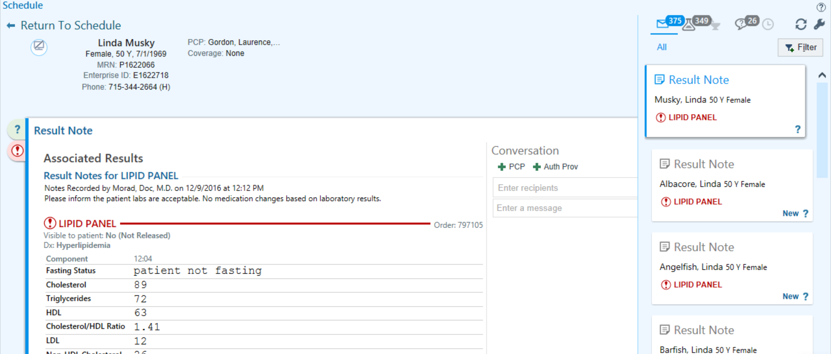

# How to Log Into The PLY/Sandbox Environment

The PLY/Sandbox environment is a place to practice workflows and complete guided practices. It is refreshed daily to allow multiple users to take advantage of this resource. Information you document or orders placed will likely not be there the next time you visit the Sandbox.

1. From the Aspirus Intranet, hover over Work Tools and Resources and click **Citrix**.

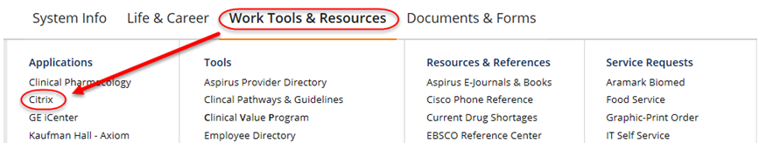

1. Log-in to **Citrix** with your Epic User name and Password.



1. Single click on each of the following folders to find the proper epic PLY19 Environment.

* Click Epic 🡪 Training 🡪 Playground (choose either Central or Eastern)

