Backroom Support Tipsheet- Aspirus Site
Backroom support will be critical to a successful training as well as develop your skills of being SUPER. While supporting, you should be able to answer general questions like: where is that button? Or how do I get there? If you have any questions that you are unclear how to respond to, please stop the instructor and he or she will assist you.
Below is a list of responsibilities with instructions on how to fulfill them. Thank you for being a SUPER user. We appreciate you and know you are going to be great!

Login to Training Computer/Laptop and turn on Projector
- Sign in using
  - Username: Aspirus ID
  - Password: Aspirus Password
- Go to aspirus.webex.com and sign in using Aspirus ID and Password
- Click Join Meeting
  - If you cannot find meeting- use search field and enter meeting invite found on your invite. Will require you to also enter password (also on meeting invite)
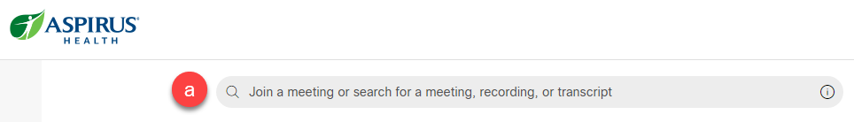
- Connect audio
  - If your room has a phone- Use Call In option
  - If your room has a white tablet- Call in from the tablet on the desk
Tips-
Close out of the picture in picture on the tablet
Move the screen closer to the student’s computers.
  - If your room has Speakers and Mic- Use Connect through computer audio

PLEASE MUTE WHEN NOT TALKING- There are multiple locations being trained at once
- Turn the power button on the projector and confirm it is displaying the instructor laptop on the screen.
  - Look for a remote and push power
  - If you used white tablet this should have connect to Cisco screen

Tip- Call the Remote Instructor using Dial In
- If needed change Audio Setting to Call In, click Audio:
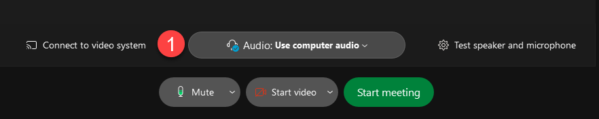

- Click Call in
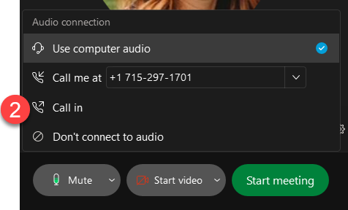
- Click Start Meeting- Phone number will be presented on next screen
- Dial into the meeting with phone number listed on training screen and listen to the prompts.
  - Enter access code followed by a # sign.
  - Enter attendee ID followed by the # sign.
  - You are now able to speak to the remote instructor.

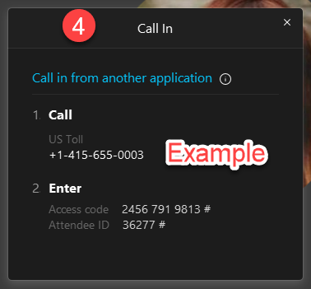

Getting the Class ready
- When students arrive have them login to the computer using:
  - Username: Aspirus ID
  - Password: Aspirus Password
- Open browser and go to citrix.aspirus.org
  - Username: Aspirus ID
  - Password: Aspirus Password
- When prompted click Already Installed
- Navigate to the Epic ACE classroom per the trainer’s instructions
Click Epic Training ACE 1,2 or 3 (choose either Central or Eastern) Instructor to choose
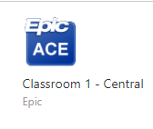



Assist the Instructor in Timekeeping and Minimizing Sidebar Conversations
- When the instructor gives breaks throughout the day, be sure to watch the clock and call students back to their workstations. This will ensure the class will not run late.
- Direct the students to raise their hand if they are off track. If you are seeing students having questions assist them quietly on the side. If multiple students are having challenges STOP the instructor and ask for reteaching or clarification.
- Stop class and have students refocus on the instructor if they are off track or having too many sidebar chats.
Technical difficulties
- If at any time during class network connection is lost or there are technical issues, please follow these steps:
  - Breathe- we got this!
  - If you can use Chat to notify instructor, they will send out an SOS to the right team.
  - If you cannot reach the instructor Dial 89-1-715-847-2000 ext 85605.

