Backroom Support Tip Sheet- Aspirus Gold/Silver/Bronze Rooms
Backroom support will be critical to a successful training as well as develop your skills of being SUPER. While supporting, you should be able to answer general questions like: where is that button? Or how do I get there? If you have any questions that you are unclear how to respond to, please stop the instructor and he or she will assist you.
Below is a list of responsibilities with instructions on how to fulfill them. Thank you for being a SUPER user. We appreciate you and know you are going to be great!

Login to Training Computer
- Sign in using
  - Username: Aspirus ID
  - Password: Aspirus Password
- Go to aspirus.webex.com and sign in using Aspirus ID and Password
- Click Join Meeting (if it will not launch select, Join from your browser)
  - If you cannot find meeting- use search field and enter meeting invite found on your invite. Will require you to also enter password (also on meeting invite)
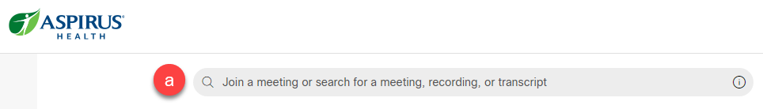

Setting Up Presentation Screens
- Turn on the tablet using the power button in the top left corner of the black tablet.
- Touch the Tablet screen to Begin.
- Select the General Presentation button.
- Select PC Monitor -2(Gold) under Presentation Sources.
- Under Projectors, touch both squares and ensure they say PC Monitor – 2. If this does not, work try repeating the steps touching PC Monitor -1(Bronze Room) You should see the monitor displayed on the screens at this point.
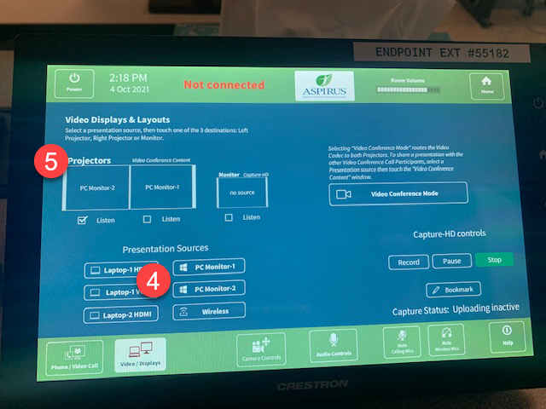
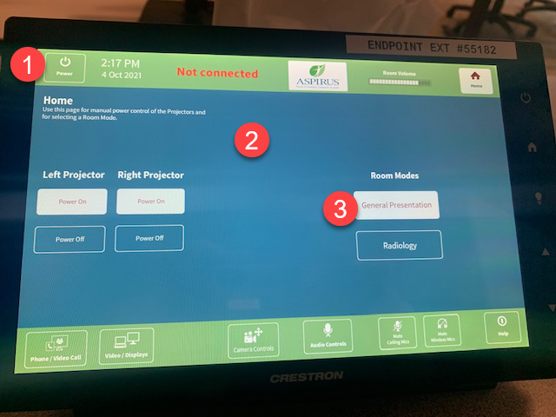

Setting up Sound
- Select Phone/Video Call Button in the bottom left corner of the tablet.
- Next, you will need to dial into the meeting. (To find the Meeting ID number you can go to the Webex and select Switch Auto to Call In.)
- On the black tablet, dial (9)-1-415-655-0003, When you hear the prompt, type in the meeting ID number, and select #. You do NOT need to select the Attendee ID, just push # again.
- If you hear loud feedback in audio you will need to select Audio Controls button on the bottom of screen and Mute the Presentation

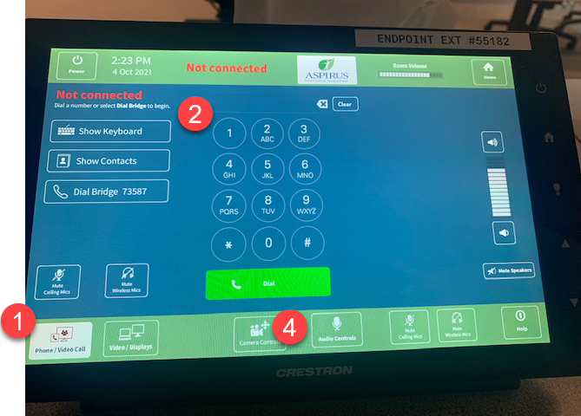

Getting the Class ready
- When students arrive have them login to the computer using:
  - Username: Aspirus ID
  - Password: Aspirus Password
- Open browser and go to citrix.aspirus.org
  - Username: Aspirus ID
  - Password: Aspirus Password
- When prompted click Already Installed
- Navigate to the Epic ACE classroom per the trainer’s instructions
Click Epic Training ACE 1,2 or 3 (choose either Central or Eastern) Instructor to choose
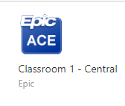



Assist the Instructor in Timekeeping and Minimizing Sidebar Conversations
- When the instructor gives breaks throughout the day, be sure to watch the clock and call students back to their workstations. This will ensure the class will not run late.
- Direct the students to raise their hand if they are off track. If you are seeing students having questions assist them quietly on the side. If multiple students are having challenges STOP the instructor and ask for reteaching or clarification.
- Stop class and have students refocus on the instructor if they are off track or having too many sidebar chats.
Technical difficulties
- If at any time during class network connection is lost or there are technical issues, please follow these steps:
  - Breathe- we got this!
  - If you can use Chat to notify instructor, they will send out an SOS to the right team.
  - If you cannot reach the instructor Dial 89-1-715-847-2000 ext 85605.

At the Completion of Class
- Log off the Webex.
- Log out of the computer by clicking the Windows icon in the bottom left corner and selecting the person icon, then choosing sign out.
- Power off the tablet. (Power button in top left corner)
