MModal Dictation/Transcription Guidebook

Dictaphone to MModal Transition 2

TELEPHONE DICTATING SYSTEM INSTRUCTIONS 3-4

**OTHER IMPORTANT INFORMATION 5**

---------------------------------------------

# Dictaphone to MMODAL Transition

**Go Live Date: December 1, 2021**

**Preparation:**

* Please be caught up on all dictations prior to 12/1/2021.
* M*Modal Front End Speech transition will occur when facilities are brought on Aspirus Network Provider PC’s are swapped out with training at that time. Until that time use Dragon into Epic.
* Dictator ID’s will change to be your Epic Provider ID.
* Facility Codes (Site ID’s) will change.
* Work types have changed. Transcription Department is preparing new dictation cards for your use. Please make sure you receive this updated information.
* Dictations will require the patient’s CSN (Contact Serial Number) or Epic Order ID:
  + Refer to Transcription Workflow Tip Sheet for information on how to view the Epic CSN number and how to add CSN Column to Patient Lists.
* All dictated items will be signed in the Epic In-Basket
  + Refer to Transcription Workflow Tip Sheet for information on signing documents in the Epic In-Basket.

**MMODAL Contacts**

|  |  |  |  |  |
| --- | --- | --- | --- | --- |
| Rhonda Gilles, Manager System Transcription  715-847-2241 or 72241  [Rhonda.gilles@aspirus.org](mailto:Rhonda.gilles@aspirus.org) | Rod Martinez, M*Modal IT Analyst  [Rod.Martinez@aspirus.org](mailto:Rod.Martinez@aspirus.org) |  | | Rhonda Gilles:  715-847-2241  [Rhonda.gilles@aspirus.org](mailto:Rhonda.gilles@aspirus.org) |
| Linda Bartelt, Revenue Cycle Business Analyst/Front End Speech Trainer  715-748-7556 or 17556  [Linda.Bartelt@aspirus.org](mailto:Linda.Bartelt@aspirus.org) | | |

ASPIRUS NORTHWOODS HOSPITALS

TELEPHONE DICTATING SYSTEM

1. Access the system by dialing: 72002 (in house)

715-847-2002 (outside)

1-800-284-8470 (outside)

2. Wait for voice prompts to begin.

3. Enter provider ID NUMBER followed by the # key.

4. Enter location code followed by # key:

Aspirus Eagle River Hospital – 600# Aspirus Sacred Heart Hospital – 604#

Aspirus Good Samaritan Hospital – 601# Aspirus St. Mary’s Hospital – 605#

Aspirus Howard Young Medical Center – 602# Aspirus St. Michael’s Hospital – 606#

Aspirus Our Lady of Victory Hospital – 603#

5. Enter work type followed by the # key:

Work types:

1. History & Physical 13- EMG
2. OP/Procedure 14- EEG
3. Discharge 28- Sleep Study

6- Consultation 71- Imaging

7- ED Note 325- Cadio/Pulm

6. Enter Epic CSN or Order ID # followed by # key.

7. To dictate press 2.

**DICTATING:**

**\*Press 2 to begin recording.** Dictate your name and the patient’s name account or document number.

**\*To indicate a priority document:** Anytime during dictation, while you are actually dictating, press 6.

**\*To dictate more than one report:** At the end of the first report, press 8, then continue with step 5 above.

**\*To complete dictation session, press 5 to disconnect or hang up.**

(If you do not press 5, the port will be out of use for 5 minutes.)

**\*To listen to a report at work type prompt: *1**

8. Press 5 to disconnect from the system.

*To dictate more than one report, press 8 at the end of the first report and continue with step 5 above.

**KEYPAD FUNCTIONS**

**NOTE:** After using any keypad functions return to the RECORD mode by pressing 2.

2 Record and pause 7 Continuous Rewind

3 Rewind and Play 8 Batching (save current report and

4 Continuous Forward begin another)

5 Disconnect 44 Move to the End of a Report

6 High Priority 77 Move to the Beginning of a Report

FOR HELP CALL: 715-847-2243

ASPIRUS NORTHWOODS CLINICS

TELEPHONE DICTATING SYSTEM

1. Access the system by dialing: 72002 (in house)

715-847-2002 (outside)

1-800-284-8470 (outside)

2. Wait for voice prompts to begin.

3. Enter provider ID NUMBER followed by the # key.

4. Enter location code followed by # key:

Aspirus Northwoods Clinics (All) – 607#

5. Enter work type followed by the # key:

Work types:

1- History & Physical 46 – Home Visit

2- OP/Procedure 47 – Occupational Health

6- Consultation 48 – Nursing Home

8- Letter 49 – Telephone Note

41- Progress Note 71- Imaging

42- Non Office Related 100 – Partial Dictation

43- Chart Note 325 – Cardio/Pulmonary

6. Enter Epic CSN or Order ID # followed by # key.

7. To dictate press 2.

**DICTATING:**

**\*Press 2 to begin recording.** Dictate your name and the patient’s name account or document number.

**\*To indicate a priority document:** Anytime during dictation, while you are actually dictating, press 6.

**\*To dictate more than one report:** At the end of the first report, press 8, then continue with step 5 above.

**\*To complete dictation session, press 5 to disconnect or hang up.**

(If you do not press 5, the port will be out of use for 5 minutes.)

**\*To listen to a report at work type prompt: *1**

8. Press 5 to disconnect from the system.

*To dictate more than one report, press 8 at the end of the first report and continue with step 5 above.

**KEYPAD FUNCTIONS**

**NOTE:** After using any keypad functions return to the RECORD mode by pressing 2.

2 Record and pause 7 Continuous Rewind

3 Rewind and Play 8 Batching (save current report and

4 Continuous Forward begin another)

5 Disconnect 44 Move to the End of a Report

6 High Priority 77 Move to the Beginning of a Report

FOR HELP CALL: 715-847-2243

**OTHER IMPORTANT INFORMATION**

* + Inpatient Progress Notes – No dictation, use Front end speech or Epic Chart Tooling.
  + Plan to train M*Modal Front end speech after facilities are brough up on network and after new PC’s deployed.
    - Module can be accessed via HealthStream or Aspirus intranet.
  + Work Type Usage:
    - H&P (1): Preop and Admission H&P’s
    - OP/PROCEDURE (2): Surgical notes
    - DIS. SUMMARY(3): Discharges
    - CONSULTATION (6): Inpatient consults
    - ED NOTE (7): ED notes
    - EEG (13): EEG’s
    - EMG (14) EMG’s
    - SLEEP STUDY(28): Sleep Studies – dictate only, unless

order based documentation fixed in Epic

* + - IMAGING (71) (Nuc. Med, Dictate only, unless order based

(non-rad BMD’s) documentation fixed in Epic

* + - CARDIO ORDERS (325) Dictate only, unless order based

Echo, Stress Test, Holters, documentation fixed in Epic.

Cardiac Caths,

PROGRESS NOTES: **No inpatient dictation**

**EPIC In Basket**

All transcribed notes will be sent to the provider’s In Basket to be reviewed, edited and/or approved. All messages appear in the Transcription folder.

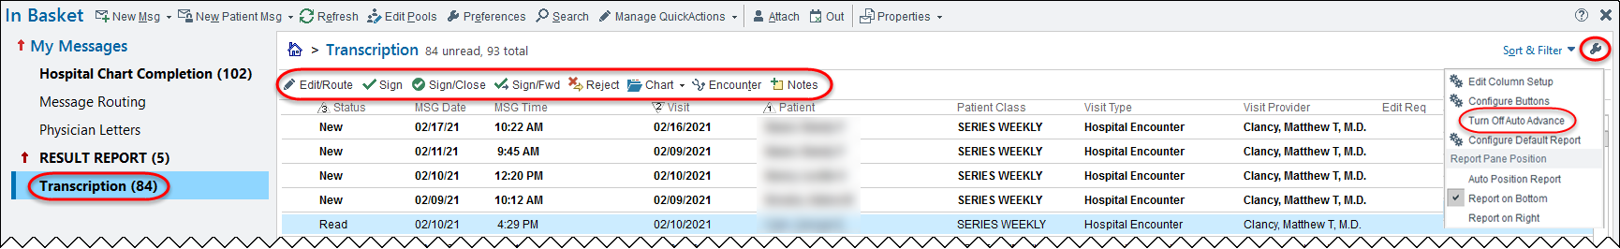

Click the wrench icon to adjust the Auto Advance feature. The function will default on meaning it will display one document after another while reviewing and signing. Click again to turn the feature off.

**Tool Bar Buttons**:

|  |  |
| --- | --- |
| Edit/Route | Allows you to open the document to edit it. Click this button to send a CC Transcription to another provider, |
| Sign | Signs the dictation without closing the encounter. |
| Sign/Close | Signs the transcription and closes the encounter. |
| Sign/Fwd | Send to a cosigner only (sending to another provider is done under Edit/Route). |
| Reject | Sends message back to the transcription error pool if it is not your dictation/patient. |
| Chart | Opens Chart Review, Flowsheets, Results Review, or Problem List |
| Encounter | Opens the specific encounter the note is linked to |
| Notes | Opens the Notes Activity |

Edit Transcription

1. Single click on message. It will appear at the bottom of the screen to review.
2. Click the **Edit/Route** button on the toolbar.
3. Edit the note as needed.
4. Click Edit CC Recipients if you would like to route your note to another provider for review.
5. Enter the name of the provider or click Add PCP.
6. Click Accept.
7. Once completed, click **Sign**.

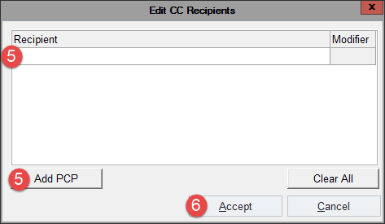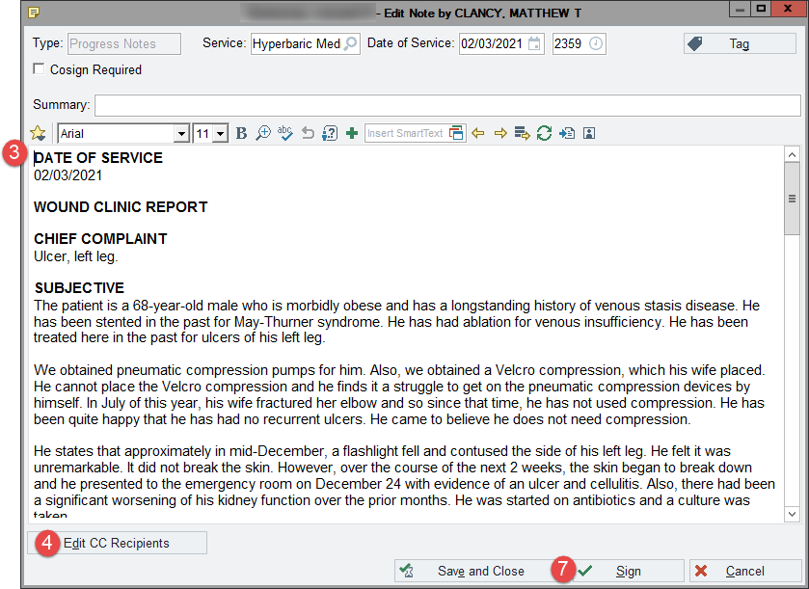

Send a Dictation for Co-Signatures

This workflow is used by providers who need to have a co-signature for their dictations.

1. Single click on the message. It will appear at the bottom of the screen to review.
2. If the transcription is correct:
   1. Click the **Sign/Fwd** button from the toolbar.
   2. In the To field, enter the **name of the provider** that needs to sign off on the dictation.
   3. Click **Accept**.
   4. You will be brought back to the In Basket and the status of the message will change to Done.

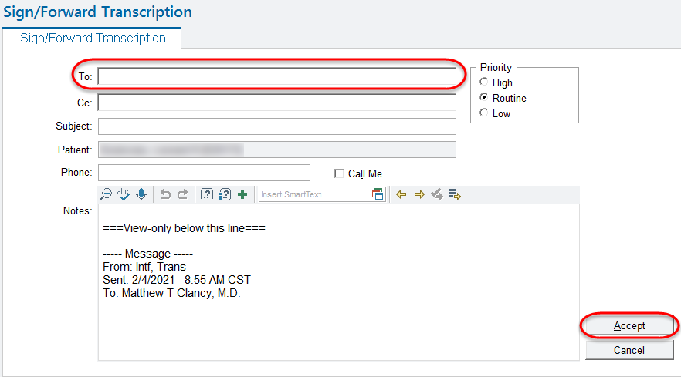

1. If the transcription is NOT correct:
   1. Click the **Edit/Route** button from the toolbar.
   2. **Edit the note** as needed.
   3. Click **Save & Close** button.
   4. Click the **Sign/Fwd** button from the toolbar.
   5. In the To field, enter the **name of the provider** that needs to sign off on the dictation.
   6. Click **Accept**.
   7. You will be brought back to the In Basket and the status of the message will change to Done.

Viewing the Contact Serial Number (CSN)

The dictation system requires the use of the CSN to link the note to the encounter.

**How to add the CSN Column to the Clinic Schedule**

1. **Highlight (single click) a schedule** under ‘My Schedule’.
2. Click the **gear** icon.

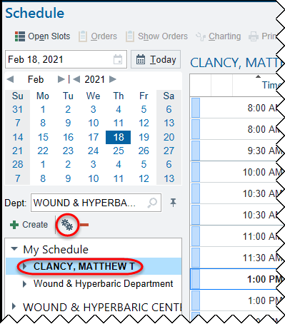

1. Under the Available Columns, **locate and highlight CSN**.
2. Click **Add Column** button to move CSN to the Selected Columns.
3. **Highlight the CSN column** in the Select Columns area and use the **up and down arrows** to move the column to its desired location. As a default all added columns start at the bottom.
4. Click **Accept**.

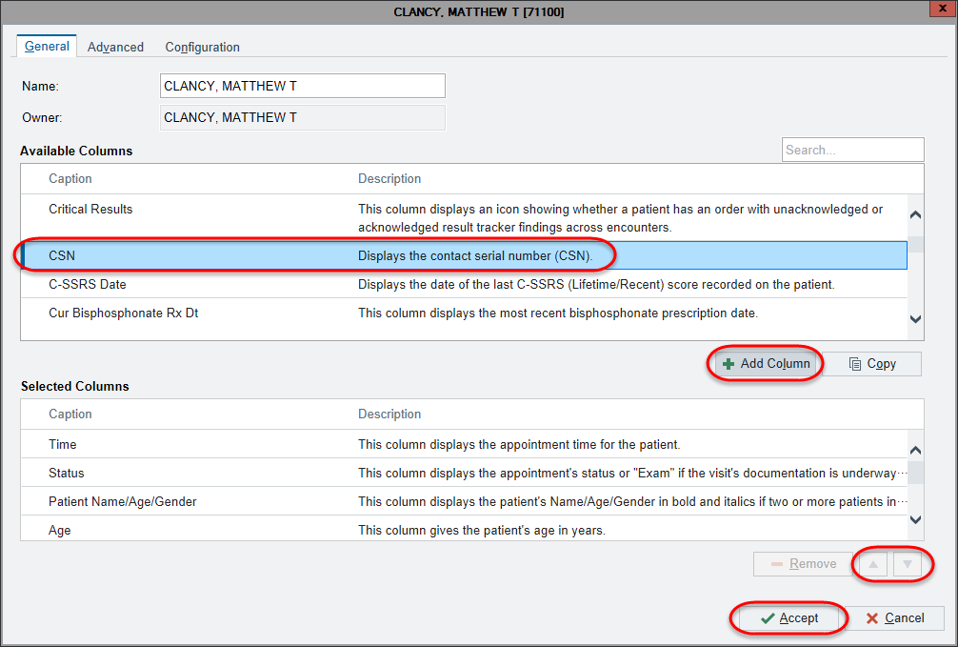

**How to add the CSN Column to the Patient Lists**

1. **Highlight (single click) a list under ‘My Patient Lists’**.
2. Click the **arrow next to the Edit List** button.
3. 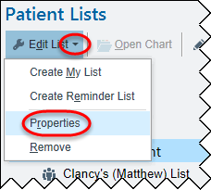Click **Properties**.
4. Under the Available Columns, **locate and highlight CSN**.
5. Click **Add Column** button to move CSN to the Selected Columns.
6. **Highlight the CSN column** in the Select Columns area and use the **up and down arrows** to move the column to its desired location. As a default all added columns start at the bottom.
7. Click **Accept**.
8. Repeat steps for any other patient lists.

