Enter – Edit Results Workflow
Scenario: Your patient Sam has diabetes, and his glucose levels need to be evaluated.
You will use the Enter- Edit results activity to add his results to Epic.

Ordering the Test
- Open your Sam patient chart.
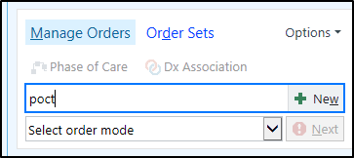
- Open the Orders activity. We will place an order for a POCT Glucose test under the direction of his provider.
  - Search for “POCT” in the orders sidebar and select Glucose Fingerstick POCT.
- Select the order and click Sign.
  - Order mode of Verbal Order with Readback.
  - Ordering and Authorizing provider: Chris Avocado.
  - Verify that the new order shows up in the Lab section of Active Orders.

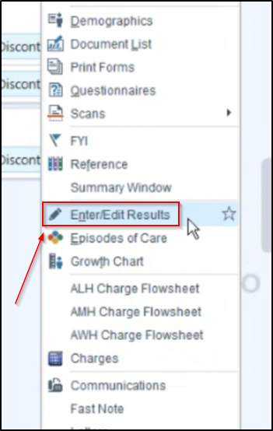
Entering Test Results
- Keep Sam’s chart open. We will pretend that time has passed, and we now have a lab result we need to enter into Epic so that it can be stored in the chart.
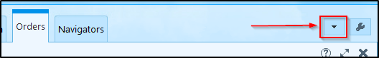
- Click the arrow to open the More Activities menu and locate Enter/Edit Results.

- The results are automatically filtered. You will have to adjust the filters to find the lab order.
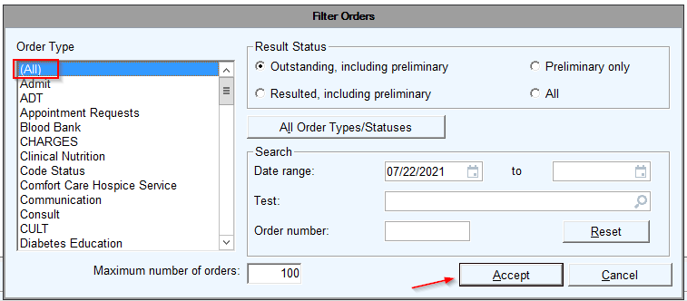
  - Click Filter and select an Order Type of (All) and click Accept to see all orders.
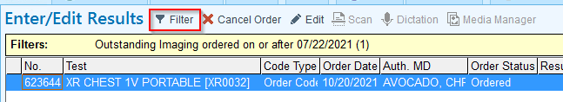

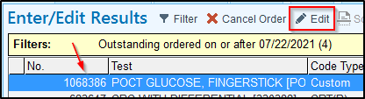
- Locate the POCT Glucose Test and click to highlight it. With the order highlighted, click Edit.

- The editing window will open.
  - Enter the lab result in the Value section (designated with the red hard stop)
  - Information about collection type, date, and time can be found in the Specimen section.
  - Results can be flagged as Abnormal if applicable.
  - After completing all necessary documentation, change the Status to Final Result.
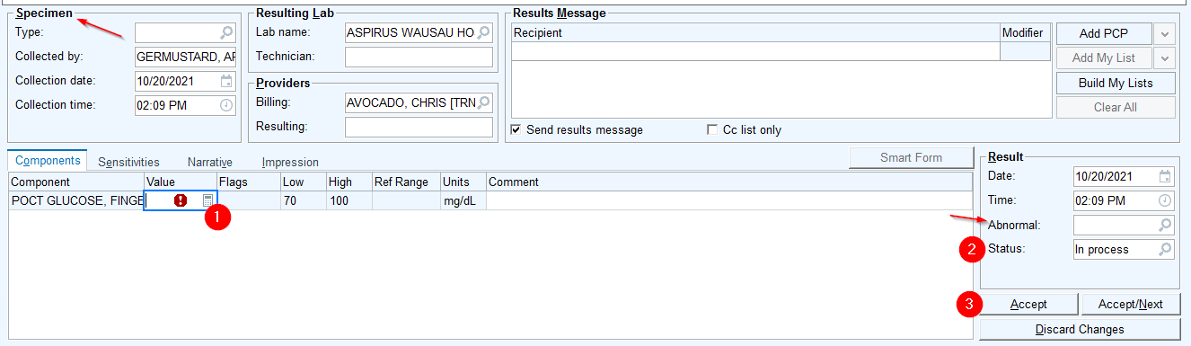
  - Click Accept when complete. The lab will fall off the list.

Reviewing Results
- After entering the lab results, you can view all finalized labs from the Chart Review activity.
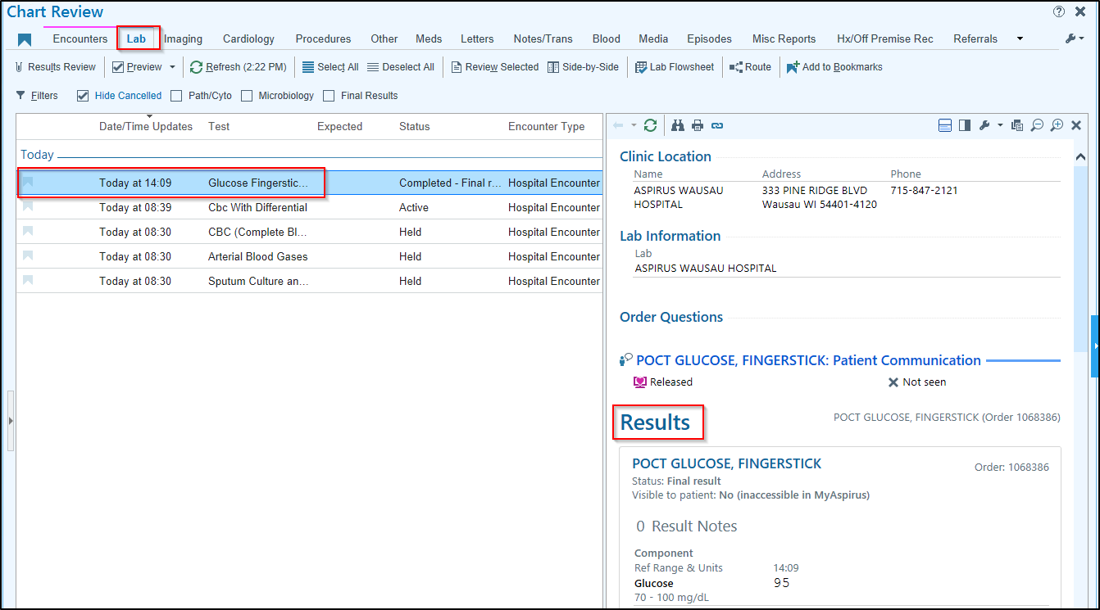
- Under the Lab tab, you can view all results entered and finalized, as well as a report on the results.

